DOCAYA
Enterprise Electronic Document Management System
Technical Architecture Document
Version 1.3
Architecture · Database Design · Search · Access Control · Development · Infrastructure · Deployment · Operations

Attribute | Value
Document type | Technical Architecture Document (TAD) — build, deployment and operations baseline
Version | 1.3 — supersedes Technical Architecture Document v1.2 in full
Authoritative source | Docaya EDMS Functional & Business Design v1.3 · Docaya Functional & Technical Specification v1.3
Platform | Microsoft Azure · Microsoft 365 · SharePoint Online · Microsoft Entra ID · UAE PASS
Architecture style | Cloud-native, event-driven, staging-first, zero-trust, portable multi-tenant product
Status | Draft for Review — build baseline subject to POC-Critical outcomes (Section 28)
Classification | OFFICIAL – Internal
Date | 13 September 2026

Baseline rule Where this document conflicts with the v1.3 Functional & Business Design or the v1.3 Functional & Technical Specification, the v1.3 documents govern. Architecture content carried forward from v1.2 has been retained only where it remains valid; everything outdated, contradictory or unsupported has been revised, replaced or deleted and is recorded in the reconciliation register.

1. Document Control

1.1 Version History
Version | Date | Status | Summary of change
1.0 | Sep 2026 | Superseded | Initial complete technical baseline, solution and application architecture.
1.1 | Sep 2026 | Superseded | Added development methodology, repository structure, infrastructure, network and packaged deployment.
1.2 | Sep 2026 | Superseded | Consolidated technical baseline aligned to the v1.2 functional design.
1.3 | 13 Sep 2026 | Draft for review | Rebuilt against the v1.3 functional baseline. Adds Ask Docaya (M10) architecture, single-file 100 MB capture, document thumbnails, Department Tag and Publishing Scope, A New Revision (M14), full database and schema design, Azure AI Search technical design, SharePoint departmental and attribute-level design, the complete identity and resource-access architecture, project initiation and repository bootstrap, portable cross-tenant deployment, offline and on-premises variants, and twenty-four connected architecture diagrams.

1.2 Reviewers and Approvals
Review area | Responsibility | Decision
Solution Architecture | Architecture fitness, integration correctness, operability | Pending
Data & Database Design | Schema separation, integrity, retention, residency | Pending
Security & Identity | Zero-trust, RBAC/ABAC, service identity scope, secrets, network | Pending
Search & AI Assurance | Permission trimming, grounding and citation, responsible-AI controls | Pending
Platform & Operations | Reliability, observability, deployment, recovery | Pending
Client Deployment & Onboarding | Cross-tenant installation, offline transfer, on-premises variant | Pending
Programme Governance | Scope, POC gating, risk, investment | Pending

1.3 Relationship to Version 1.2 — Reconciliation Register
Every material change from v1.2 is recorded below. Architecture that appeared in v1.2 has been carried forward only where the v1.3 functional baseline still requires it.
v1.2 content | Action | v1.3 position
Bulk drag-and-drop upload; 5 GB maximum file size | Replaced | One file per registration, maximum 100 MB, resumable and chunked, validated in the browser and re-validated server-side.
Exclusion of embeddings, vectors and AI answering | Reversed | Ask Docaya (M10) introduces post-approval embeddings and cited natural-language answering over published content only.
Azure OpenAI as a general RAG service across the estate | Narrowed | An embedding and answering endpoint used strictly after publication, in-region, permission-trimmed and citation-bound.
On-Behalf-Of (OBO) access to SharePoint as the signed-in user | Deleted | A governed service identity performs all content operations; the user token stops at the Docaya API and is never forwarded.
AI or OCR classification suggestions during upload | Deleted | Classification remains entirely manual and Editor-driven; only technical metadata, source text, preview and thumbnail are extracted.
Auto-approval for Public sensitivity | Deleted | Publication always requires completion of the configured final approval stage.
Single generic approve/reject gate | Expanded | Configurable three- or four-stage named review chain with threaded comments, correction-point return and a working-day SLA engine.
Azure Cache for Redis as a core store | Removed from baseline | Not required by the v1.3 functional design; session and presence needs are met by the API and SignalR. May be reinstated only on evidence from load testing.
“Existing Document Modification” (M14) naming | Renamed | M14 is A New Revision; the on-screen action is “Submit a New Revision”. Modification, change request and amendment are not used in the interface.
“Search & Discovery” (M10) naming | Renamed | M10 is Ask Docaya — Search, Discovery & AI Answering, a single entry point covering Quick Search, Ask and Browse.
Fifteen modules (M1–M15) | Extended | Sixteen modules (M1–M16); M16 Audit & Compliance is a distinct module.
Data architecture described at entity level only | Expanded | Full multi-schema database design: stg, docaya, wf, sec, ref, idx, ntf, aud and ops, with DDL, indexing and integrity rules (Section 11).
Search described as a capability | Expanded | Complete Azure AI Search technical design: index schema, analyzers, identity separation, permission-key generation and lifecycle triggers (Section 12).
SharePoint described as “the system of record” | Expanded | Departmental site and library information architecture, folder convention, Sites.Selected scoping and attribute-level column mapping (Section 13).
Deployment described for one client environment | Expanded | Portable product model: seven deployment variants including unrelated tenant, restricted zone and on-premises, with a signed release package (Sections 22–25).
No document thumbnail concept | Added | A thumbnail is captured at registration and at every approved revision, retained per version and permission-trimmed exactly as the document is.
No Department Tag or Publishing Scope | Added | Both are classification dimensions captured at registration; they drive navigation, visibility and notification reach.
Disconnected illustrative diagrams | Replaced | Twenty-four connected diagrams; every path is directional, names its caller and target, and matches the written design.

2. Executive Summary

2.1 Purpose of this Document
This Technical Architecture Document is the authoritative engineering baseline for building, deploying, operating and supporting Docaya. It translates the v1.3 Functional & Business Design and the v1.3 Functional & Technical Specification into a concrete architecture and an executable implementation plan. It is written to be sufficient for a development team to create the repository and begin building, for a cloud team to provision Azure from Infrastructure-as-Code, for a security team to validate every identity and access path, for a deployment team to package the product, for a client team to install it into an unrelated tenant, and for an operations team to run, upgrade, recover and eventually decommission it.

2.2 What Docaya Is
Docaya is a governance and intelligence layer over SharePoint Online. It replaces uncontrolled shared drives and email-based approvals with a single governed lifecycle: every document is captured into a controlled staging zone, registered and manually classified, reviewed through a configurable three- or four-stage chain with a working-day service-level target, and only then promoted — unchanged, in its native format — into the correct SharePoint library where it becomes an official record. After publication, and only after publication, the approved content is indexed and embedded so that Ask Docaya can answer questions about it with citations, trimmed to each user's effective permission.

2.3 Major Architecture Changes from v1.2
Change | Architectural consequence
Ask Docaya (M10) added | A new post-publication indexing and answering zone, physically separated from capture, registration and classification so unapproved content cannot reach it. Requires an index schema with permission keys, a dual-identity model separating write from query, and grounding and citation controls.
Capture reduced to one file per registration at 100 MB | Simplifies the upload session, removes the need for very large multi-part orchestration, and makes browser-side validation practical. Thumbnail generation becomes feasible synchronously at registration.
Document thumbnail per version | Introduces a regenerable preview store in Blob, a permission-checked thumbnail endpoint, and a per-version retention rule so history remains visually identifiable.
Department Tag and Publishing Scope | Become first-class classification dimensions driving navigation, search facets, visibility and — critically — the reach of the publication broadcast notification.
Governed service identity confirmed; OBO removed | Establishes a hard authority boundary: the user token stops at the API. All content operations execute under least-privilege workload identities, with the real user recorded as actor and the identity as executor.
Full database design specified | Nine bounded schemas replace an entity list, allowing least-privilege database roles per workload, independent staging lifecycle, append-only audit and rebuildable projections.
Portable product deployment model | The architecture no longer assumes one environment. Seven deployment variants are supported, including an unrelated Microsoft tenant, a restricted zone with no internet access, and a client on-premises estate behind provider adapters.
POC gating introduced | Modules classified POC-Critical must be proven before their build stream commits, which changes the delivery sequence and the definition of ready for those phases.

2.4 Architecture Principles Carried Forward
- SharePoint Online is the published content system of record. Published binaries and their native version history live in governed libraries; there is no proprietary content store and no lock-in.
- Azure SQL Database is authoritative for everything structured. Registry, business metadata, classification, workflow and stage state, review thread, SLA data, notification history, access policy, retention data and the hash-chained audit.
- Staging-first. The unchanged original file remains in a controlled staging zone throughout capture, registration, classification and review, and is promoted only on final approval.
- No format conversion, ever. The byte stream published to SharePoint is identical to the byte stream uploaded; this is verified by hash comparison before the registry is updated.
- Manual classification. No AI classification, metadata suggestion or approver recommendation is offered at loading, registration or classification.
- Deny by default. Authorization is evaluated before every data call and results are trimmed after every retrieval.
- Idempotent side effects. Promotion, indexing and notification tolerate retries without duplication.
- Everything as code. Infrastructure, configuration, policies and pipelines are versioned, reviewed and reproducible.
- Portable by construction. No artifact contains a tenant identifier, subscription identifier, endpoint, resource name or secret.

2.5 Target-State Overview
The platform is composed of five deployable packages — a React single-page application, an ASP.NET Core API and backend-for-frontend, an Azure Functions workers package containing the Durable workflow, a shared OpenAPI contract package, and a Bicep infrastructure package — deployed onto Azure behind Front Door, a Web Application Firewall and API Management, with private-endpoint-only connectivity to Azure SQL, Blob Storage, Key Vault, Service Bus and Azure AI Search, and explicitly allow-listed egress to Microsoft Graph.

3. Scope and Architecture Drivers

3.1 In Scope and Out of Scope
In scope | Out of scope
Sixteen functional modules M1–M16; the governed staging-first lifecycle; single-file 100 MB capture with thumbnail; manual classification including Department Tag, Publishing Scope and Standard; the configurable review chain and working-day SLA engine; A New Revision; Ask Docaya search and post-approval answering; records, retention and legal hold; embedded analytics; hash-chained audit; the complete database and schema design; Azure AI Search technical design; SharePoint departmental and attribute-level design; identity, authorization and resource-access architecture; project initiation and repository structure; Bicep infrastructure; CI/CD; portable cross-tenant, restricted-zone and on-premises deployment; testing, observability, operations, upgrade, rollback and decommissioning. | Migration of pre-existing content (separate workstream); physical records handling beyond scan capture; any AI classification, metadata or approver recommendation at upload, registration or classification; indexing, embedding or answering over unapproved content; file-format conversion; bulk multi-file upload; commercial licensing negotiation; final infrastructure sizing, which is confirmed by performance testing; detailed low-level class design and source code, which is produced during build against this baseline.

3.2 Architecture Drivers
Driver | Origin | Architectural response
One governed repository | O1 | SharePoint Online as published system of record; Azure SQL as authoritative registry; no parallel content store.
Controlled lifecycle | O2 | Staging-first pipeline; publication gated on the configured final approval stage; promotion is the only writer to SharePoint.
Accountable review | O3 | Configurable stage chain, threaded comments, correction-point return, stage-duration capture, hash-chained audit.
Fast secure retrieval | O4 | Post-publication hybrid index with permission keys; department and Standard navigation; sub-second facet filtering.
Trusted ecosystem | O5 | UAE PASS federated to Entra ID; native Azure and Microsoft 365 services only; no third-party platform dependency.
Bilingual service | O6 | Arabic and English as first-class throughout: RTL layout, dual analyzers, cross-language retrieval, bilingual notification templates.
Governed change control | O7 | Working-day SLA engine with 12/30-day targets, authorised extension, at-risk and overdue signalling, bottleneck analytics.
National compliance | IA / PDPL | UAE region pinning, private networking, sensitivity labelling, tamper-evident audit, defensible disposition and legal hold.
Portable product | Commercial | No tenant-specific value in any artifact; signed release package; seven deployment variants; provider-abstraction ports.

3.3 Constraints
- The platform is delivered with native Azure and Microsoft 365 services; no third-party platform is required in the Azure-native model.
- A licensed SharePoint Online tenant and a federated national single-sign-on provider are available in the target client tenant.
- All data, including indexing, embedding and answering, resides and executes within the approved UAE Azure region(s).
- User access is governed inside Docaya; content operations use one governed service identity per workload.
- The development tenant has no trust relationship, network path or identity federation with a client production tenant.
- The target environment may have no internet access; the release package must install offline without modification.

3.4 Assumptions and Open Decisions
Assumptions are recorded explicitly and are not treated as approved requirements. Each carries a recommended option and the approver required.
Ref | Assumption or open decision | Recommended position | Approver
A1 | Azure Blob is the production staging store rather than a SharePoint staging area. | Retain Azure Blob staging — lifecycle, private endpoint and cost control are materially simpler. | Architecture + Client IT (POC P2)
A2 | Document classes, handling markings, Standard taxonomy and the departmental library map. | Confirm with the client before Phase 6; seed as configuration, not code. | PMO / Records
A3 | Stage count per document type, parallel/quorum rules and correction-point behaviour. | Adopt a single four-stage chain organisation-wide for V1; add departmental variants post-go-live via Admin Center. | PMO (POC P6)
A4 | Working-day calendar, public holidays and the at-risk warning window. | Client-supplied calendar seeded as reference data and versioned. | Client HR / PMO
A5 | Microsoft Graph application permission scope and approved site collections. | Sites.Selected scoped per approved site; never Sites.ReadWrite.All. | Security (POC P1)
A6 | Power BI capacity, licensing and dashboard layouts. | Deliver the standard report library in V1; add embedded Power BI in V2 once capacity is approved. | Client IT / Finance
A7 | E-signature requirement and provider for final authorisation. | Decision required before Phase 8; architecture supports native or integrated. | Product / Security
A8 | Whether Ask (AI answering) enters V1 or is deferred to V2. | Gate on POC P4 and P5 thresholds; Quick Search and Browse ship in V1 regardless. | Architecture / PMO
A9 | Customer-managed keys for encryption at rest. | Platform-managed keys by default; CMK available where client policy requires it. | Security
A10 | Target container registry and image-signing approach at the client site. | Client-owned private registry; images transferred by digest and verified before import. | Platform / Client IT

4. Functional-to-Technical Traceability
Every v1.3 functional module maps to a named application component, an API or event, a database object, an integration, a security control, a deployment component and a test layer. No architecture component exists in this document unless it appears in this matrix.
Module | Application component | API / event | Database object | Integration | Deployment
M1 Capture & Registration | CaptureService · ChunkUploadHandler · ThumbnailService | POST /documents · POST /documents/{id}/chunks · DocumentRegistered | stg.UploadSession · stg.StagedFile · stg.FileChunk · docaya.Document | Blob · Defender malware scan · Purview DLP | src/api · src/functions
M2 Classification & Metadata | ClassificationService · SchemaValidator | PATCH /registration · PUT /classification | docaya.DocumentMetadata · docaya.DocumentTag · ref.* | Admin configuration store | src/api
M3 Workflow & Approval | WorkflowEngine · SlaCalculator · RoutingResolver | POST /submit · POST /reviews/{id}/decision · ReviewDecisionRecorded | wf.WorkflowInstance · wf.WorkflowStage · wf.ReviewThread · wf.SlaEvent | Durable Functions · Service Bus | src/functions
M4 Promotion & Publishing | PromotionWorker · GraphAdapter · HashVerifier | FinalApprovalGranted · DocumentPublished | docaya.DocumentVersion · ops.PromotionLedger | Microsoft Graph → SharePoint Online | src/functions
M5 Staging Lifecycle | StagingLifecycleService · ReplayHandler | (timer) · staging reconcile | stg.* · ops.DeadLetter | Blob lifecycle rules | src/functions
M6 Extraction & Index Data | ExtractionService · EmbeddingWorker · IndexBuilder | DocumentIndexed | idx.DocumentIndexRecord · idx.IndexChunk · idx.EmbeddingRun | Azure AI Search · embedding endpoint | src/functions
M7 Notification Center | NotificationService · AudienceResolver · ChannelDispatcher | (events) · SignalR push | ntf.Notification · ntf.NotificationPreference · ntf.BroadcastAudience | SignalR · Communication Services · Graph | src/api · src/functions
M8 Correspondence | CorrespondenceService · ReferenceGenerator | POST /correspondence · GET /correspondence/{ref} | docaya.Document (class = Correspondence) · docaya.DocumentRelation | Core pipeline reuse | src/api
M9 Records & Retention | RetentionService · LegalHoldService · DispositionWorker | RetentionActionDue | docaya.Document.LegalHoldFlag · ref.RetentionPolicy | Purview · Blob archive tier | src/api · src/functions
M10 Ask Docaya | AskOrchestrator · QueryPlanner · AnswerComposer · CitationBinder | POST /search · POST /ask | idx.DocumentIndexRecord (read) · aud.AuditEvent | Azure AI Search · embedding endpoint | src/api
M11 Identity & SharePoint | IdentityAdapter · TokenValidator · GraphTokenProvider | (middleware) | sec.Principal | UAE PASS → Entra ID · Managed Identity | src/api · infra
M12 Access Control | PolicyEngine · PermissionKeyBuilder · DecisionLogger | (middleware) · access decision event | sec.AccessPolicy · sec.AbacAttribute · sec.AccessDecisionLog | Entra app roles | src/api
M13 Admin Center | AdminConfigService · RouteDesigner · TaxonomyManager | GET/PUT /admin/* | ref.* · ops.ConfigurationSet | Configuration store | src/api · src/web
M14 A New Revision | RevisionService · VersionComparer | POST /documents/{id}/revisions · RevisionApproved | docaya.DocumentVersion · wf.WorkflowInstance | Graph versioning | src/api · src/functions
M15 Analytics | ReportingModel · EmbedTokenService | GET /analytics/embed | rpt.* views over docaya · wf · aud | Power BI Embedded + RLS | src/api · infra
M16 Audit & Compliance | AuditService · HashChainWriter · EvidenceExporter | GET /documents/{id}/timeline | aud.AuditEvent · aud.AuditExport · aud.ChainCheckpoint | Immutable export storage | src/api · src/functions

How to read this matrix A phase in the implementation plan (Section 26) is complete only when every row it covers has its component built, its API or event contract published, its database objects migrated, its integration proven, its security control tested and its test layer green. This matrix is therefore also the definition of done at module level.

5. Target Solution Architecture
The platform is organised into seven cooperating zones: identity, users and channels, the security edge, application services, asynchronous orchestration, data and content, and delivery and platform services. The diagram overleaf is presented full width and shows every component and every directional path, including the staging-first promotion path and the separately-fed post-publication indexing path.

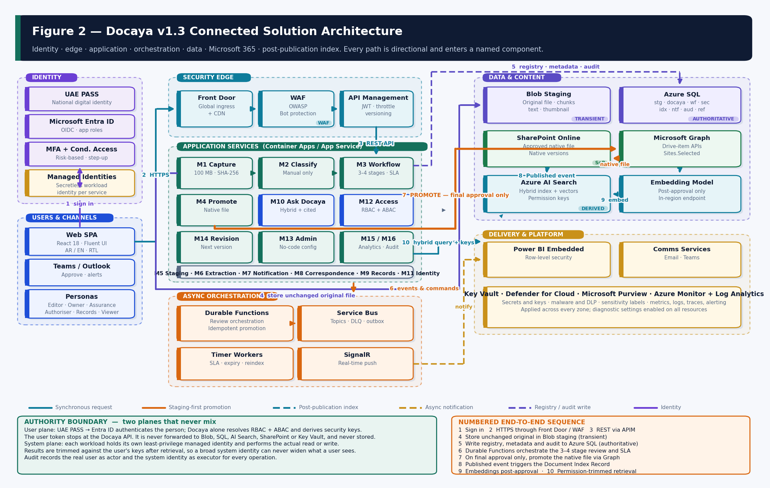
Figure 2 — Connected solution architecture. Numbered 1–10 is the end-to-end sequence from sign-in to permission-trimmed retrieval.

5.1 Zone Responsibilities
Zone | Components | Responsibility
Identity | UAE PASS · Microsoft Entra ID · MFA and Conditional Access · Managed Identities | Federated sign-on for people; secretless workload identity for services. Entra issues application tokens and enforces step-up for sensitive actions.
Users & channels | React SPA · Microsoft Teams · Outlook | Bilingual, RTL-capable experience for capture, classification, review, browse and Ask Docaya. Teams and Outlook are secondary approval and notification surfaces.
Security edge | Azure Front Door · Web Application Firewall · Azure API Management | The only public ingress. OWASP rules and bot protection at the edge; JWT validation, throttling and versioning before any service is reached.
Application services | ASP.NET Core API/BFF hosting modules M1–M16 | Validates input, evaluates authorization, applies the domain state machine and rules, and issues commands. Never calls a data store without an authorization decision first.
Async orchestration | Durable Functions · Service Bus · timer workers · SignalR | Long-running and side-effecting work: the review chain, SLA timers, idempotent promotion, index building, cleanup, expiry and real-time push.
Data & content | Blob staging · Azure SQL · SharePoint Online · Microsoft Graph · Azure AI Search · embedding endpoint | Transient original file; authoritative structured registry; published content system of record; derived retrieval index.
Delivery & platform | Power BI Embedded · Communication Services · Key Vault · Defender · Purview · Monitor and Log Analytics | Permission-trimmed reporting, multi-channel delivery, secrets, threat protection, labelling and full observability.

5.2 End-to-End Request Sequence
# | Step | What happens | Identity in use
1 | Sign in | The user authenticates with UAE PASS, federated to Entra ID. MFA and Conditional Access are evaluated by Entra, not by Docaya. | User
2 | HTTPS ingress | The SPA calls through Front Door and the WAF; TLS terminates at the edge and the request is inspected. | User
3 | REST via APIM | API Management validates issuer, audience, signature, expiry and scope, applies throttling, and routes to the API over a private path. | User
4 | Capture to staging | The unchanged original file is written to Blob staging in chunks; SHA-256 is computed; malware and DLP checks run before progression. | API service identity
5 | Registry write | Tracking number, technical attributes, business metadata, classification and the first audit record are written to Azure SQL. | API service identity
6 | Orchestrate | Durable Functions run the configured review chain, the working-day SLA and the return and resubmission paths. | Workflow worker identity
7 | Promote | On final approval only, the promotion worker uploads the same native file via Microsoft Graph and writes back item, URL and version. | Promotion worker identity
8 | Publish event | DocumentPublished triggers the Document Index Record build — the only trigger that can put content into the live index. | Indexing worker identity
9 | Embed | Approved passages are embedded by the in-region model endpoint; nothing in staging is ever embedded. | Indexing worker identity
10 | Retrieve | Ask Docaya performs hybrid retrieval carrying the caller's security keys, composes a cited answer and trims every result. | API service identity (query only)

Authority boundary The user token stops at the Docaya API. It is never forwarded to Blob, Azure SQL, Azure AI Search, SharePoint, Service Bus or Key Vault, and it is never stored. Each workload holds its own least-privilege managed identity and performs the actual read or write; results are then trimmed against the user's security keys. Audit records the real user as actor and the system identity as executor.

6. Application Architecture
The software is composed as five deployable packages over a Clean Architecture core. Dependencies point inward only: the Domain knows nothing about Azure, the Application defines ports, and the Infrastructure implements them. This is what allows the same business logic to run unchanged in the Azure-native model and in the on-premises variant described in Section 22.

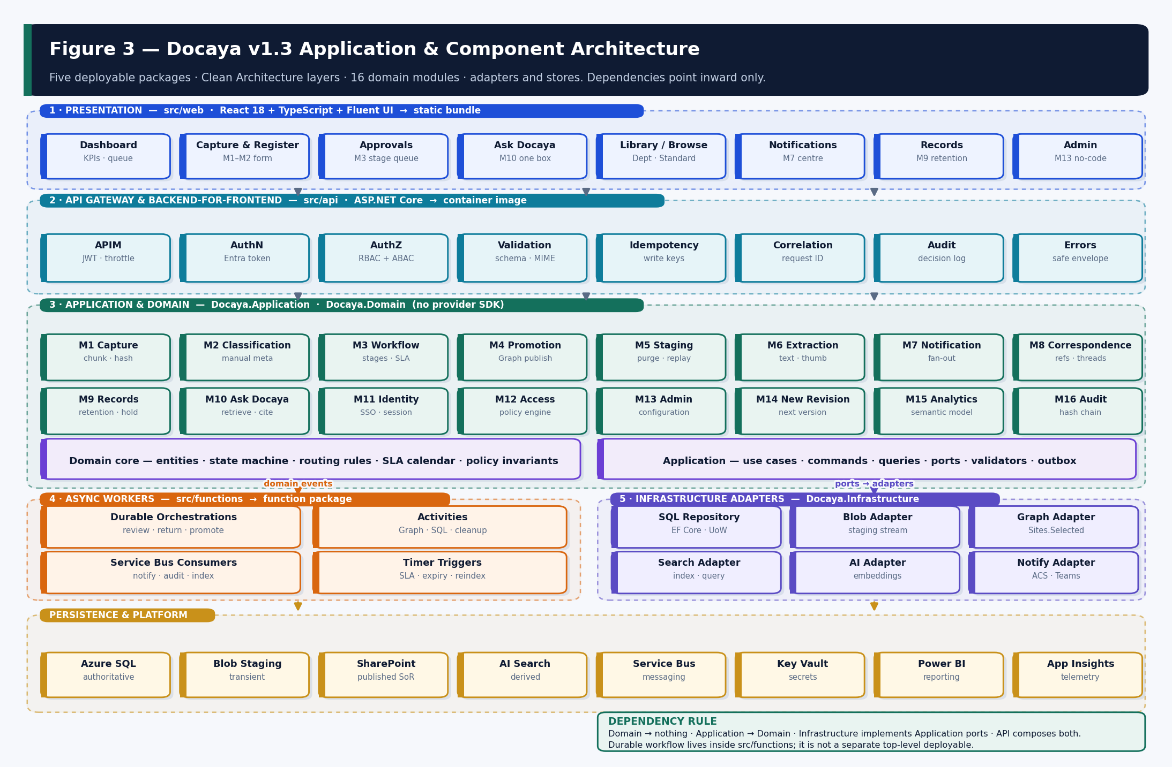
Figure 3 — Application and component architecture: five deployable packages, Clean Architecture layers, sixteen domain modules, adapters and stores.

6.1 Layer Responsibilities and Dependency Rule
Layer | Project | Responsibility | May reference
Presentation | src/web | Bilingual RTL single-page application; feature folders aligned to M1–M16; consumes the generated OpenAPI client only. | Generated contract client
API / BFF | Docaya.Api | HTTP host, middleware pipeline, OpenAPI surface, response shaping, correlation, safe error envelope. | Application + Infrastructure
Application | Docaya.Application | Use cases, commands, queries, validators, ports (interfaces), transactional outbox. | Domain only
Domain | Docaya.Domain | Entities, the document state machine, routing rules, SLA calendar arithmetic, policy invariants. | Nothing — no Azure or Microsoft SDK
Infrastructure | Docaya.Infrastructure | EF Core persistence and the SQL, Blob, Graph, Search, embedding, messaging and Power BI adapters. | Application (implements its ports)
Workers | src/functions | Durable orchestrations, activities, Service Bus consumers and timer triggers. Invokes application use cases; never duplicates domain logic. | Application + Infrastructure
Contracts | src/contracts | OpenAPI 3.1 document, event schemas and the generated TypeScript and C# clients. | Nothing

Non-negotiable dependency rule Docaya.Domain must compile with no reference to any Azure, Microsoft Graph, SharePoint, EF Core or messaging package. Provider SDKs appear only inside Infrastructure adapters behind an Application port. This is what makes the on-premises variant (Section 24) possible without rewriting business logic, and it is enforced by an architecture test in the CI pipeline.

6.2 Request-Processing Pipeline
Stage | Function | Failure behaviour
Authentication | Validate the Entra-issued bearer token: issuer, audience, signature, expiry, required scope. | 401 with a safe envelope; no detail leaked.
Authorization | Evaluate RBAC role gate then ABAC predicates against subject, resource and action. Deny by default. | 403; the data call is never issued; the decision is logged.
Validation | Body, schema, MIME signature, identifier format and state-transition legality. | 400 with field-level errors.
Idempotency | Look up or record the idempotency key for every write. | Returns the original result rather than repeating the effect.
Correlation | Attach or propagate the W3C trace-context correlation ID. | n/a — always applied.
Execution | Invoke the application use case; the adapter performs the data operation under a workload identity. | Domain exceptions map to conflict or unprocessable responses.
Trimming | Filter the result set against the caller's security keys before serialisation. | Unauthorised items are removed, not masked.
Audit | Write the action, actor, executor, outcome and correlation ID to the hash-chained audit. | Audit failure is an incident; the response is still safe.

6.3 Localisation, Accessibility and Error Handling
- Bilingual by construction. Arabic and English are first-class. Layout direction is driven by the active locale, not by content; every component is tested in both directions.
- Accessibility. WCAG 2.2 AA is a build gate, not a review activity — automated axe checks run in the pull-request pipeline and manual keyboard and screen-reader passes run before each release.
- Error envelope. A single problem-detail shape carries a machine-readable code, a human-readable message, field-level validation detail and the correlation ID. Internal exception text and stack traces are never returned.
- Feature flags. Capabilities gated on POC outcomes — most importantly Ask (AI answering) — are behind configuration flags so V1 can ship with Quick Search and Browse while answering is deferred.

7. Document Lifecycle Architecture
The lifecycle is the backbone of the platform and the control that everything else depends on. Nine governed steps carry a document from capture to a searchable published record, and the original file remains unchanged in the controlled staging zone until the configured final approval stage completes.

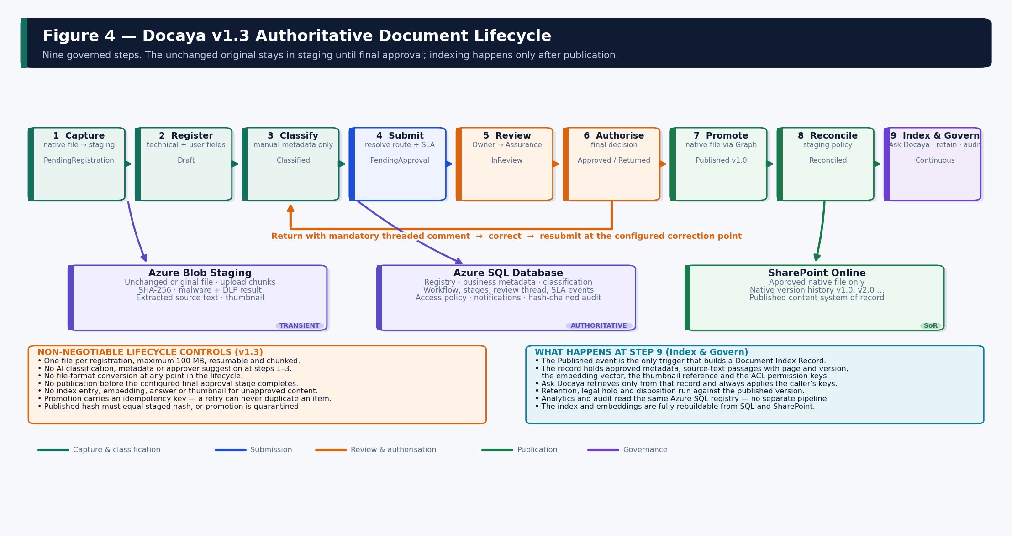
Figure 4 — The authoritative nine-step lifecycle, the stores it touches, and the return path.

7.1 Step-by-Step Runtime Behaviour
# | Stage | Runtime behaviour | State · location
1 | Capture | One file per registration, maximum 100 MB. Extension and file-signature validation, resumable chunked upload, unchanged byte stream to staging, SHA-256 computed, malware and DLP gate, tracking number DOC-YYYY-NNNNNN issued, thumbnail captured. | PendingRegistration · staging
2 | Register | Technical attributes pre-filled by the system; the Editor supplies business title, description, keywords and references. | Draft · staging
3 | Classify | The Editor manually selects document class, sensitivity, owning department, priority, Standard, Department Tag, Publishing Scope, access scope and approval flow. No AI suggestion is offered at any point. | Classified · staging
4 | Submit | Metadata is validated against the active type schema; routing rules resolve the target SharePoint library and the review chain; the working-day SLA starts. | PendingApproval · staging
5 | Review | Each configured stage approves, returns with a mandatory threaded comment and correction point, reassigns, or (where authorised) extends the target. | InReview / Returned · staging
6 | Final approval | Publication is permitted only after every required stage completes. Exactly one idempotent promotion command is emitted. | Approved · staging
7 | Promote | The promotion worker uploads the same native file through Microsoft Graph under the governed service identity, then writes back site, drive, item, URL, version and the published hash. | Published · SharePoint
8 | Reconcile | The staging copy is purged, retained or moved per policy. A failed promotion is retained and replayable. | Reconciled
9 | Index & govern | DocumentPublished builds the Document Index Record. Retention, legal hold, analytics and audit operate continuously on the published version. | Continuous · published only

7.2 Status State Machine
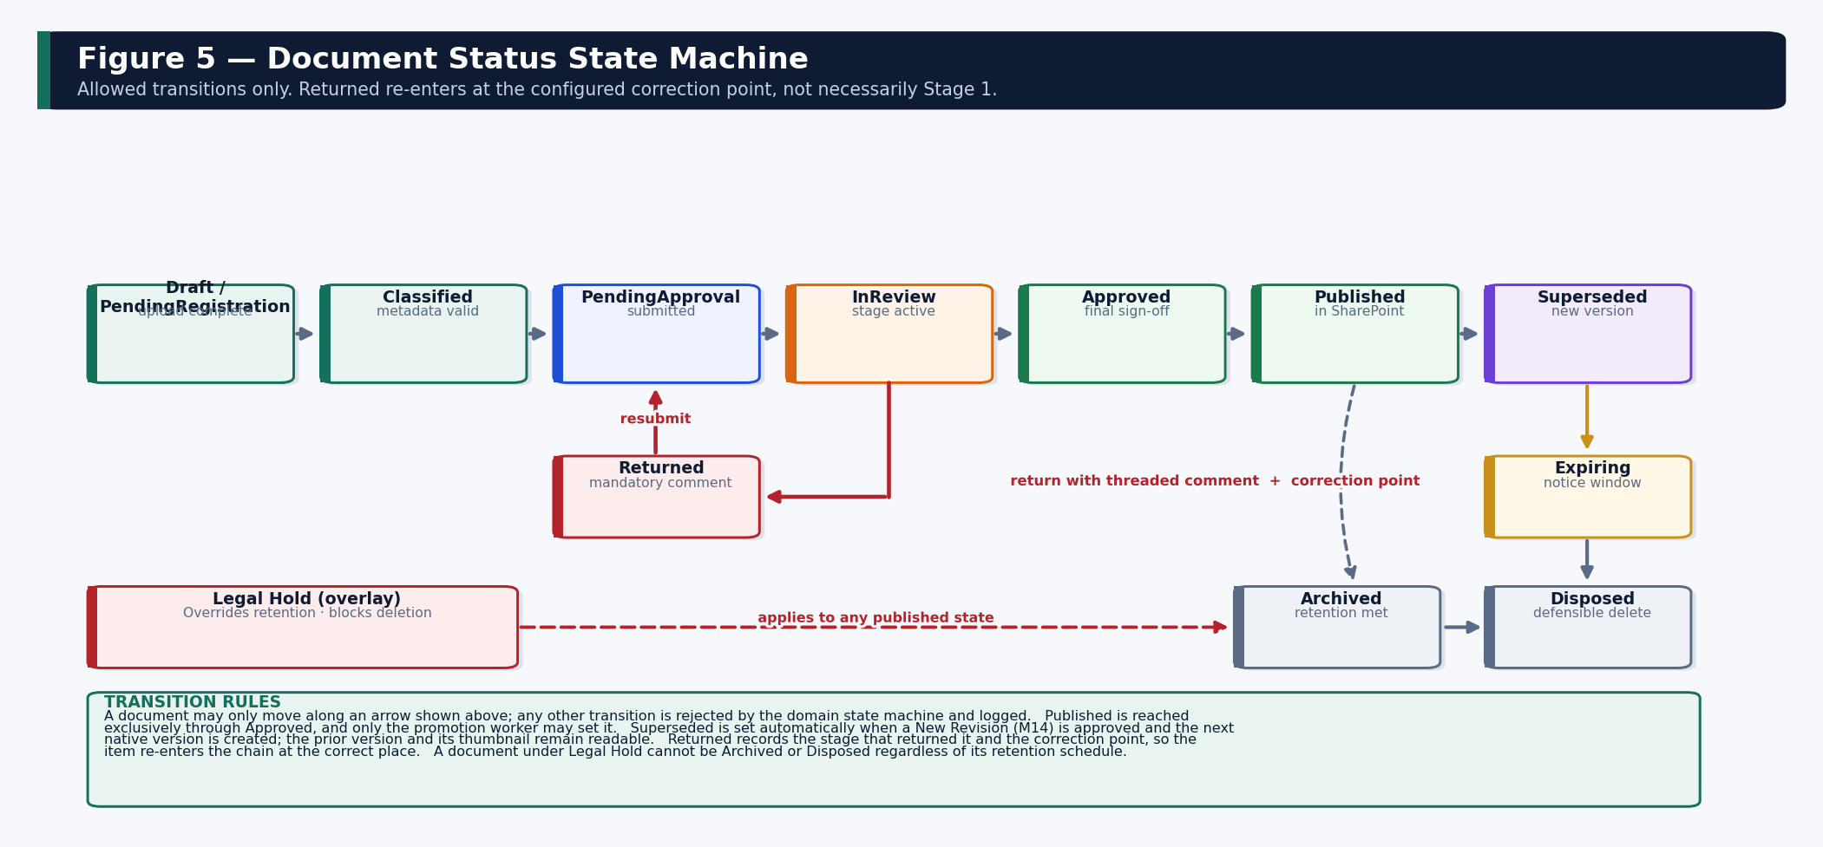
Figure 5 — Allowed status transitions. Any transition not shown is rejected by the domain state machine and logged.
State | Meaning | File location | Entered by
Draft / PendingRegistration | Uploaded; technical attributes populated; registration fields being completed. | Staging | Capture service
Classified | Class, sensitivity, department, Standard, tags and approval flow selected and validated. | Staging | Classification service
PendingApproval | Submitted; awaiting the decision of the current review stage. | Staging | Workflow engine
InReview | A stage is actively assigned and the SLA clock is attributing time to it. | Staging | Workflow engine
Returned | Returned with a mandatory comment to the Editor or the immediately preceding stage. | Staging | Reviewer at any stage
Approved | Final configured sign-off complete; promotion pending. | Staging (transient) | Authoriser
Published | Promoted to the SharePoint library; native version assigned. | SharePoint Online | Promotion worker only
Superseded | Replaced by a newer approved version created through M14. | SharePoint Online | Revision approval
Expiring | Within the configured expiry notification window. | SharePoint Online | Timer worker
Archived / Disposed | Retention reached; archived to cold tier or defensibly deleted with approval. | Archive / removed | Records officer + disposition worker

Non-negotiable lifecycle controls No AI classification, metadata or approver suggestion at steps 1–3. No file-format conversion at any step. No publication before final approval. No index entry, embedding, answer or thumbnail exposure for unapproved content. Published hash must equal staged hash or the promotion is quarantined rather than completed. A document under legal hold cannot be archived or disposed regardless of its retention schedule.

8. Workflow, Review Chain and SLA Architecture (M3)
The review chain is configuration, not code. Its stage count, roles, routing pattern, service-level targets and extension authority are set per document type or department in the Admin Center, and a change to a route never requires a deployment.

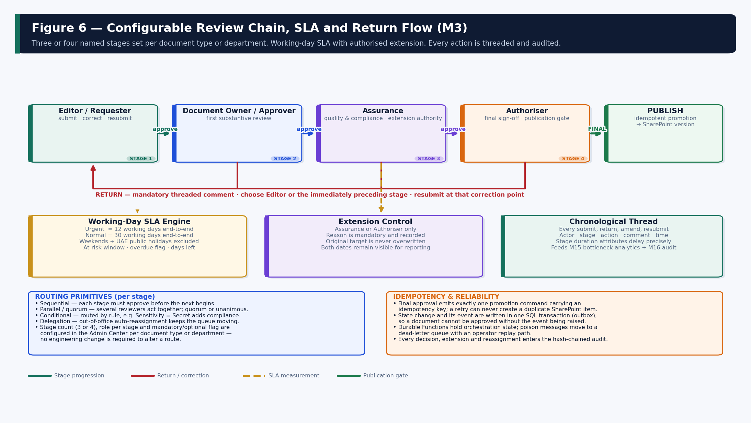
Figure 6 — Configurable review chain, SLA engine, extension control and the correction-point return path.

8.1 Configurable Stage Chain
The review chain is a named, ordered sequence of three or four stages configured per document type or department in the Admin Center. Changing a route is a configuration action and never an engineering change. The default organisation-wide chain is Editor, Document Owner, Assurance and Authoriser.
Stage | Default role | Purpose | Authority
1 | Editor / Change Requester | Registers, classifies and submits; corrects and resubmits after a return. | Submit · resubmit
2 | Document Owner / Approver | First substantive review of content and classification. | Approve · return
3 | Assurance | Quality and compliance review; the only role (with Authoriser) that may extend a target date. | Approve · return · extend
4 | Authoriser (typically CEO) | Final sign-off; the publication gate. | Approve · return · extend

8.2 Routing Primitives
Pattern | Behaviour | Typical use
Sequential | Each stage must approve before the next begins. | Standard policies and procedures.
Parallel / quorum | Several reviewers act concurrently; quorum or unanimous configured per stage. | Cross-departmental documents.
Conditional | A rule adds or removes a stage, e.g. Sensitivity = Secret adds a compliance reviewer. | Sensitive or high-value records.
Delegation | Out-of-office auto-reassignment within the same stage and role. | Continuity — the queue keeps moving.

8.3 Working-Day SLA Engine
Element | Rule
Targets | Urgent = 12 working days end-to-end. Normal = 30 working days end-to-end. Both are configurable per document type.
Calendar | Weekends and client-supplied UAE public holidays are excluded. The calendar is versioned reference data in ref.HolidayCalendar.
Counter | A remaining-working-days counter is shown on every in-flight request and recomputed on each calendar or target change.
At risk | Raised when remaining days fall inside the configured warning window — before the target date, not after it.
Overdue | Raised when the current target is passed; the request remains actionable and continues to accrue stage duration.
Extension | Only Assurance or Authoriser may extend. A reason is mandatory. The original target is never overwritten — both dates persist for reporting.
Stage duration | Time held at each stage is captured automatically, so delay is attributed to a specific stage rather than reported only in aggregate.
Escalation | Breach escalates to the configured delegate or manager and raises a notification through M7.

8.4 Return, Correction Point and Resubmission
A return is never a restart. The returning stage records a mandatory threaded comment and selects the correction point — the Editor, or the immediately preceding stage. The item re-enters the chain at that point, preserving the decision history and the elapsed SLA. This is what makes bottleneck attribution meaningful: a document returned three times from Assurance shows that stage's cumulative duration honestly.

8.5 Orchestration, Idempotency and Recovery
- Durable Functions hold orchestration state. A worker restart resumes the orchestration; it does not replay side effects that have already committed.
- Transactional outbox. The state change and its domain event are written in a single SQL transaction and dispatched afterwards, so a document can never reach Approved without the promotion event being raised.
- At-least-once delivery with idempotent consumers. Every write carries an idempotency key; a redelivered message produces one result, never a duplicate.
- Dead-letter and replay. Poison messages move to a dead-letter queue with an operator replay path and an alert; nothing is silently dropped.
- Exactly-once promotion. ops.PromotionLedger.IdempotencyKey is UNIQUE — a retried promotion finds the existing row and stops.

9. A New Revision Architecture (M14)
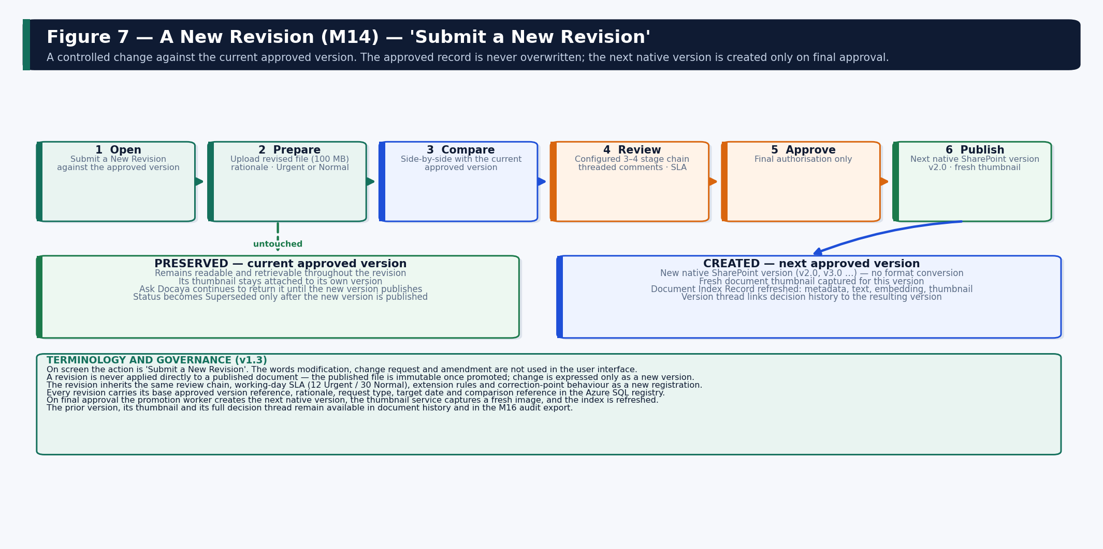
Figure 7 — A New Revision: the approved record is preserved; the next native version is created only on final approval.

9.1 Behaviour
A published document is immutable. Change is expressed only as a new version, raised through the on-screen action “Submit a New Revision”. The requester opens the revision against the current approved version, uploads the revised file, records rationale and request type, and the revision then follows the same configured review chain, SLA, extension rules and correction-point behaviour as a new registration.
Aspect | Design
Terminology | The interface uses “Submit a New Revision”. The words modification, change request and amendment are not used on screen.
Base reference | Every revision stores the base approved VersionId, rationale, request type (Urgent or Normal), target date and comparison reference.
Preservation | The current approved version stays readable and retrievable throughout; its thumbnail remains attached to its own version.
Comparison | The reviewer sees the proposed file alongside the current approved version before deciding.
Publication | Only final approval creates the next native SharePoint version (v2.0, v3.0 …). No format conversion occurs.
Thumbnail | A fresh thumbnail is captured for the new version; earlier thumbnails are retained against their own versions.
Index refresh | RevisionApproved upserts the new version into the index and demotes the prior version to history-only.
Search behaviour | Ask Docaya continues to return the current approved version until the new one publishes, then switches; earlier versions appear only in document history.
Audit | The full decision thread links to the resulting version, so any past state can be reconstructed.

10. Ask Docaya Architecture (M10)
Ask Docaya is a single box and a single result surface. The user types a keyword, a tracking number or a full question in Arabic or English and the system decides how to answer it. Two sources sit behind it: the registry metadata in Azure SQL and the document embedding produced only after final approval and publication. Permission is resolved before retrieval, never after.

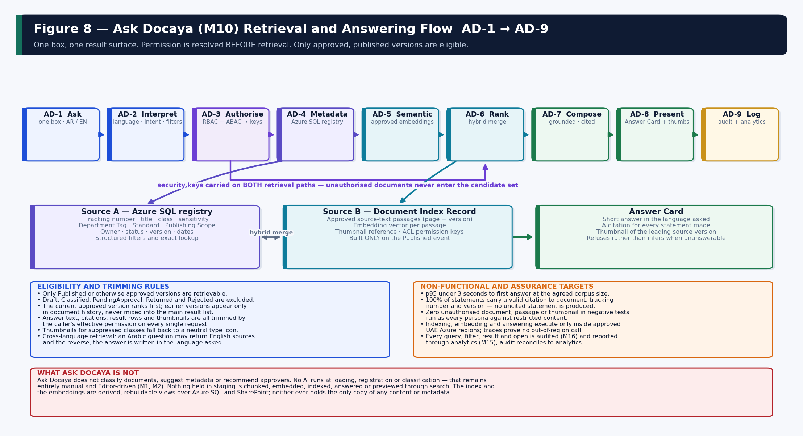
Figure 8 — Ask Docaya AD-1 to AD-9. Permission is resolved before retrieval; both retrieval paths carry the caller's security keys.

10.1 One Entry Point, Three Behaviours
Mode | User input | Answered from | Example
Quick Search | Keyword, document name or tracking number, optionally with facets. | Azure SQL registry metadata plus approved source text. | “DOC-2026-000123” or “information security policy”
Ask (AI Search) | A full question in Arabic or English. | Document embeddings of approved content, filtered by registry metadata. | “What is the escalation route if an urgent revision passes its target date?”
Browse | Navigation by Department or Standard tab with filters. | Azure SQL registry and the Admin-configured taxonomy. | “Everything under Health & Safety, status Published”

The user is never asked to choose a mode. AD-2 interprets the input, detects language, recognises whether it is a lookup or a question, and lifts any implied filters.

10.2 The AD-1 to AD-9 Sequence
Step | Stage | What happens | Owning module
AD-1 | Ask | A keyword, tracking number or natural-language question is entered in Arabic or English. | M10
AD-2 | Interpret | Language detection, intent classification and extraction of implied filters (department, Standard, class, status, date). | M10
AD-3 | Authorise | Effective permission is resolved from RBAC and ABAC and converted into security keys for this request — before any retrieval. | M12
AD-4 | Retrieve metadata | A structured query runs against the Azure SQL registry and approved source text. | M10 · M1 · M2
AD-5 | Retrieve semantic | In parallel, the question is matched against embeddings of approved content, enabling cross-language retrieval. | M6
AD-6 | Merge and rank | The two result sets are fused; only Published or otherwise approved versions are eligible; the current version ranks first. | M10
AD-7 | Compose | A short answer is written in the language asked, using only retrieved approved passages, with a citation for every statement. | M10
AD-8 | Present | The Answer Card sits above the ranked list; each row carries the version thumbnail and one-click preview, download or open actions. | M10 · M4
AD-9 | Log | The query, filters, results and anything opened are written to audit and feed search and access analytics. | M16 · M15

10.3 Governance Rules
- Approved content only. Indexing, embedding and answering occur after final approval and publication. Nothing in staging — Draft, Classified, PendingApproval, Returned or Rejected — is searchable, answerable or previewable through search.
- No AI at capture, registration or classification. Ask Docaya never suggests metadata, classification or approvers; the manual Editor-driven model of M1 and M2 is preserved absolutely.
- Grounded and cited. No citation, no statement. Where the approved estate does not contain the answer, the system says so plainly instead of generalising.
- Permission-trimmed at query time. Answer text, citations, result rows and thumbnails are all filtered by effective rights on every request; keys are never cached per user across requests.
- Bilingual by design. Questions and answers in Arabic and English with full RTL rendering, including a question asked in one language against documents written in the other.
- In-region only. Indexing, embedding and answering execute entirely within the approved UAE Azure regions.
- Fully audited. Every query and every document opened from a result is recorded in the tamper-evident audit trail and reported through analytics.

10.4 Assurance Targets
Target | Threshold | Verification
Answer latency | p95 under 3 seconds to first answer at the agreed corpus size. | Load test against the labelled question set.
Citation completeness | 100% of statements carry a valid citation to document, tracking number and version. | Automated assertion over the acceptance question set.
Refusal behaviour | The system refuses rather than infers on every unanswerable question. | Negative question set with no supporting approved source.
Retrieval accuracy | Agreed top-5 accuracy threshold met in both Arabic and English. | Labelled set of at least one hundred real business questions with known sources.
Cross-language | An Arabic question and its English equivalent return the same source document. | Bilingual test pairs.
Disclosure | Zero unauthorised document, passage or thumbnail returned in any negative test. | Per-persona negative tests against restricted content — a release gate.
Index freshness | A newly published document is retrievable within the agreed cadence. | Timed publication-to-retrieval measurement.

11. Data Architecture and Database Design
This section is the authoritative database design. It defines which store owns which data, the schema separation strategy inside Azure SQL, the physical table design for every functional area, the indexing and integrity rules, and how each module writes to and reads from the model.

11.1 Store Ownership and Authority
Store | Authority | Content | Rebuildable?
Azure SQL Database | Authoritative for all structured data | Registry, business metadata, classification, workflow and stage state, review thread, SLA data, access policy, notification history, retention data, index projection state, operational integrity and the hash-chained audit. | No — backed up and restored
Azure Blob Storage (staging) | Transient file authority before publication | Upload chunks, the unchanged original file, scan status, extracted source text and the version thumbnail. | No while in flight; purged after publication
SharePoint Online | Authoritative for published content | The approved native file and its native version history. The published content system of record. | No — the content SoR
Azure AI Search | Derived read model | Approved metadata, source-text passages, embedding vectors, thumbnail reference and permission keys. | Yes — fully rebuildable from SQL + SharePoint
Blob (preview store) | Regenerable visual store | One thumbnail per approved version, served only through a permission-checked endpoint. | Yes — regenerable from the published file
Power BI semantic model | Derived reporting model | Operational and historical facts over Azure SQL with row-level security. | Yes — refreshed from SQL

The single most important data rule Azure SQL is the master for every attribute. SharePoint columns are a projection written by the promotion worker and the search index is a second projection written by the indexing worker. Neither projection is ever treated as a source of truth, and a reconcile job restores both from SQL if they drift.

11.2 Schema Separation Strategy

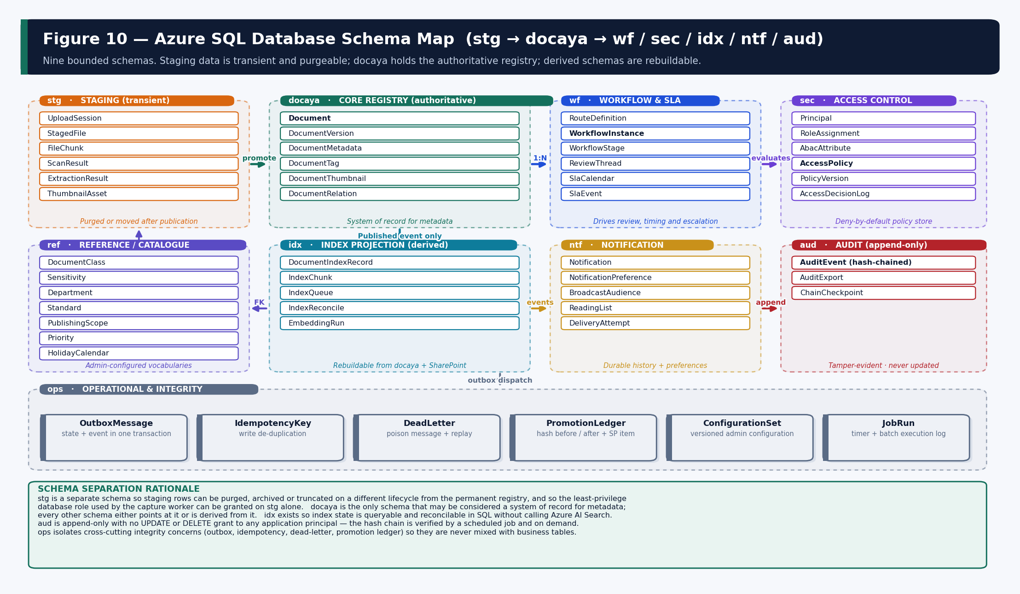
Figure 10 — Nine bounded schemas inside one Azure SQL database, with the relationships and the operational schema.

Schema | Purpose | Why it is separate | Principal granted
stg | Staging and upload processing | Rows are transient and purgeable on a different lifecycle from the permanent registry; the capture worker needs write access here and nowhere else. | Capture identity — read/write on stg only
docaya | Core document registry | The only schema that is a system of record for metadata; every other schema points at it or is derived from it. | API identity — read/write
wf | Workflow, stages, thread and SLA | High write frequency and a distinct retention profile; isolating it keeps the registry tables narrow and index-stable. | API + workflow identity — read/write
sec | Access control policy and decisions | Security-sensitive; separated so policy changes are independently auditable and the decision log can be retained differently. | API identity — read; admin identity — write
ref | Reference data and catalogues | Admin-configured vocabularies that change on a governance cadence, not a transactional one; seeded by configuration deployment. | Admin identity — write; all — read
idx | Index projection state | Lets index state be queried and reconciled in SQL without calling Azure AI Search, and makes a full rebuild verifiable. | Indexing identity — read/write
ntf | Notification history and preference | Large, append-heavy and separately prunable; keeps delivery detail out of the registry. | API + notification identity — read/write
aud | Append-only hash-chained audit | No UPDATE or DELETE grant exists for any application principal; this is what makes the chain defensible. | API identity — INSERT + SELECT only
ops | Operational integrity | Outbox, idempotency, dead-letter, promotion ledger, configuration sets and job runs — cross-cutting concerns kept out of business tables. | All workload identities — scoped
rpt | Reporting views | Read-only views shaped for the Power BI semantic model with row-level security predicates applied. | Analytics identity — SELECT only

11.3 Core Entity Relationship Model

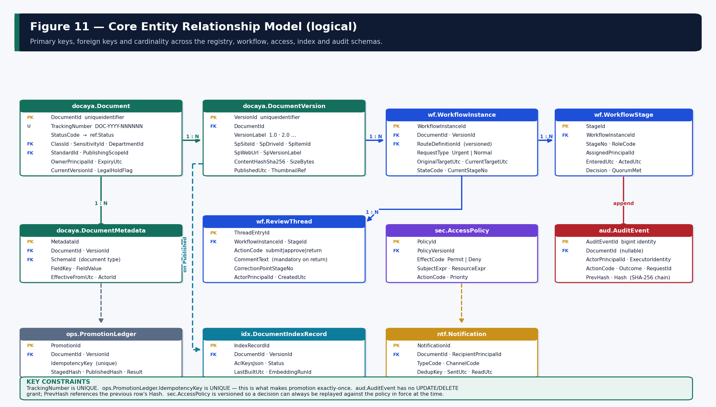
Figure 11 — Core entities, primary and foreign keys and cardinality across the registry, workflow, access, index and audit schemas.

11.4 Staging Schema — stg
Staging exists so that an unapproved document is never mixed with the permanent registry and so that its storage lifecycle can be managed independently. Every table here is purgeable.
Table | Purpose | Key columns | Lifecycle
stg.UploadSession | Tracks a resumable chunked upload for exactly one file. | SessionId PK · DocumentId · TotalBytes · ChunkSize · ReceivedBytes · ExpiresUtc · StateCode | Expires automatically; abandoned sessions cleaned nightly
stg.FileChunk | Individual chunk receipt for resume and integrity. | ChunkId PK · SessionId FK · Ordinal · ByteRange · ChunkHash · ReceivedUtc | Deleted on commit
stg.StagedFile | The committed unchanged original awaiting approval. | StagedFileId PK · DocumentId FK · BlobUri · SizeBytes · MimeDetected · Sha256 · CommittedUtc | Purged, retained or moved after publication
stg.ScanResult | Malware and DLP verdict; progression is blocked until clean. | ScanId PK · StagedFileId FK · Engine · Verdict · DetailJson · ScannedUtc | Retained with the audit reference
stg.ExtractionResult | Basic machine-readable text, language and page count. | ExtractionId PK · StagedFileId FK · LanguageCode · PageCount · TextUri · ExtractedUtc | Retained until index build, then purgeable
stg.ThumbnailAsset | The generated preview image for this version. | ThumbId PK · DocumentId · VersionLabel · BlobUri · Width · Height · GeneratedUtc | Promoted to the preview store on publication

Why a separate staging schema matters The capture worker's database principal is granted on stg only. Even if that worker were compromised, it could not read or alter the document registry, the workflow state, the access policy or the audit chain. Staging rows can also be truncated or archived on an entirely different schedule from the permanent record without touching business tables.

11.5 Core Registry Schema — docaya
Table | Purpose | Notable columns
docaya.Document | The central registry row — created the instant a tracking number is issued and the anchor for chain of custody. | DocumentId PK · TrackingNumber UNIQUE · StatusCode · ClassId · SensitivityId · DepartmentId · StandardId · PublishingScopeId · PriorityId · OwnerPrincipalId · CurrentVersionId · ExpiryUtc · LegalHoldFlag · CreatedUtc · CreatedBy
docaya.DocumentVersion | One row per approved version; carries the SharePoint coordinates and the integrity evidence. | VersionId PK · DocumentId FK · VersionLabel · SpSiteId · SpDriveId · SpItemId · SpWebUrl · SpVersionLabel · ContentHashSha256 · SizeBytes · PublishedUtc · ThumbnailRef · SupersededByVersionId
docaya.DocumentMetadata | Schema-validated business metadata, versioned so a past state is reconstructable. | MetadataId PK · DocumentId FK · VersionId FK · SchemaId FK · FieldKey · FieldValue · EffectiveFromUtc · ActorPrincipalId
docaya.DocumentTag | Department Tag as a multi-value relationship (owning plus related departments). | TagId PK · DocumentId FK · DepartmentId FK · IsOwning · AddedUtc
docaya.DocumentThumbnail | Per-version thumbnail reference and suppression flag for sensitive classes. | ThumbnailId PK · DocumentId FK · VersionId FK · BlobUri · Suppressed · GeneratedUtc
docaya.DocumentRelation | Correspondence threading and revision lineage. | RelationId PK · FromDocumentId · ToDocumentId · RelationType · CreatedUtc

11.5.1 Representative DDL — the registry table
-- docaya.Document : the anchor of chain of custody.
-- A row exists from the instant a tracking number is issued.
CREATE TABLE docaya.Document (
DocumentId UNIQUEIDENTIFIER NOT NULL CONSTRAINT PK_Document PRIMARY KEY,
TrackingNumber NVARCHAR(20) NOT NULL, -- DOC-YYYY-NNNNNN
StatusCode NVARCHAR(24) NOT NULL, -- FK ref.Status
ClassId INT NOT NULL, -- FK ref.DocumentClass
SensitivityId INT NOT NULL, -- FK ref.Sensitivity
DepartmentId INT NOT NULL, -- owning department
StandardId INT NULL, -- FK ref.Standard
PublishingScopeId INT NOT NULL, -- FK ref.PublishingScope
PriorityId INT NOT NULL,
OwnerPrincipalId UNIQUEIDENTIFIER NOT NULL,
CurrentVersionId UNIQUEIDENTIFIER NULL,
ExpiryUtc DATE NULL,
LegalHoldFlag BIT NOT NULL CONSTRAINT DF_Doc_Hold DEFAULT (0),
RowVersion ROWVERSION NOT NULL, -- optimistic concurrency
CreatedUtc DATETIME2(3) NOT NULL,
CreatedByPrincipalId UNIQUEIDENTIFIER NOT NULL,
CONSTRAINT UQ_Document_Tracking UNIQUE (TrackingNumber),
CONSTRAINT FK_Document_Class FOREIGN KEY (ClassId) REFERENCES ref.DocumentClass(ClassId),
CONSTRAINT FK_Document_Sens FOREIGN KEY (SensitivityId) REFERENCES ref.Sensitivity(SensitivityId),
CONSTRAINT FK_Document_Dept FOREIGN KEY (DepartmentId) REFERENCES ref.Department(DepartmentId),
CONSTRAINT FK_Document_Scope FOREIGN KEY (PublishingScopeId)REFERENCES ref.PublishingScope(ScopeId)
);

-- Queue and browse pattern: department + status + recency
CREATE INDEX IX_Document_Dept_Status ON docaya.Document (DepartmentId, StatusCode)
INCLUDE (TrackingNumber, StandardId, OwnerPrincipalId, CurrentVersionId);

-- Expiry sweep (timer worker) - filtered to keep the index small
CREATE INDEX IX_Document_Expiry ON docaya.Document (ExpiryUtc)
WHERE ExpiryUtc IS NOT NULL AND LegalHoldFlag = 0;

-- Ownership view used by 'my documents' and ABAC ownership predicate
CREATE INDEX IX_Document_Owner_Status ON docaya.Document (OwnerPrincipalId, StatusCode);

11.6 Workflow Schema — wf
Table | Purpose | Notable columns
wf.RouteDefinition | The versioned configured chain for a document type or department. | RouteDefinitionId PK · Scope · DocumentClassId · DepartmentId · StageCount · VersionNo · EffectiveFromUtc · PublishedBy
wf.RouteStage | One row per configured stage within a route version. | RouteStageId PK · RouteDefinitionId FK · StageNo · RoleCode · IsMandatory · PatternCode (sequential/parallel/quorum/conditional) · QuorumCount · ConditionExpr
wf.WorkflowInstance | A live or completed run of a route against a document version. | WorkflowInstanceId PK · DocumentId FK · VersionId FK · RouteDefinitionId FK · RequestType (Urgent/Normal) · OriginalTargetUtc · CurrentTargetUtc · StateCode · CurrentStageNo · StartedUtc · CompletedUtc
wf.WorkflowStage | The actual execution record of each stage in an instance. | StageId PK · WorkflowInstanceId FK · StageNo · RoleCode · AssignedPrincipalId · EnteredUtc · ActedUtc · DurationWorkingMinutes · Decision · QuorumMet
wf.ReviewThread | The chronological thread of every action and comment. | ThreadEntryId PK · WorkflowInstanceId FK · StageId FK · ActionCode · CommentText · CorrectionPointStageNo · ActorPrincipalId · CreatedUtc
wf.SlaEvent | At-risk, overdue and extension events, each retained separately. | SlaEventId PK · WorkflowInstanceId FK · EventType · PreviousTargetUtc · NewTargetUtc · ReasonText · ActorPrincipalId · RaisedUtc
ref.HolidayCalendar | Non-working days used by the working-day arithmetic. | CalendarId PK · CalendarCode · HolidayDate · Description · VersionNo

11.6.1 Working-day arithmetic
The SLA engine never subtracts calendar dates. Working days are computed against ref.HolidayCalendar and the configured weekend pattern, so a target is stable even if the calendar is amended mid-flight — an amendment creates a new calendar version and the affected instances are recalculated and logged rather than silently changed.
-- Stage duration is stored in working minutes so bottleneck
-- reporting is comparable across weekends and holidays.
SELECT ws.StageNo, ws.RoleCode,
SUM(ws.DurationWorkingMinutes) / 480.0 AS WorkingDaysAtStage
FROM wf.WorkflowStage ws
JOIN wf.WorkflowInstance wi ON wi.WorkflowInstanceId = ws.WorkflowInstanceId
WHERE wi.CompletedUtc >= @FromUtc
GROUP BY ws.StageNo, ws.RoleCode
ORDER BY WorkingDaysAtStage DESC; -- the bottleneck stage surfaces first

11.7 Access Control Schema — sec
Table | Purpose | Notable columns
sec.Principal | A user, group or workload known to Docaya, projected from Entra. | PrincipalId PK · ExternalObjectId · PrincipalType · DisplayName · DepartmentId · EmploymentStatus · IsActive
sec.RoleAssignment | RBAC — which principal holds which application role, in which scope. | AssignmentId PK · PrincipalId FK · RoleCode · ScopeType · ScopeId · GrantedUtc · GrantedBy · ExpiresUtc
sec.AbacAttribute | Attribute values attached to a principal (clearance, geography, business unit). | AttributeId PK · PrincipalId FK · AttributeKey · AttributeValue · EffectiveFromUtc
sec.AccessPolicy | A single permit or deny rule with subject, resource and action expressions. | PolicyId PK · PolicyVersionId FK · EffectCode · SubjectExpr · ResourceExpr · ActionCode · Priority · IsActive
sec.PolicyVersion | A published set of policies, so a decision can be replayed against the rules in force at the time. | PolicyVersionId PK · VersionNo · PublishedUtc · PublishedBy · Notes
sec.AccessDecisionLog | Every evaluation: who, what, which policy version, the decision and the reason. | DecisionId PK · PrincipalId · DocumentId · ActionCode · PolicyVersionId · Decision · ReasonCode · CorrelationId · DecidedUtc

11.8 Index Projection Schema — idx
Table | Purpose | Notable columns
idx.DocumentIndexRecord | One row per approved version that is present in the search index. | IndexRecordId PK · DocumentId FK · VersionId FK · AclKeysJson · StatusCode · LastBuiltUtc · EmbeddingRunId · ChunkCount
idx.IndexChunk | Passage-level state so a partial rebuild is possible. | ChunkId PK · IndexRecordId FK · Ordinal · PageNumber · CharStart · CharEnd · VectorWritten
idx.IndexQueue | Pending index work with attempt count and last error. | QueueId PK · DocumentId · VersionId · Operation · Attempts · LastError · EnqueuedUtc
idx.EmbeddingRun | Which model and version produced which vectors — essential when a model is upgraded. | EmbeddingRunId PK · ModelName · ModelVersion · Dimensions · StartedUtc · CompletedUtc · DocumentCount
idx.IndexReconcile | Result of each reconcile pass: drift found and repaired. | ReconcileId PK · RunUtc · RecordsChecked · DriftFound · DriftRepaired · DetailJson

Why index state lives in SQL Holding projection state in idx.* means the platform can answer “is the index correct?” without calling Azure AI Search, can rebuild deterministically after a model upgrade, and can prove during audit that no unapproved version was ever present. It also makes the index disposable — there is no backup requirement for the search service itself.

11.9 Notification, Audit and Operational Schemas
Table | Purpose | Notable columns
ntf.Notification | Durable notification history per recipient. | NotificationId PK · DocumentId · RecipientPrincipalId · TypeCode · ChannelCode · DedupKey · SentUtc · ReadUtc
ntf.NotificationPreference | Per-user, per-type, per-channel preference with quiet hours. | PreferenceId PK · PrincipalId · TypeCode · ChannelCode · Enabled · QuietFromLocal · QuietToLocal
ntf.BroadcastAudience | Resolved audience for a publication broadcast, retained for evidence. | BroadcastId PK · DocumentId · ScopeCode · ResolvedCount · ResolvedUtc
ntf.ReadingList | The onboarding reading list and per-joiner acknowledgement. | ReadingListId PK · PrincipalId · DocumentId · AssignedUtc · AcknowledgedUtc
aud.AuditEvent | Append-only hash-chained record of every action. | AuditEventId PK (bigint identity) · DocumentId · ActorPrincipalId · ExecutorIdentity · ActionCode · Outcome · RequestId · SourceIp · PrevHash · Hash · OccurredUtc
aud.ChainCheckpoint | Periodic anchor so verification does not require reading the whole chain. | CheckpointId PK · UpToAuditEventId · ChainHash · CreatedUtc
ops.OutboxMessage | State change and event written in one transaction, dispatched after commit. | OutboxId PK · AggregateId · EventType · PayloadJson · CreatedUtc · DispatchedUtc · Attempts
ops.IdempotencyKey | Write de-duplication across API and workers. | KeyValue PK · Endpoint · ResultRef · CreatedUtc · ExpiresUtc
ops.PromotionLedger | The exactly-once guarantee for publication. | PromotionId PK · DocumentId · VersionId · IdempotencyKey UNIQUE · StagedHash · PublishedHash · ResultCode · CompletedUtc
ops.DeadLetter | Poison messages with replay state. | DeadLetterId PK · Source · MessageId · PayloadJson · ErrorText · ReplayedUtc

11.9.1 The audit hash chain
-- Append-only. No UPDATE or DELETE grant exists for any application principal.
-- Hash = SHA256( PrevHash || canonical(payload) ), so any alteration is detectable.
CREATE TABLE aud.AuditEvent (
AuditEventId BIGINT IDENTITY(1,1) NOT NULL CONSTRAINT PK_Audit PRIMARY KEY,
DocumentId UNIQUEIDENTIFIER NULL,
ActorPrincipalId UNIQUEIDENTIFIER NOT NULL, -- the REAL user
ExecutorIdentity NVARCHAR(128) NOT NULL, -- the system identity that acted
ActionCode NVARCHAR(48) NOT NULL,
Outcome NVARCHAR(16) NOT NULL,
RequestId NVARCHAR(64) NOT NULL, -- correlation ID
SourceIp NVARCHAR(45) NULL,
PayloadJson NVARCHAR(MAX) NULL,
PrevHash BINARY(32) NOT NULL,
Hash BINARY(32) NOT NULL,
OccurredUtc DATETIME2(3) NOT NULL
);

GRANT SELECT, INSERT ON SCHEMA::aud TO [docaya_api]; -- no UPDATE, no DELETE
DENY UPDATE, DELETE ON SCHEMA::aud TO [docaya_api];

CREATE INDEX IX_Audit_Doc_Time ON aud.AuditEvent (DocumentId, OccurredUtc DESC);
CREATE INDEX IX_Audit_Actor ON aud.AuditEvent (ActorPrincipalId, OccurredUtc DESC);

11.10 How Each Function Is Covered by the Database Design
Functional need | Primary tables | Read pattern | Write pattern
Capture and registration (M1) | stg.UploadSession · stg.FileChunk · stg.StagedFile · stg.ScanResult · docaya.Document | Session resume; scan verdict check. | Chunk append then single commit; registry insert in the same transaction as the first audit event.
Manual classification (M2) | docaya.DocumentMetadata · docaya.DocumentTag · ref.* | Schema and vocabulary lookup for the form. | Validated upsert; previous values retained by EffectiveFromUtc.
Review, SLA and return (M3) | wf.* · ref.HolidayCalendar | Stage queue by assignee and status; remaining-days calculation. | Stage row per transition; thread entry per action; SLA event per at-risk, overdue or extension.
Promotion (M4) | ops.PromotionLedger · docaya.DocumentVersion | Ledger lookup by idempotency key before any Graph call. | Ledger insert, then version insert with SharePoint coordinates and both hashes.
Staging lifecycle (M5) | stg.* · ops.DeadLetter | Published-but-unreconciled sweep. | Purge, retain or move; failed promotion retained for replay.
Extraction and index (M6) | stg.ExtractionResult · idx.* | Index queue drain; reconcile comparison against docaya. | Index record and chunk rows on Published; embedding run recorded with model version.
Notification (M7) | ntf.* | Preference and quiet-hours lookup; audience resolution from tags and scope. | Notification row per recipient with a dedup key; delivery attempts appended.
Correspondence (M8) | docaya.Document · docaya.DocumentRelation | Thread retrieval by reference number. | Relation rows link reply to original.
Records and retention (M9) | docaya.Document · ref.RetentionPolicy | Disposition due sweep, excluding legal hold. | Hold flag set or released; disposition recorded in audit.
Ask Docaya (M10) | idx.DocumentIndexRecord (read) · aud.AuditEvent | Metadata filter and permission-key composition. | Query, filters and opens appended to audit.
Identity and access (M11, M12) | sec.* | Role and attribute load per request; policy set by version. | Decision log appended for every evaluation.
Admin configuration (M13) | ref.* · ops.ConfigurationSet · wf.RouteDefinition | Effective configuration by scope and date. | New version published rather than in-place edit; rollback restores the prior version.
A New Revision (M14) | docaya.DocumentVersion · wf.WorkflowInstance | Base approved version and comparison reference. | New version row on approval; prior version marked superseded.
Analytics (M15) | rpt.* views over docaya · wf · aud | Row-level-security-filtered reads only. | None — reporting never writes.
Audit and compliance (M16) | aud.* | Timeline by document; export by date range. | Append only; checkpoint written periodically.

11.11 Integrity, Indexing and Performance Rules
- Every write is idempotent. ops.IdempotencyKey is checked before the effect; ops.PromotionLedger.IdempotencyKey is UNIQUE and is the mechanism that makes publication exactly-once.
- Optimistic concurrency. docaya.Document carries a ROWVERSION; a stale update is rejected rather than silently overwriting a concurrent change.
- Transaction boundary. A state change and its outbox event commit together. Nothing dispatches an event for a state that did not persist.
- Filtered indexes. Sweep indexes (expiry, disposition due, index queue) are filtered so they remain small regardless of corpus size.
- Covering indexes for queues. Reviewer queue and department browse are served by covering indexes to avoid key lookups on the hot path.
- No cross-schema cascade delete. Deletion is a governed disposition action, never a referential side effect.
- Retention of derived data. idx, ntf and rpt may be pruned or rebuilt; docaya, wf, sec and aud may not.
- Encryption. Transparent Data Encryption is enabled; customer-managed keys are available where client policy requires. Sensitive columns are candidates for Always Encrypted subject to the client decision recorded in A9.

11.12 Backup, Restore and Recovery Objectives
Store | Backup mechanism | RPO | RTO | Restore validation
Azure SQL | Point-in-time restore plus long-term retention; geo-redundant where required. | ≤ 5 minutes | ≤ 1 hour | Quarterly restore rehearsal into an isolated environment with hash-chain verification.
Blob staging | Soft delete and versioning; content is transient by design. | ≤ 5 minutes | ≤ 1 hour | Replay of a failed promotion from a restored staged file.
SharePoint Online | Native Microsoft 365 retention and version history. | Per tenant policy | Per tenant policy | Version history retrieval test per release.
Azure AI Search | None required — derived. | n/a | Rebuild window | Full rebuild timed during POC P4 and re-verified annually.
Power BI model | None required — derived. | n/a | Refresh window | Scheduled refresh health monitored.
Configuration | Versioned in ops.ConfigurationSet and in the release package. | Per release | Immediate | Re-import from the release manifest.

12. Azure AI Search Technical Design
Ask Docaya is the only consumer of this design. The index is a derived, rebuildable read model built exclusively from approved, published content. This section defines the index schema, the analyzer strategy, the identity separation that keeps write and query rights apart, how permission keys are generated and applied, and every event that changes the index.

12.1 Approved Capability Set
The v1.3 baseline explicitly approves hybrid retrieval — keyword plus vector — with grounded, cited answering over published content. The capability set below is therefore in scope; anything not listed is excluded and no infrastructure or code for it appears in this architecture.
Capability | Status in v1.3 | Notes
Keyword and full-text search | In scope | Over approved metadata and approved source text, with bilingual analyzers.
Faceted and filtered search | In scope | Department, Standard, class, sensitivity, owner, status, date, tracking number.
Vector search | In scope — post-approval only | Embeddings generated only after final approval and publication.
Hybrid search | In scope | Keyword and vector results fused and ranked into one result set.
Semantic ranking | In scope where available in region | Improves ordering; never changes eligibility or trimming.
Grounded answering with citation | In scope — Ask (AI Search) | Answers composed only from retrieved approved passages; every statement cited.
Indexing of unapproved content | EXCLUDED | No staged, draft, classified, pending, returned or rejected item may be indexed.
AI classification or metadata suggestion | EXCLUDED | No AI at loading, registration or classification — this remains manual.
Answering without citation | EXCLUDED | The system refuses rather than infers when no approved source supports an answer.
Cross-tenant or out-of-region processing | EXCLUDED | Indexing, embedding and answering execute only in approved UAE regions.

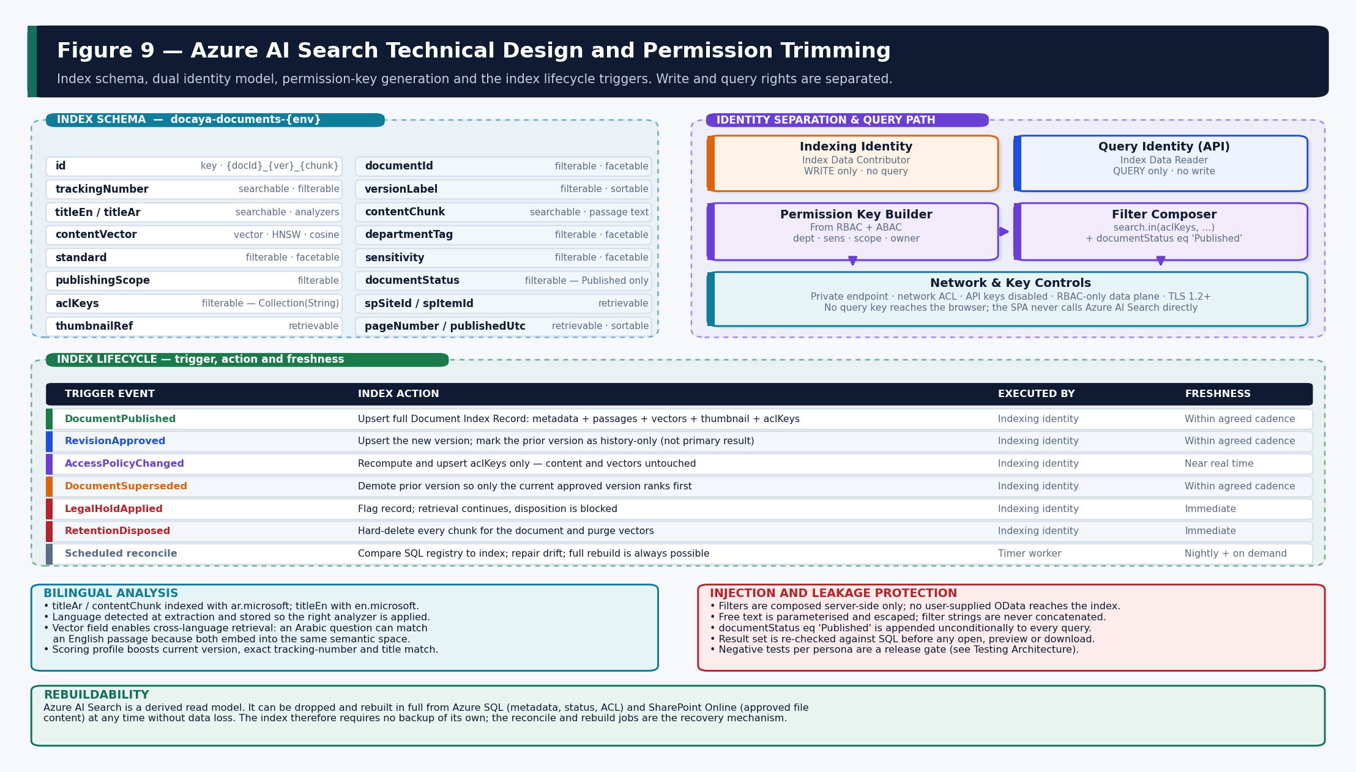
Figure 9 — Index schema, identity separation, permission-key generation and the complete index lifecycle.

12.2 Index Schema
Field | Type | Attributes | Purpose
id | Edm.String | key | Composite {documentId}_{versionLabel}_{chunkOrdinal} — unique per passage.
documentId | Edm.String | filterable, facetable | Groups passages back to one document.
versionId / versionLabel | Edm.String | filterable, sortable | Current-version ranking and history separation.
trackingNumber | Edm.String | searchable, filterable | Exact lookup; boosted in the scoring profile.
titleEn | Edm.String | searchable (en.microsoft) | English title analysis.
titleAr | Edm.String | searchable (ar.microsoft) | Arabic title analysis.
contentChunk | Edm.String | searchable (language-matched) | The approved passage text used for keyword match and as the citation source.
contentVector | Collection(Edm.Single) | vector · HNSW · cosine | Semantic and cross-language retrieval.
departmentTag | Collection(Edm.String) | filterable, facetable | Owning plus related departments; drives browse and reach.
standard | Edm.String | filterable, facetable | Standard-based navigation and reporting.
sensitivity | Edm.String | filterable, facetable | Used in the permission filter and in governance reporting.
publishingScope | Edm.String | filterable | Departmental · Cross-Departmental · Organisation-wide · Public.
documentStatus | Edm.String | filterable | Unconditionally constrained to Published on every query.
aclKeys | Collection(Edm.String) | filterable | The permission-trimming mechanism — see 12.4.
spSiteId / spDriveId / spItemId / spWebUrl | Edm.String | retrievable | Open-in-SharePoint and citation targets.
thumbnailRef | Edm.String | retrievable | Version thumbnail, served only through the permission-checked endpoint.
pageNumber | Edm.Int32 | retrievable | Citation precision — which page a statement came from.
publishedUtc | Edm.DateTimeOffset | filterable, sortable | Recency ranking and date filtering.
languageCode | Edm.String | filterable | Records which analyzer was applied at build time.

12.3 Bilingual Analysis and Ranking
- Analyzer selection. Language is detected during extraction and stored, so titleAr and Arabic passages are indexed with ar.microsoft and English content with en.microsoft. A mixed-language document is chunked so each passage uses the correct analyzer.
- Cross-language retrieval. The vector field allows an Arabic question to match an English passage and the reverse, because both embed into the same semantic space. The answer is always written in the language of the question.
- Scoring profile. Boosts exact tracking-number match, title match, the current approved version, and recency. Semantic ranking, where available in region, refines ordering only — it never alters eligibility or trimming.
- Chunking. Passages are sized to preserve citation precision: large enough to carry meaning, small enough that a citation points at a specific page rather than a whole document.

12.4 Permission Trimming — how it actually works
- The API resolves the caller's effective permission from RBAC roles and ABAC attributes (Section 14) before any retrieval is issued.
- That decision is converted into a set of security keys — for example dept:HSE, sens:Internal, scope:OrgWide, owner:{principalId}.
- The filter composer builds a server-side OData filter combining search.in(aclKeys, …) with documentStatus eq 'Published'.
- No user-supplied text ever reaches the filter expression; free text is parameterised and escaped, and filter strings are never concatenated from input.
- Azure AI Search returns only candidate passages whose aclKeys intersect the caller's keys.
- The result set is re-checked against Azure SQL before any open, preview, download or citation is rendered — the index is never the final authority on access.
- The query, the filters applied, the documents returned and anything opened are written to the audit trail.
// Filter composition is server-side only. User text never enters the filter.
var keys = policyEngine.ResolveSecurityKeys(user); // from sec.* evaluation
var filter = $"documentStatus eq 'Published' and " +
$"search.in(aclKeys, '{string.Join("|", keys)}', '|')";

var options = new SearchOptions {
Filter = filter, // never built from user input
QueryType = SearchQueryType.Semantic,
VectorSearch = new() { Queries = { vectorQuery } },
Size = pageSize,
IncludeTotalCount = false // do not leak corpus size
};
// Post-retrieval: re-verify every hit against Azure SQL before rendering.

Defence in depth Permission trimming is applied twice: as a filter before retrieval so unauthorised content never enters the candidate set, and as a re-check against Azure SQL before anything is rendered or opened. If the index were ever stale or drifted, the second check still prevents disclosure. Negative tests per persona against restricted content are a release gate.

12.5 Identity Separation
Identity | Role granted | May do | May not do
Indexing worker identity | Search Index Data Contributor | Create, upsert and delete index documents; manage the index schema. | Issue a query on behalf of a user.
API service identity | Search Index Data Reader | Issue queries with a server-composed filter. | Write, delete or alter the index or its schema.
Browser / SPA | None | Nothing — it never contacts Azure AI Search. | Hold any key or call the search endpoint directly.

API keys are disabled on the search service; the data plane is RBAC-only and reachable exclusively over a private endpoint with a network ACL. No query key is ever issued to a browser.

12.6 Index Lifecycle Triggers
Trigger event | Index action | Executed by | Freshness
DocumentPublished | Upsert the full Document Index Record: metadata, passages, vectors, thumbnail reference and aclKeys. | Indexing worker | Within the agreed cadence
RevisionApproved | Upsert the new version and demote the prior version to history-only so it no longer ranks as a primary result. | Indexing worker | Within the agreed cadence
AccessPolicyChanged | Recompute and upsert aclKeys only — content and vectors are untouched, so the operation is cheap. | Indexing worker | Near real time
DocumentSuperseded | Ensure only the current approved version ranks first. | Indexing worker | Within the agreed cadence
LegalHoldApplied | Flag the record; retrieval continues but disposition is blocked. | Indexing worker | Immediate
RetentionDisposed | Hard-delete every chunk for the document and purge its vectors. | Indexing worker | Immediate
Scheduled reconcile | Compare the SQL registry to the index, repair drift and report it in idx.IndexReconcile. | Timer worker | Nightly and on demand
Model upgrade | Re-embed affected documents under a new idx.EmbeddingRun; vectors from different model versions are never mixed in one index. | Indexing worker | Planned maintenance

12.7 Responsible-AI and Data-Residency Controls
- Grounding. The answer composer receives only the retrieved approved passages; it has no ability to reach beyond them.
- Citation binding. Each statement is bound to the passage that supports it, carrying document, tracking number, version and page.
- Refusal. Where retrieval returns nothing adequate, the system states that plainly rather than generalising or inferring.
- Prompt and retrieval logging. Query, filters, retrieved document identifiers and the answer are logged for audit; document content is not exported outside the region.
- Region pinning. The search service, the vector store and the embedding and answering endpoints are all deployed in the approved UAE region; traces are inspected during POC P5 to prove no out-of-region call occurs.
- Model versioning. idx.EmbeddingRun records the model name, version and dimensions used for every vector, so an upgrade is a controlled re-embedding rather than an undetected drift.
- Content exclusion. Classes configured as thumbnail-suppressed are also excluded from passage-level preview in the Answer Card; only the citation reference is shown.

13. SharePoint Online Information Architecture

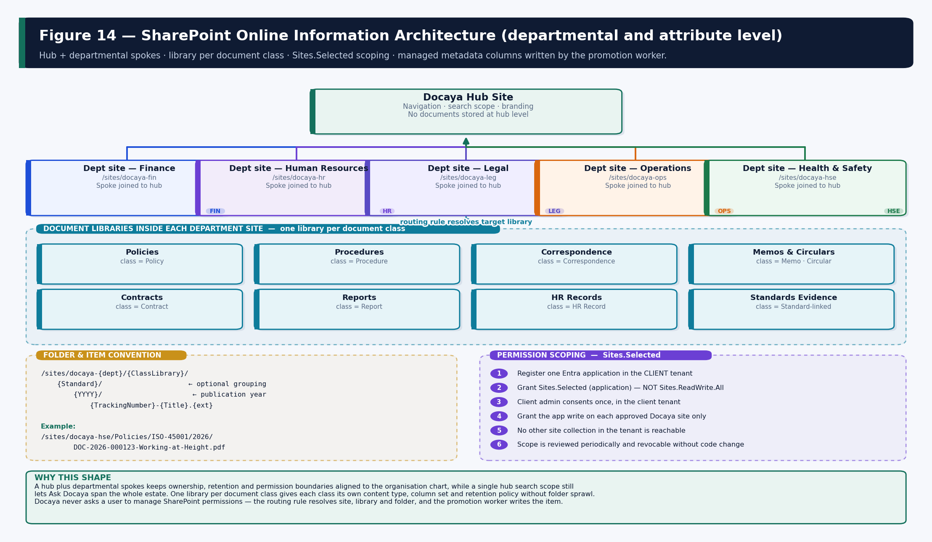
Figure 14 — Hub and departmental spokes, library per document class, folder convention and Sites.Selected scoping.

13.1 Site Topology — departmental level
Element | Design | Rationale
Hub site | One Docaya hub providing navigation, a unified search scope and branding. No documents are stored at hub level. | Gives Ask Docaya a single scope to span while keeping ownership at department level.
Departmental spoke sites | One site per owning department, joined to the hub — for example /sites/docaya-hse. | Aligns ownership, retention and permission boundaries to the organisation chart.
Library per document class | Within each departmental site, one library per class: Policies, Procedures, Correspondence, Memos & Circulars, Contracts, Reports, HR Records, Standards Evidence. | Each class gets its own content type, column set and retention policy without folder sprawl.
Folder convention | /{ClassLibrary}/{Standard}/{YYYY}/{TrackingNumber}-{Title}.{ext} | Predictable, machine-generated paths; Standard grouping supports audit and certification evidence.
Content types | One content type per document class carrying the Docaya-managed columns. | Allows class-specific metadata and retention without a bespoke library schema.
Term store | Managed metadata term sets for Department, Department Tag and Standard. | One term set drives SharePoint navigation, Docaya browse tabs and search facets consistently.

13.1.1 Worked example
/sites/docaya-hse/ <- departmental spoke site
Policies/ <- library = document class
ISO-45001/ <- Standard grouping
2026/ <- publication year
DOC-2026-000123-Working-at-Height.pdf
DOC-2026-000187-Permit-to-Work.docx
Procedures/
IMS/
2026/
DOC-2026-000204-Incident-Reporting.docx

13.2 Permission Scoping — Sites.Selected
- A single Entra application is registered in the client tenant (never in the supplier tenant).
- It is granted the Microsoft Graph application permission Sites.Selected — never Sites.ReadWrite.All or a tenant-wide equivalent.
- A client administrator consents once, inside the client tenant, with the consent recorded as deployment evidence.
- Write permission is then granted to that application on each approved Docaya site collection individually.
- No other site collection in the tenant is reachable by the application, even accidentally.
- The scope is reviewed periodically and can be revoked per site without a code change or redeployment.
Five distinct things that are often confused 1. The signed-in Docaya user — the person. 2. The Docaya authorization decision — whether that person may perform this action on this document. 3. The governed service identity — the workload credential that calls Microsoft Graph. 4. The audit actor — always the real user, with the service identity recorded as executor. 5. The SharePoint permission granted to the service identity — deliberately broad within the approved sites, because it is never the access-control mechanism for users.

A service identity with broad technical access cannot bypass a denied user decision for a simple structural reason: when Docaya denies the action, the Graph call is never issued. There is no code path in which an adapter is invoked without an authorization decision having already permitted it, and this is enforced by the request pipeline and verified by security tests.

13.3 Attribute-Level Design
Every business attribute is defined once and mapped deterministically to four representations: the authoritative Azure SQL column, the SharePoint column written by the promotion worker, the search field written by the indexing worker, and its role in access control or navigation.

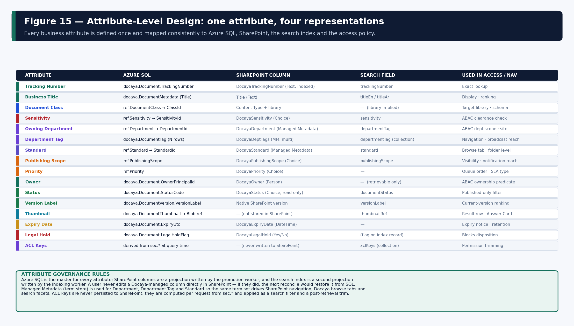
Figure 15 — Attribute-level mapping across Azure SQL, SharePoint, the search index and the access policy.

13.4 Metadata Write-Back Rules
- SQL is the master. SharePoint columns are a projection. A user never edits a Docaya-managed column directly in SharePoint; if they did, the next reconcile would restore it from Azure SQL and record the correction.
- Write on promotion only. Columns are written when the version is published and when a revision publishes — not during review, because nothing exists in SharePoint until then.
- Managed metadata for shared vocabularies. Department, Department Tag and Standard use term sets so SharePoint navigation, Docaya browse tabs and search facets cannot diverge.
- ACL keys are never written. Permission keys are computed per request from sec.* and applied as a search filter and a post-retrieval trim. They are not persisted to SharePoint under any circumstance.
- Native versioning is authoritative for versions. Docaya records the SharePoint version label; it does not attempt to maintain a parallel version numbering scheme.

13.5 Promotion Sequence
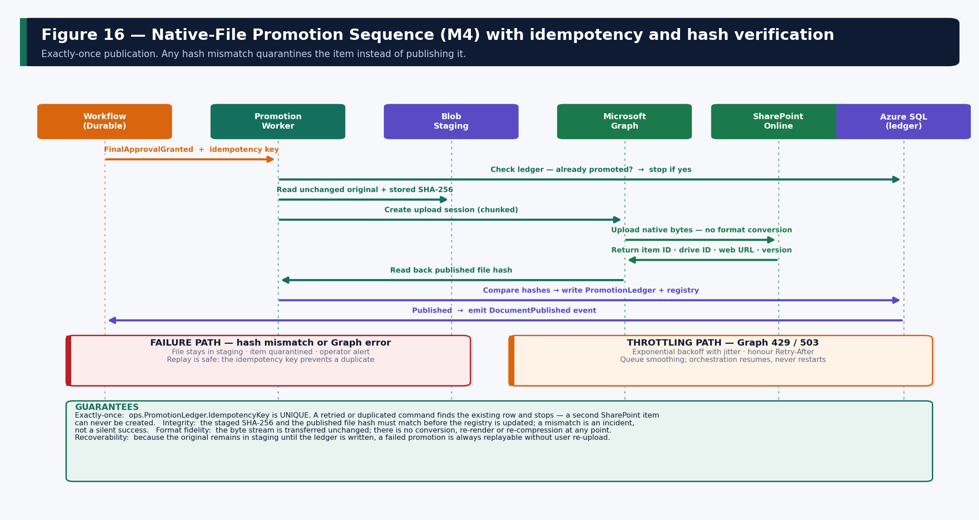
Figure 16 — Native-file promotion with idempotency key, hash verification, failure quarantine and throttling behaviour.
Concern | Design
Exactly-once | ops.PromotionLedger.IdempotencyKey is UNIQUE. The worker checks the ledger before calling Graph; a retried or duplicated command finds the row and stops.
Large files | Graph upload sessions transfer the byte stream in chunks; the session is resumable and the transfer is verified on completion.
Format fidelity | The stream is transferred unchanged — no conversion, re-render or re-compression. The published hash must equal the staged hash.
Write-back | Site, drive, item, web URL and native version label are written to docaya.DocumentVersion only after the hash comparison succeeds.
Failure | The file remains in staging, the item is quarantined and an operator alert is raised. Replay is safe because of the idempotency key.
Throttling | Graph 429 and 503 are handled with exponential backoff and jitter, honouring Retry-After; the orchestration resumes rather than restarting.
Permission drift | A periodic reconciliation compares the SQL registry to SharePoint and reports any item whose location, version or columns have diverged.

14. Docaya Identity, Authorization and Resource Access Architecture
This section is written to be sufficient for a developer to implement the access mechanism, for a security architect to validate it, and for an infrastructure engineer to configure it. It covers authentication, session and token handling, RBAC, ABAC, document-level authorization, service-to-service authorization, and the specific access design for every resource Docaya touches.

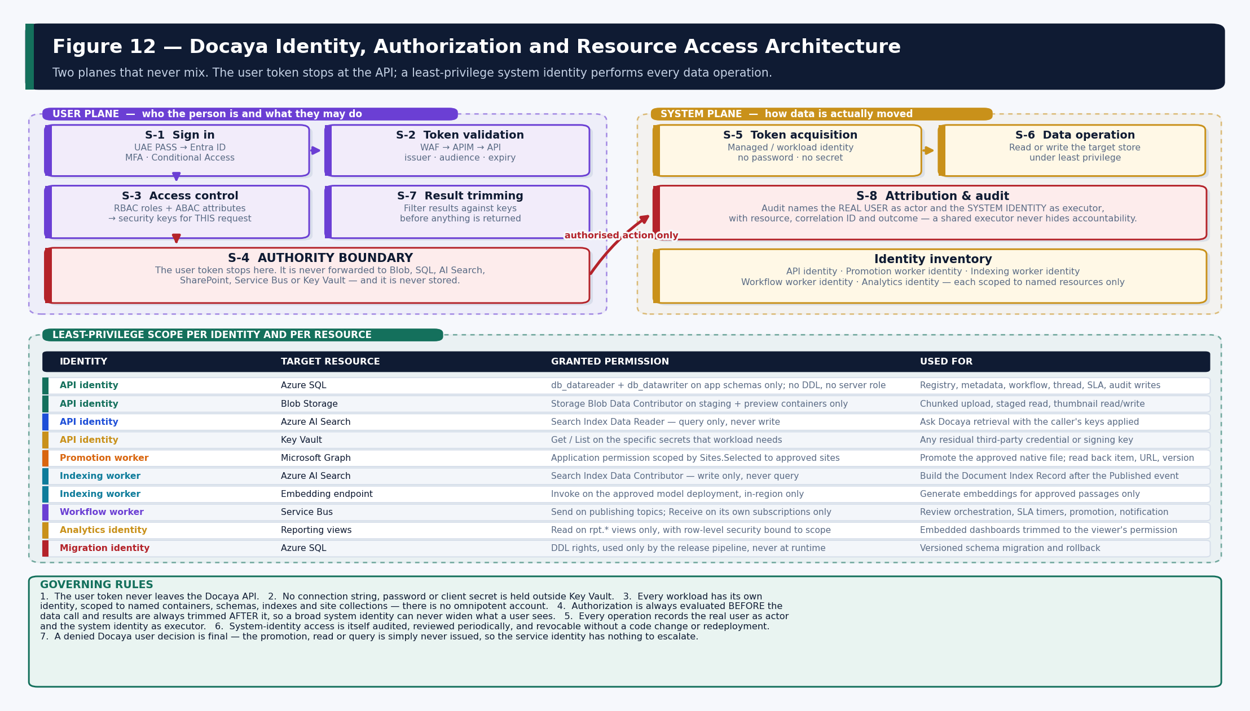
Figure 12 — The two planes, the authority boundary, and the least-privilege scope granted to each workload identity.

14.1 The Two-Plane Model
Step | Plane | What happens | Identity
S-1 | User | The user authenticates with UAE PASS, federated to Entra ID. MFA and Conditional Access are evaluated by Entra. | User
S-2 | User | The SPA calls the API through the WAF and API Management, which validate issuer, audience, signature, expiry, scope and rate. | User
S-3 | User | Docaya resolves effective permission from RBAC roles plus ABAC attributes and converts it into security keys for this request. Deny by default; the decision is logged. | User
S-4 | Boundary | The user token stops here. It is never forwarded to any downstream store and is never persisted. | —
S-5 | System | The service requests a token for the target resource using its managed or workload identity. No client secret or password exists in configuration or code. | System
S-6 | System | The system identity performs the read or write — Blob, Azure SQL, Azure AI Search, Service Bus, Key Vault, or SharePoint via Graph. | System
S-7 | Both | Results are filtered against the security keys resolved at S-3 before anything is returned. | Both
S-8 | Both | Audit records the real user as actor and the system identity as executor, with resource, correlation ID and outcome. | Both

14.2 Authentication, Session and Token Management
Concern | Design
Protocol | OpenID Connect Authorization Code Flow with PKCE for the single-page application. No implicit flow.
Federation | UAE PASS is the primary identity provider, federated to Microsoft Entra ID which issues the application token carrying app roles.
Token lifetime | Short-lived access tokens with silent renewal; refresh handling follows the Entra default policy for the tenant.
Token storage | Tokens are held in memory by the SPA. They are not written to local storage, session storage or a cookie readable by script.
Validation | API Management validates issuer, audience, signature and expiry; the API independently re-validates and additionally checks required scope and app role.
Step-up authentication | Required for sensitive actions: approving a Secret-marked document, changing access policy, granting an SLA extension at Authoriser level, and administrative configuration publication.
Session termination | Sign-out clears in-memory tokens and revokes the SignalR connection; Entra session policy governs single sign-out behaviour.
Workload tokens | Acquired by managed identity, cached in memory, refreshed before expiry and never written to a log or a diagnostic dump.

14.3 Required Claims and Their Source
Claim / attribute | Source | Used for
Subject identifier (oid) | Microsoft Entra ID | Primary principal identity; joined to sec.Principal.
National identity assurance | UAE PASS (via Entra) | Assurance level; may gate high-sensitivity actions.
Application roles | Entra app roles on the API registration | RBAC capability gate.
Department | Docaya internal profile, seeded from the client directory | ABAC department scope and browse default.
Clearance level | Docaya clearance catalogue (sec.AbacAttribute) | ABAC sensitivity check — clearance is never taken from a self-asserted claim.
Business unit / geography | Docaya internal profile | Optional ABAC scoping where the client requires it.
Employment status | Directory synchronisation | Suspension and offboarding enforcement.
Workflow assignment | wf.WorkflowStage at evaluation time | Only the currently assigned principal may act on the active stage.
Document attributes | docaya.Document and docaya.DocumentTag | Resource side of every ABAC predicate.

Why clearance is not a token claim Clearance and departmental scope are held in Docaya, not asserted in the token. A token claim can only be changed by re-issuing a token; an attribute held in sec.AbacAttribute can be revoked immediately and takes effect on the next request. This matters for offboarding and for emergency revocation.

14.4 RBAC — Role Design
Role | Modules | Key permissions | Restrictions
System Administrator | All | Platform configuration, routes, schemas, taxonomy, security policy publication. | Cannot approve or authorise business content; actions are audited and reviewable.
Department Administrator | M13 scoped | Departmental routing, metadata and taxonomy within own department. | No platform-wide configuration; no cross-department scope.
Records & Compliance Officer | M9, M16 | Retention schedules, disposition, legal hold, full audit visibility and export. | Cannot approve, authorise or publish business content.
Editor / Change Requester | M1, M2, M14 | Register, classify, submit, correct, resubmit, submit a new revision. | May act only on own Draft or Returned items; cannot approve.
Document Owner / Approver | M3 stage 2 | Approve or return at stage 2 with mandatory comment. | Scoped to the assigned stage and document scope only.
Assurance Reviewer | M3 stage 3 | Approve, return, and grant an SLA extension with a recorded reason. | Cannot perform final authorisation.
Authoriser | M3 stage 4 | Final sign-off; the publication gate. May also extend. | Cannot alter classification or bypass earlier stages.
Consumer / Viewer | M10 | Permission-trimmed browse, search, preview and download. | No write of any kind.
Auditor | M16 | Read-only access to audit, decision log and evidence export. | No document content write; no configuration.
Support Operator | Ops surfaces | Technical status, queue depth, dead-letter and job state. | No document content access; no business metadata.
Deployment Operator | Infrastructure | Provision and deploy via pipeline identity. | No data-plane read on document content or registry business data.
Emergency Administrator | Break-glass | Time-boxed elevated access under approval. | Auto-expiring, session-logged, post-event review mandatory.

14.5 ABAC — Attributes and Evaluation
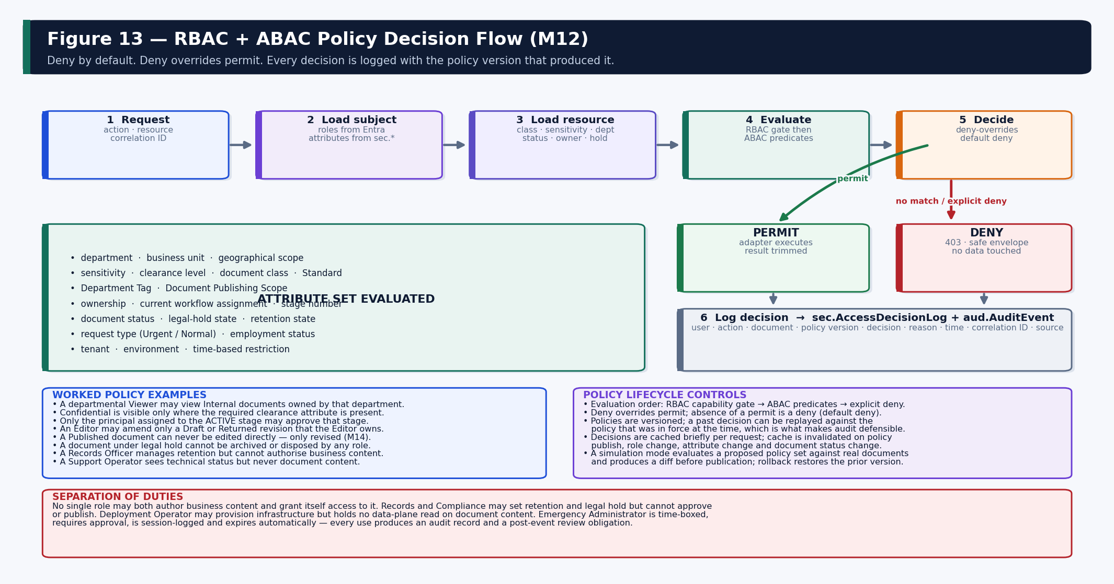
Figure 13 — Policy decision flow: subject and resource load, evaluation order, deny-overrides and the decision log.
Control | Rule
Evaluation order | RBAC capability gate first, then ABAC predicates on subject, resource and action, then explicit deny.
Combining algorithm | Deny overrides permit. Absence of a permit is a deny — the system is default-deny.
Conflict handling | Priority is explicit on each policy; an explicit deny at any priority defeats a permit.
Caching | Decisions are cached for the life of a request only; keys are never cached across requests or shared between users.
Invalidation | Policy publication, role change, attribute change, document status change and legal-hold change all invalidate.
Versioning | Policies are published as an immutable version set; a past decision is replayable against the version in force.
Simulation | A proposed policy set is evaluated against real documents and a diff is produced before publication.
Rollback | Publishing restores a prior version atomically; no partial policy state can exist.
Logging | Every decision writes user, action, document, policy version, decision, reason, correlation ID and time.

14.5.1 Worked policy examples
- A departmental Viewer may view Internal documents whose owning department matches the viewer's department.
- Confidential documents are visible only where the required clearance attribute is present — clearance is never inferred from role.
- Only the principal assigned to the currently active workflow stage may approve or return that stage.
- An Editor may amend only a Draft or Returned revision that the Editor owns.
- A Published document can never be edited directly; change is only expressible as a new revision through M14.
- A new version can be published only after the configured final approval stage completes.
- A document under legal hold cannot be archived or disposed by any role, including System Administrator.
- A Records Officer may manage retention and hold but cannot approve or authorise business content.
- A Support Operator may view technical status, queue depth and job state but never document content or business metadata.

14.6 Resource Access Design

14.6.1 SharePoint Online
Aspect | Design
Identity | A governed workload identity per function — the promotion worker for writes, a read identity for preview and download brokering.
Permission | Microsoft Graph application permission scoped by Sites.Selected to the approved Docaya sites only.
Consent | Granted once by a client administrator inside the client tenant; recorded as deployment evidence.
Operations | Create upload session, upload chunks, read item metadata, read version history, update Docaya-managed columns.
Attribution | Every operation records the real user as actor; the service identity is recorded as executor.
Escalation prevention | A denied Docaya decision means the Graph call is never issued — there is no code path that reaches an adapter without a prior permit.
Throttling | Exponential backoff with jitter, honouring Retry-After; orchestration resumes rather than restarting.
Rotation and revocation | Credential rotation is a configuration action; site scope can be revoked per site without redeployment.

14.6.2 Azure Blob Storage
Aspect | Design
Network | Private endpoint only; public network access disabled; storage firewall denies all other traffic.
Identity and role | Managed identity holding Storage Blob Data Contributor on the staging and preview containers only — never at account scope.
Container separation | Separate containers for upload chunks, committed staged files, extraction output and thumbnails, each with its own lifecycle rule.
Path convention | {container}/{yyyy}/{mm}/{documentId}/{versionOrChunk} — deterministic, and never derived from user-supplied text.
Browser upload | Where direct-to-Blob upload is used, the API authenticates and authorizes the user, then issues a short-lived user-delegation SAS scoped to a single blob path and a single write operation, with no list permission.
SAS constraints | Minutes-scale lifetime, write-only, single-path, IP-conditioned where feasible; never reusable for another document.
Post-upload validation | The commit is validated server-side: size, signature, hash and scan verdict. The file is not readable by any downstream process until the scan passes.
Protection | Encryption at rest, soft delete and versioning enabled; customer-managed keys available where client policy requires.
Diagnostics | Storage logs and metrics flow to Log Analytics; anomalous access patterns raise an alert.

14.6.3 Azure SQL Database
Identity | Database principal | Grant | Used for
API service identity | docaya_api | SELECT/INSERT/UPDATE on docaya, wf, ntf, idx read; INSERT+SELECT only on aud; SELECT on ref and rpt. | Runtime application operations.
Capture identity | docaya_capture | SELECT/INSERT/UPDATE on stg only. | Upload session and staging processing.
Workflow worker identity | docaya_worker | SELECT/INSERT/UPDATE on wf, ops; INSERT on aud. | Orchestration, SLA, outbox dispatch.
Indexing worker identity | docaya_index | SELECT on docaya, ref; SELECT/INSERT/UPDATE on idx. | Index build and reconcile.
Analytics identity | docaya_report | SELECT on rpt views only. | Power BI semantic model refresh.
Migration identity | docaya_migrate | DDL rights — used only by the release pipeline. | Versioned schema migration and rollback.

- Authentication. Microsoft Entra authentication with managed identity. No SQL authentication, no connection string with credentials, no shared administrator account in normal operation.
- Network. Private endpoint; public network access disabled; firewall denies all other sources.
- Resilience. Connection pooling with transient-fault handling and bounded exponential retry; explicit transaction boundaries around state-change plus outbox write.
- Protection. Transparent Data Encryption enabled; Always Encrypted considered for specific sensitive columns subject to decision A9; auditing enabled to Log Analytics.
- Break-glass. An emergency database principal exists but is disabled by default, requires approval to enable, expires automatically and is fully session-logged.

14.6.4 Azure AI Search, Power BI, Service Bus and Key Vault
Resource | Identity and grant | Controls
Azure AI Search | Indexing identity = Index Data Contributor (write only). API identity = Index Data Reader (query only). | API keys disabled; RBAC-only data plane; private endpoint; server-composed filters; documentStatus constrained to Published on every query.
Power BI Embedded | Service principal generates an embed token carrying the effective identity for the signed-in user. | Row-level security mirrors Docaya department and sensitivity scope; direct dataset access is not granted to end users; export controls and scheduled subscriptions are permission-aware.
Service Bus | Workflow worker = Send on publishing topics, Receive on its own subscriptions only. | Private endpoint; no shared access signature in configuration; dead-letter monitored and replay is an audited operator action.
Key Vault | Each workload holds Get and List on only the specific secrets it needs. | RBAC data plane; private endpoint; soft delete and purge protection enabled; secrets referenced by URI and never emitted to logs or template outputs.
Notification channels | Notification identity sends via Communication Services and Graph. | Recipients are resolved from entitlement, never from a user-supplied list; security notifications cannot be disabled by a user.

14.7 Service-to-Service Access Matrix
Caller | Target | Auth method | Authorization | Network | Secret
Browser SPA | API Management | OIDC bearer (user) | Scope + app role | Public → WAF | None
API Management | API | Managed identity / mTLS | Gateway policy | Private (snet-edge → snet-app) | None
API | Azure SQL | Managed identity | docaya_api role | Private endpoint | None
API | Blob Storage | Managed identity | Blob Data Contributor (containers) | Private endpoint | None
API | Key Vault | Managed identity | Get/List on named secrets | Private endpoint | None
API | Service Bus | Managed identity | Send on named topics | Private endpoint | None
API | Azure AI Search | Managed identity | Index Data Reader | Private endpoint | None
API | Power BI | Service principal | Embed token + RLS | Public (Microsoft) | Key Vault
Functions | Azure SQL | Managed identity | docaya_worker / docaya_index | Private endpoint | None
Functions | Blob Storage | Managed identity | Blob Data Contributor | Private endpoint | None
Functions | Service Bus | Managed identity | Receive on own subscriptions | Private endpoint | None
Functions | Microsoft Graph | Managed identity | Sites.Selected (approved sites) | Allow-listed egress | None
Functions | Azure AI Search | Managed identity | Index Data Contributor | Private endpoint | None
Functions | Embedding endpoint | Managed identity | Invoke on approved deployment | Private endpoint | None
Pipeline | Azure Resource Manager | Workload identity federation (OIDC) | Scoped deployment role | Public (Microsoft) | None
Migration job | Azure SQL | Managed identity | docaya_migrate (DDL) | Private endpoint | None
Support identity | Log Analytics | Entra user + PIM | Reader on telemetry only | Public (Microsoft) | None

14.8 Joiner, Mover, Leaver and Emergency Access
Event | Action | Timing
Joiner | Principal projected from the directory; default role and department assigned; onboarding reading list issued at first sign-in with acknowledgement tracked. | On first sign-in
Mover | Department and attribute change takes effect on the next request; in-flight stage assignments are reassigned or delegated explicitly rather than silently inherited. | Next request
Leaver | Principal marked inactive; all sessions invalidated; open stage assignments reassigned; document ownership transferred by a Records or Department Administrator; audit history is never anonymised. | Immediate
Role change | Role assignment updated; decision cache invalidated; the change itself is audited with actor and justification. | Next request
Emergency access | Break-glass principal enabled under approval, time-boxed with automatic expiry, session-logged, and subject to mandatory post-event review. | On approval
Periodic review | Role assignments, ABAC attributes, service-identity scopes and Sites.Selected grants are reviewed on a defined cycle with evidence retained. | Scheduled

14.9 Access-Control Implementation Plan
# | Step | Where it is built | Proven by
1 | Define claims, roles and the attribute catalogue. | docs/security · ref + sec seed data | Role matrix review signed off
2 | Create Entra app registrations (SPA, API, workloads) and scopes. | infra/modules/identity.bicep | Sign-in succeeds for every persona
3 | Implement token validation middleware. | Docaya.Api/Middleware/TokenValidation | Unit + integration tests on issuer, audience, expiry
4 | Implement RBAC authorization policies. | Docaya.Api/Authorization/Policies | Policy test per role per endpoint
5 | Implement the ABAC policy engine and evaluation order. | Docaya.Domain/Policy · Docaya.Application | Truth-table unit tests incl. deny-overrides
6 | Implement document-scope evaluation and security-key builder. | Docaya.Application/Security/PermissionKeyBuilder | Key composition tests per persona
7 | Implement access-decision logging. | Docaya.Infrastructure/Audit | Every decision produces a log row
8 | Create managed identities and role assignments. | infra/modules/identity.bicep · rbac.bicep | what-if review + post-deploy assertion
9 | Configure Key Vault access per workload. | infra/modules/keyvault.bicep | Workload can read only its own secrets
10 | Configure Blob data-plane roles and container scope. | infra/modules/storage.bicep | Cross-container access denied in test
11 | Create SQL principals and grants per workload. | scripts/database/roles.sql | Negative test: capture identity cannot read docaya
12 | Configure Service Bus send/receive scope. | infra/modules/servicebus.bicep | Worker cannot send on another topic
13 | Configure the governed Graph identity and Sites.Selected. | deploy/tenant-bootstrap | Access denied to a non-approved site
14 | Implement the Graph adapter with attribution. | Docaya.Infrastructure/Adapters/Graph | Audit shows user as actor, identity as executor
15 | Configure Search identities and permission trimming. | infra/modules/search.bicep · SearchAdapter | Negative retrieval test per persona
16 | Configure Power BI effective identity and RLS. | infra/modules/analytics.bicep | Report scope matches application scope
17 | Implement privileged and emergency access controls. | sec.* + PIM configuration | Expiry and session logging verified
18 | Implement joiner, mover and leaver processing. | Docaya.Application/Identity | Offboarding revokes within the agreed window
19 | Access-control penetration test and UAT. | tests/security | No finding above the agreed severity threshold

15. Security Architecture

15.1 Zero-Trust Control Summary
Control area | Design
Authentication | UAE PASS federated to Entra ID; OIDC with PKCE; MFA and Conditional Access enforced by Entra; step-up for sensitive actions.
Authorization | Deny-by-default RBAC plus ABAC on department, sensitivity, clearance, ownership, workflow assignment and document status.
Workload identity | A separate managed identity per workload; no stored password, connection string or client secret anywhere outside Key Vault.
Network | Single public ingress via Front Door and WAF; API Management internal; private endpoints for every data service; explicitly allow-listed Graph egress.
Data protection | TLS 1.2 or higher in transit; encryption at rest with platform-managed keys and optional customer-managed keys; Key Vault with soft delete and purge protection.
Content safety | Every upload is scanned for malware and evaluated by DLP before it can progress; Purview sensitivity labels applied to published content.
Audit integrity | Append-only hash-chained audit in Azure SQL with no UPDATE or DELETE grant; periodic chain checkpoints; export to immutable storage for legal purposes.
Secrets and rotation | Key Vault only; referenced by URI; rotation is a configuration action; secrets never appear in logs, template outputs or diagnostics.
Vulnerability management | SAST, SCA, container and IaC scanning on every pull request; SBOM per release; dependency currency tracked and patched on a defined cycle.
Penetration testing | Independent test before production and on a periodic cycle, with access-control abuse cases explicitly in scope.
Residency | All data and all processing — including indexing, embedding and answering — confined to approved UAE Azure regions.

15.2 STRIDE Threat Model
Threat | Vector | Mitigation | Verified by
Spoofing | Stolen or replayed user token. | Short-lived tokens, audience and issuer validation, MFA and Conditional Access, anomaly alerting, step-up for sensitive actions. | Security test suite
Spoofing | Compromised workload credential. | Managed identity only — no long-lived secret exists to steal; per-workload scope limits blast radius; rotation without redeployment. | Infrastructure review
Tampering | Altered document after approval. | Published hash compared to staged hash; SharePoint native versioning; reconciliation detects divergence. | Promotion integrity test
Tampering | Altered audit record. | Append-only grants plus hash chain; verification job and checkpoints; alteration breaks the chain visibly. | Chain verification job
Repudiation | “I did not approve this.” | Every decision records actor, executor, stage, comment, policy version, correlation ID and time; step-up on high-sensitivity approval. | Audit export review
Information disclosure | Unauthorised search result or answer. | Permission keys applied before retrieval, re-checked against SQL before render; per-persona negative tests are a release gate. | Negative retrieval tests
Information disclosure | Thumbnail leakage for a sensitive class. | Thumbnails are treated as document content and trimmed identically; suppressed classes fall back to a neutral icon. | Persona preview tests
Information disclosure | Data exfiltration through reporting. | Power BI row-level security mirrors Docaya scope; no direct dataset access; export controls and audit on subscriptions. | RLS conformance test
Denial of service | Upload or query flood. | WAF rate limiting, APIM throttling per key and per user, 100 MB single-file cap, queue smoothing and backpressure. | Load test
Elevation of privilege | Service identity used to bypass a denied user decision. | A denied decision means the adapter is never invoked; no code path reaches a provider call without a prior permit. | Architecture test + security test
Elevation of privilege | Malicious upload executing downstream. | Extension and signature validation, malware scan, DLP, quarantine until clean, no server-side rendering of untrusted content. | Malicious file corpus test
Injection | Filter or query injection into search. | Filters composed server-side only; free text parameterised and escaped; documentStatus constraint appended unconditionally. | Injection test suite

15.3 Secure Development Lifecycle
- Threat model reviewed and updated at the start of each phase that introduces a new trust boundary or data flow.
- Architecture tests in CI enforce the dependency rule — a provider SDK reference inside Docaya.Domain fails the build.
- SAST, dependency, secret, container and IaC scanning run on every pull request; findings above the agreed threshold block merge.
- An SBOM is generated per release and shipped inside the release package alongside the vulnerability report.
- Security test cases live beside the code in tests/security and include the access-control abuse cases listed in the threat model.
- Penetration test findings are tracked to closure with retest evidence before production sign-off.

16. Network Architecture
The network is designed on zero-trust principles: one controlled public ingress, private-only connectivity to every data service, segmented subnets with default-deny rules, private DNS so internal resolution never leaves the virtual network, and explicitly allow-listed egress to Microsoft 365. No client ever reaches a data store directly.

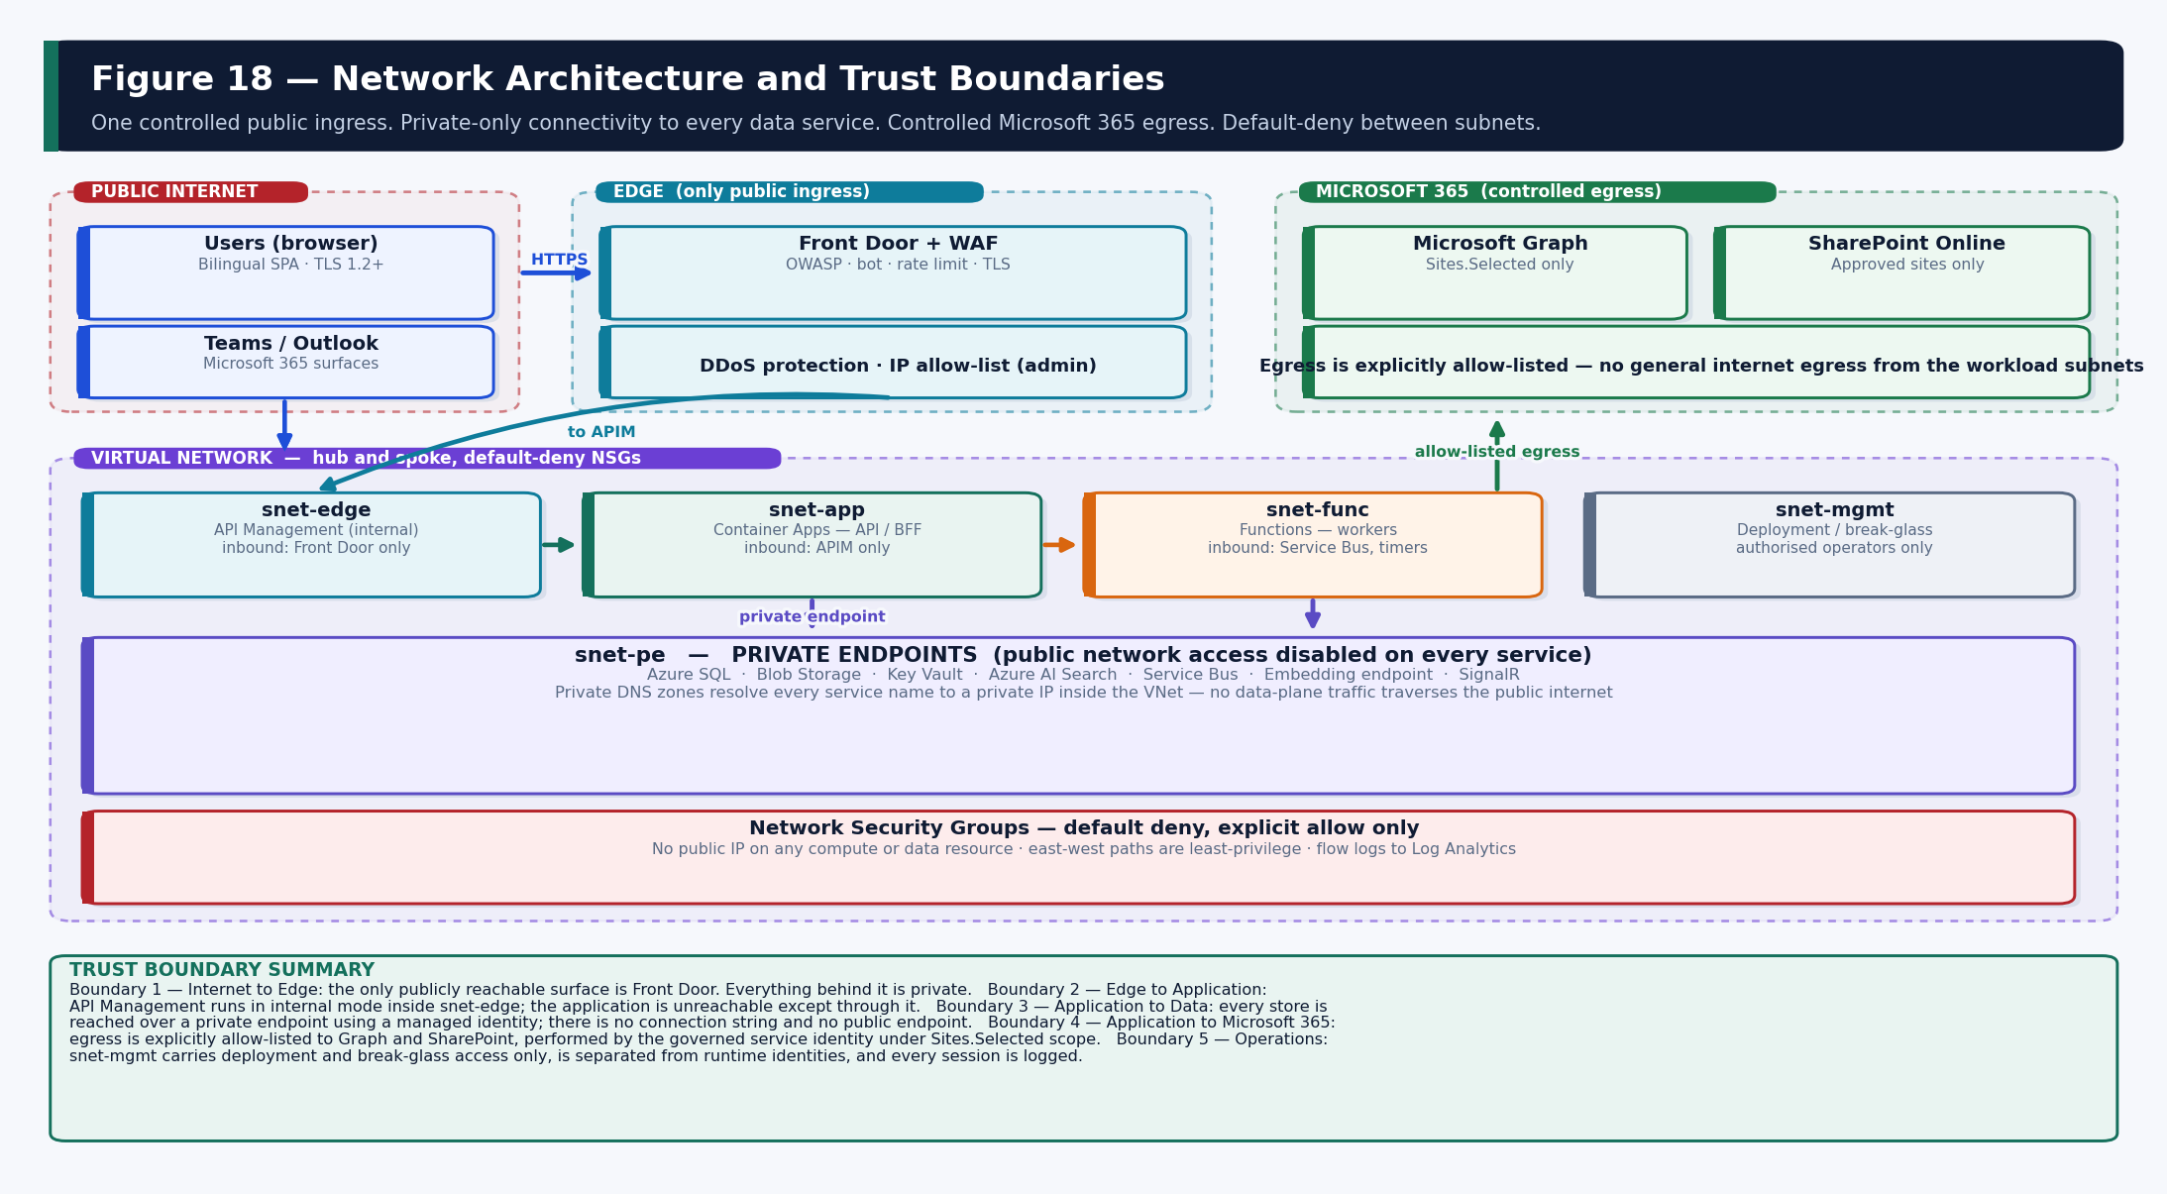
Figure 18 — Subnet segmentation, private endpoints, controlled Microsoft 365 egress and the five trust boundaries.

16.1 Subnet Design
Subnet | Hosts | Inbound permitted from | Outbound permitted to
snet-edge | API Management (internal mode) | Front Door only | snet-app
snet-app | Container Apps — API and BFF | snet-edge only | snet-pe, Service Bus, allow-listed Graph
snet-func | Azure Functions — workers | Service Bus, timer triggers | snet-pe, allow-listed Graph and embedding endpoint
snet-pe | Private endpoints: SQL, Blob, Key Vault, AI Search, Service Bus, SignalR | snet-app, snet-func | —
snet-mgmt | Deployment and break-glass connectivity | Authorised operators via PIM | Control plane only

16.2 Connectivity Rules
- Single public surface. Front Door is the only publicly reachable component. No compute or data resource has a public IP.
- Private-endpoint-only data plane. Azure SQL, Blob, Key Vault, Azure AI Search, Service Bus and the embedding endpoint have public network access disabled.
- Private DNS. Private DNS zones resolve every service name to a private IP inside the virtual network, so no data-plane traffic traverses the public internet.
- Default-deny NSGs. Every subnet denies by default with explicit allows only; flow logs are collected to Log Analytics.
- Controlled egress. Outbound access is allow-listed to Microsoft Graph, SharePoint and the approved Microsoft 365 endpoints; there is no general internet egress from workload subnets.
- Connectivity as a release gate. Private-endpoint resolution and DNS are verified from the running workload during deployment; failure blocks the release.

16.3 Trust Boundaries
# | Boundary | Control
1 | Internet → Edge | Front Door, WAF with OWASP ruleset, bot protection, rate limiting, TLS termination, optional DDoS protection and IP allow-list for administrative paths.
2 | Edge → Application | API Management in internal mode validates the token and applies policy; the application is unreachable by any other route.
3 | Application → Data | Private endpoint plus managed identity; no connection string; authorization already evaluated before the call is made.
4 | Application → Microsoft 365 | Allow-listed egress only, executed by the governed service identity under Sites.Selected scope.
5 | Operations → Platform | snet-mgmt carries deployment and break-glass only, separated from runtime identities, time-boxed and fully session-logged.

17. Project Initiation, Repository Structure and Development Bootstrap
This section defines exactly how the Docaya development project is created and structured before any module is implemented. It is written so a developer can follow it from an empty folder to a building, debuggable solution in Visual Studio Code.

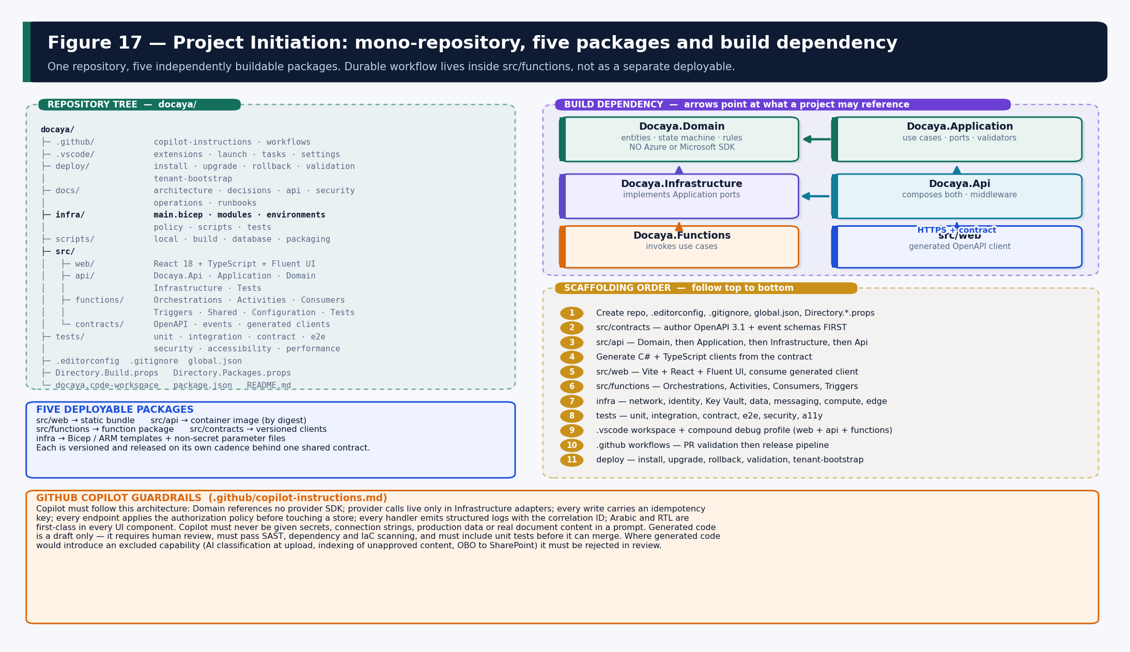
Figure 17 — Mono-repository tree, the five deployable packages, the build dependency direction and the scaffolding order.

17.1 Repository Model and Package Count
Docaya uses a single mono-repository containing five independently buildable and independently deployable packages. This gives one place for versioning, cross-cutting change and pull requests, while preserving strong boundaries and separate release cadences.
# | Package | Contents | Produced artifact
1 | src/web | React 18, TypeScript, Fluent UI; feature folders aligned to M1–M16; i18n and RTL; generated API client. | Versioned static bundle
2 | src/api | Docaya.Api, Docaya.Application, Docaya.Domain, Docaya.Infrastructure, Docaya.Tests. | Immutable container image (by digest)
3 | src/functions | Orchestrations, Activities, Consumers, Triggers, Shared, Configuration, Tests. | Versioned function package
4 | src/contracts | OpenAPI 3.1 document, event schemas, generated TypeScript and C# clients. | Versioned contract package
5 | infra | main.bicep, modules, environments, policy, scripts, tests. | Bicep + compiled ARM templates

Why Durable workflow is not a sixth package Durable orchestrations, their activities, the Service Bus consumers and the timer triggers share the same host, the same configuration and the same release cadence. Splitting them into a separate deployable would add an artifact, a pipeline and a version to manage with no operational benefit. They therefore live inside src/functions.

17.2 Project Dependency Boundaries
Project | May reference | Must never reference
Docaya.Domain | Nothing outside the .NET base library. | Any Azure SDK, Microsoft Graph, EF Core, messaging or HTTP client.
Docaya.Application | Docaya.Domain. | Any provider SDK — it defines ports, it does not implement them.
Docaya.Infrastructure | Docaya.Application (implements its ports) and provider SDKs. | Docaya.Api.
Docaya.Api | Docaya.Application and Docaya.Infrastructure. | Business rules — it composes and exposes, it does not decide.
Docaya.Functions | Docaya.Application and Docaya.Infrastructure. | Duplicated domain logic — it invokes use cases.
src/web | The generated client from src/contracts. | Any direct call to Azure AI Search, Blob, SQL or Graph.

17.3 Bootstrap Checklist
- Create the empty repository, then add .editorconfig, .gitignore, global.json (pins the .NET SDK), Directory.Build.props and Directory.Packages.props (central package version management).
- Author src/contracts first — the OpenAPI 3.1 document and the event schemas. The contract precedes the code so the UI and API cannot drift.
- Scaffold src/api in dependency order: Docaya.Domain, then Docaya.Application, then Docaya.Infrastructure, then Docaya.Api, then Docaya.Tests.
- Add the architecture test that fails the build if Docaya.Domain references a provider package.
- Generate the C# and TypeScript clients from the contract and commit the generation script, not hand-edited output.
- Scaffold src/web with Vite, React, TypeScript and Fluent UI; wire i18n and RTL from the first commit rather than retrofitting.
- Scaffold src/functions with the Orchestrations, Activities, Consumers, Triggers, Shared and Configuration folders.
- Scaffold infra with main.bicep and the module folder; add the what-if script before any deployment is attempted.
- Create tests/ with unit, integration, contract, end-to-end, security, accessibility, performance and deployment folders.
- Add .vscode with extensions.json, settings.json, tasks.json and launch.json including the compound full-stack profile.
- Add .github/workflows with the pull-request validation pipeline, then the release pipeline.
- Add .github/copilot-instructions.md encoding the architecture rules so generated code follows them by default.
- Add deploy/ with install, upgrade, rollback, validation and tenant-bootstrap scripts.
- Run the full local loop once — build, test, run web, API and Functions together under F5 — before the first feature branch is opened.

17.4 Baseline Packages and Standards
Area | Baseline
API packages | ASP.NET Core, EF Core with the SQL Server provider, Azure.Identity, Azure.Storage.Blobs, Azure.Messaging.ServiceBus, Azure.Search.Documents, Microsoft.Graph, FluentValidation, MediatR or an equivalent use-case dispatcher, OpenTelemetry, Serilog.
Functions packages | Durable Task extension, Service Bus extension, Timer extension, Azure.Identity, the shared Docaya.Application and Docaya.Infrastructure references.
Web packages | React, TypeScript, Vite, Fluent UI, TanStack Query, react-i18next, MSAL browser, the generated OpenAPI client, axe for accessibility tests, Playwright for end-to-end.
Version management | Directory.Packages.props centrally pins every NuGet version; package-lock.json pins npm. No floating versions in any package.
Naming | Projects Docaya.{Layer}; database objects {schema}.{PascalCase}; Azure resources {type}-docaya-{env}-{region}; branches feature/*, fix/*, chore/*.
Logging | Structured logging only; every log carries the correlation ID; no document content, personal data or secret is ever logged.
Testing | Unit tests beside the code; integration tests against an isolated database and a mocked Graph; contract tests on every OpenAPI and event change.
Commits and versioning | Conventional Commits; semantic versioning; a Git tag per release; squash merge with a green pipeline and an up-to-date branch.

17.5 Visual Studio Code Workspace
// docaya.code-workspace — one window, all five packages, correct tooling per folder
{
"folders": [
{ "name": "web", "path": "src/web" },
{ "name": "api", "path": "src/api" },
{ "name": "functions", "path": "src/functions" },
{ "name": "contracts", "path": "src/contracts" },
{ "name": "infra", "path": "infra" }
],
"settings": {
"editor.formatOnSave": true,
"editor.codeActionsOnSave": { "source.fixAll": "explicit" },
"dotnet.defaultSolution": "src/api/Docaya.Api.sln",
"files.eol": "\n"
}
}

Extension | Used for
C# Dev Kit | Build, run and debug the ASP.NET Core API and the Functions host.
Azure Functions + Azurite | Run and debug Durable and timer functions locally against a storage emulator.
Bicep + Azure Resources | Author, lint, what-if and deploy Infrastructure-as-Code.
ESLint + Prettier | Lint and format the web package on save and in CI.
REST Client / OpenAPI | Explore and test the contract without leaving the editor.
Docker | Build and inspect the API container image locally.
SQL Database Projects / mssql | Apply and inspect migrations against the local or dev database.
axe Accessibility Linter | Catch accessibility defects while writing components rather than at test time.
GitLens | Review authorship and history during code review.

17.6 Local Development Loop
# 1) clone and open the multi-root workspace
git clone <repo-url> docaya && cd docaya
code docaya.code-workspace

# 2) contracts first - generate clients before building anything that consumes them
npm run gen:client # -> src/web/src/api (TypeScript)
dotnet tool run nswag # -> src/api/Generated (C#)

# 3) API (folder: src/api)
dotnet restore && dotnet run # https://localhost:5001 · Swagger at /swagger

# 4) Web (folder: src/web)
npm ci && npm run dev # http://localhost:5173

# 5) Functions (folder: src/functions)
func start # Durable + timer functions against Azurite

# 6) Infrastructure (folder: infra)
az bicep build --file main.bicep
az deployment sub what-if --location <region> \
--template-file main.bicep --parameters environments/dev.json

Debug profile | Launches | Notes
Web: Vite + Chrome | SPA with source maps | Hot module reload; MSAL configured against the dev app registration.
API: .NET | ASP.NET Core with Swagger | Hot reload on save; user-secrets for local configuration, never committed.
Functions: Host | Durable and timer functions | Azurite provides local storage; local.settings.json is git-ignored.
Compound: Full stack | Web + API + Functions together | A single F5 runs the whole local loop so an end-to-end flow can be stepped through.

- Local secrets. dotnet user-secrets and a git-ignored local.settings.json. No secret, connection string or production value is ever committed.
- Local data. A containerised SQL Server or a developer Azure SQL database, seeded with synthetic documents only.
- Local Graph. A mocked Graph adapter by default so developers do not need tenant access; an opt-in configuration targets a dedicated development SharePoint site.
- Local search. A mocked search adapter for unit work; a shared development search service for integration work.

17.7 GitHub Copilot Assisted Development
Copilot is used as an accelerator, never as an authority. The repository carries .github/copilot-instructions.md so generated code follows the approved architecture by default rather than by reviewer vigilance alone.
Copilot may assist with | Mandatory human control
Repository and project scaffolding; folder structure; configuration files. | A reviewer confirms the structure matches Section 17 before the first feature merge.
React components, hooks, forms and i18n wiring. | Accessibility and RTL are verified by automated and manual test, not assumed.
ASP.NET Core endpoints, validators and mapping code. | Every endpoint must apply the authorization policy before touching a store — verified in review and by test.
Domain models and state-machine transitions. | Transitions are checked against Figure 5; an illegal transition must fail a unit test.
Durable orchestrations and activities. | Idempotency and replay safety are reviewed explicitly; a generated orchestration is never merged without a replay test.
Bicep modules and parameter files. | what-if output is reviewed by a named approver; no module merges without IaC scanning.
Unit, integration and contract tests. | Coverage of the negative and denial paths is checked, not only the happy path.
OpenAPI documentation and SQL migrations. | Migrations require a rehearsed rollback before they may run against a shared environment.

Copilot guardrails Never place a secret, connection string, production data or real document content in a prompt. Generated code is a draft: it must pass SAST, dependency and IaC scanning, must include tests, and must be reviewed by a person who is accountable for it. Any suggestion that would introduce an excluded capability — AI classification at upload, indexing of unapproved content, on-behalf-of access to SharePoint, a floating container tag in production — must be rejected in review.

18. Azure Infrastructure and Bicep Infrastructure-as-Code

18.1 Subscription, Environment and Naming Strategy
Concern | Design
Subscription | One subscription per environment where the client permits it; otherwise one subscription with strictly separated resource groups and no shared data resources.
Resource group | rg-docaya-{env}-{region}, one per environment. Shared or cross-environment resource groups are not used.
Region | Approved UAE region as primary; paired region used only for backup and recovery, never for live processing.
Naming | {type}-docaya-{env}-{region} with a documented abbreviation list, so every resource is identifiable from its name alone.
Tagging | workload, environment, owner, costCentre, dataClassification, residency and releaseVersion applied to every resource by the template.
Policy | Azure Policy denies public network access on data services, denies resource creation outside approved regions, and requires the mandatory tag set.

18.2 Bicep Module Structure
infra/
├─ main.bicep # subscription-scope composition root
├─ environments/
│ ├─ dev.json test.json prod.json # non-secret parameters only
├─ modules/
│ ├─ network.bicep # VNet, subnets, NSGs, private DNS zones
│ ├─ identity.bicep # user-assigned managed identities
│ ├─ rbac.bicep # data-plane role assignments (least privilege)
│ ├─ keyvault.bicep # Key Vault + private endpoint + RBAC data plane
│ ├─ sql.bicep # Azure SQL + private endpoint + TDE + auditing
│ ├─ storage.bicep # Blob staging/preview + lifecycle + private endpoint
│ ├─ servicebus.bicep # topics, queues, subscriptions, dead-letter
│ ├─ search.bicep # Azure AI Search + private endpoint (RBAC only)
│ ├─ aiendpoint.bicep # embedding / answering deployment, in-region
│ ├─ containerapp.bicep # API environment + app (image by digest)
│ ├─ functions.bicep # Functions plan + app + Durable storage
│ ├─ staticwebapp.bicep # web hosting
│ ├─ apim.bicep # API Management (internal) + policies
│ ├─ frontdoor.bicep # Front Door + WAF policy
│ ├─ signalr.bicep # real-time service
│ ├─ communication.bicep # email / notification service
│ ├─ analytics.bicep # Power BI embed prerequisites
│ └─ observability.bicep # Log Analytics, App Insights, alerts, diagnostics
├─ policy/ # Azure Policy assignments
├─ scripts/ # build, what-if, deploy, drift-detect
└─ tests/ # template unit tests + post-deploy assertions

18.3 Provisioning Order
# | Provision | Depends on | Why the order matters
1 | Network — VNet, subnets, NSGs, private DNS zones | — | Private endpoints cannot be created before the subnet and DNS zone exist.
2 | Managed identities | — | Role assignments in later steps reference these principal IDs.
3 | Observability — Log Analytics, Application Insights | — | Diagnostic settings on every later resource target this workspace.
4 | Key Vault + private endpoint | 1 | Later modules reference secrets by URI rather than value.
5 | Data — SQL, Blob, Search, embedding endpoint | 1, 4 | All created with public network access disabled from the outset.
6 | Messaging — Service Bus | 1 | Topics and subscriptions must exist before workers start.
7 | Compute — Container Apps, Functions | 1–6 | Applications must be able to resolve and reach their dependencies on first start.
8 | Edge — API Management, Front Door, WAF, Static Web App | 7 | Routing targets must exist and be healthy before traffic is accepted.
9 | Role assignments — data-plane RBAC | 2, 4–8 | Assigned last so every target resource exists and scope is exact.
10 | Policy assignment and diagnostic settings | 1–9 | Guardrails applied once the estate is complete.

18.4 Representative Bicep
// main.bicep — subscription-scope composition root (no secrets, no tenant values)
targetScope = 'subscription'

@allowed(['dev','test','prod'])
param environmentName string
param location string
@description('API image referenced by immutable digest, supplied by the pipeline')
param apiImageDigest string
param tags object = {
workload: 'docaya'
environment: environmentName
residency: 'uae'
}

resource rg 'Microsoft.Resources/resourceGroups@2023-07-01' = {
name: 'rg-docaya-${environmentName}-${location}'
location: location
tags: tags
}

module network 'modules/network.bicep' = {
name: 'network'
scope: rg
params: { environmentName: environmentName, location: location, tags: tags }
}

module identity 'modules/identity.bicep' = {
name: 'identity'
scope: rg
params: { environmentName: environmentName, location: location, tags: tags }
}

module data 'modules/sql.bicep' = {
name: 'sql'
scope: rg
params: {
environmentName: environmentName
location: location
tags: tags
peSubnetId: network.outputs.privateEndpointSubnetId
privateDnsZoneId: network.outputs.sqlPrivateDnsZoneId
logAnalyticsId: observability.outputs.workspaceId
publicNetworkAccess: 'Disabled' // enforced, not defaulted
}
}

module api 'modules/containerapp.bicep' = {
name: 'api'
scope: rg
params: {
environmentName: environmentName
location: location
tags: tags
appSubnetId: network.outputs.appSubnetId
identityId: identity.outputs.apiIdentityId
// digest, never a floating tag - this is what makes rollback deterministic
containerImage: '${data.outputs.registryLoginServer}/docaya-api@${apiImageDigest}'
keyVaultUri: keyvault.outputs.vaultUri
}
}

output apiFqdn string = api.outputs.internalFqdn
output webUrl string = edge.outputs.staticWebAppUrl

18.5 Validation, Drift and Rollback
Activity | Command or mechanism | Gate
Compile and lint | az bicep build --file infra/main.bicep | Pull-request pipeline
Template unit tests | infra/tests — assert naming, tagging, public-access disabled, TLS minimum | Pull-request pipeline
IaC security scan | Static analysis of templates for insecure configuration | Pull-request pipeline — blocking
Preview | az deployment sub what-if | Reviewed and approved by a named person before any environment change
Deploy | az deployment sub create with the environment parameter file | Release pipeline under workload identity federation
Post-deploy assertion | Private-endpoint resolution, DNS, identity and role assignment verified from the running workload | Blocking — failure stops the release
Drift detection | Scheduled what-if against the deployed environment; unexpected drift raises an alert | Operational
Rollback | Re-deploy the previous template version and re-point the API to the previous image digest | Rehearsed each release

18.6 Environment Matrix
Setting | dev | test / UAT | production
High availability | Single zone | Zone-redundant | Zone-redundant with geo-redundant backup
Private endpoints | Optional | Enabled | Enforced by policy
Scale | Minimal fixed | Production-like | Auto-scale to tested target
Data | Synthetic only | Anonymised | Live, residency-pinned
Search service | Shared, small | Dedicated | Dedicated, private endpoint
Ask (AI answering) | Enabled for development | Enabled for acceptance | Feature-flagged on POC outcome
Access | Developers | Release and QA | Break-glass and operators only, via PIM
Retention of telemetry | 30 days | 90 days | Per client policy

19. CI/CD Architecture
Artifacts are built once and promoted unchanged through every environment. Pipelines authenticate to Azure with workload identity federation, so no cloud credential is ever stored. Every release publishes a manifest, a software bill of materials, scan results and the reviewed infrastructure change set as audit evidence.

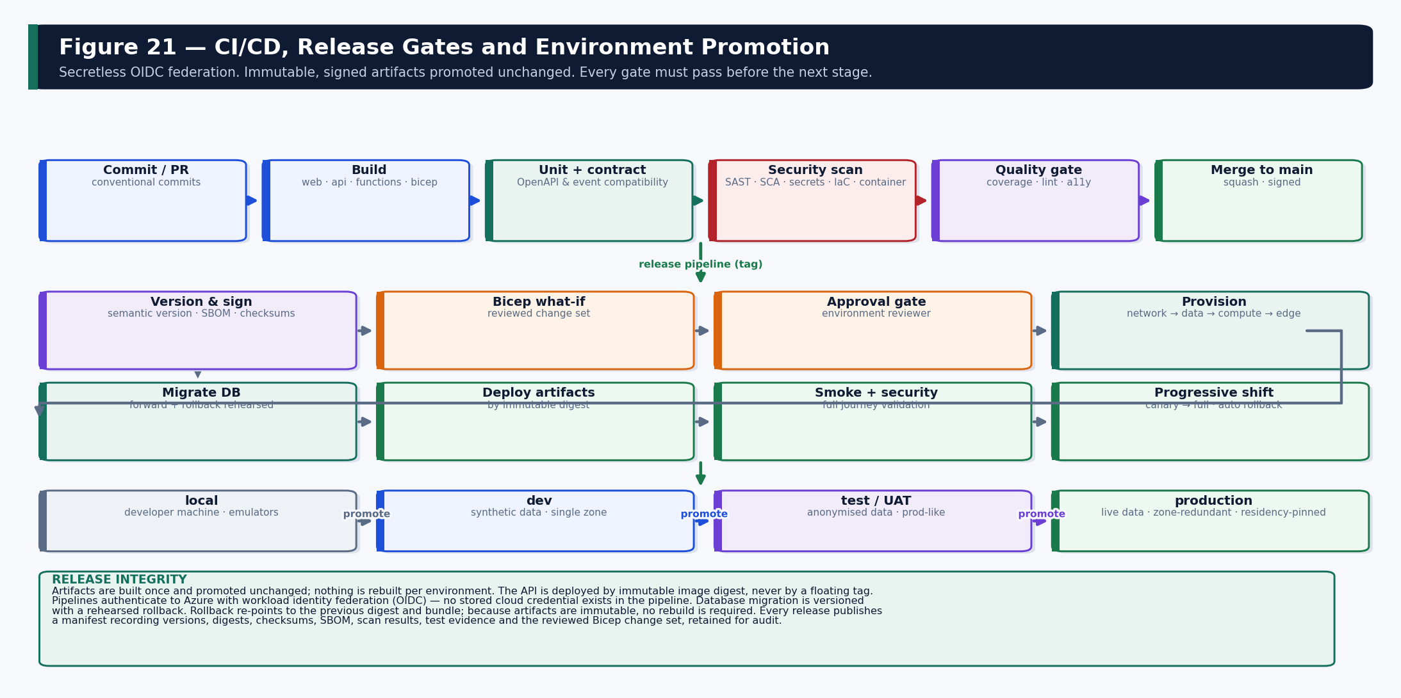
Figure 21 — Pull-request validation, release gates, environment promotion and release integrity.

19.1 Branching and Pull-Request Gates
Gate | Check | Blocking
Build | All five packages build; architecture test enforces the dependency rule. | Yes
Unit tests | Domain, SLA arithmetic, routing, idempotency, hash chain, policy truth tables. | Yes
Contract tests | OpenAPI and event schema backward compatibility; a breaking change requires a version bump. | Yes
Integration tests | SQL repositories, Blob chunking, Graph upload session, index publication, Service Bus. | Yes
Security scanning | SAST, dependency (SCA), secret detection, container scan, IaC scan. | Yes above threshold
Accessibility | Automated axe checks on changed components. | Yes
Coverage | Minimum threshold on domain and application logic. | Yes
Bicep validation | Compile, lint, template unit tests, what-if on the dev environment. | Yes

19.2 Release Pipeline
- A semantic version tag triggers the release pipeline.
- Artifacts are built once: web bundle, API container image pushed by digest, Functions package, contract package, compiled Bicep and ARM templates, migration bundle and configuration seed.
- An SBOM, checksums and vulnerability reports are generated and signed into the release manifest.
- Bicep what-if runs against the target environment and the change set is reviewed by a named approver.
- The environment approval gate is satisfied — for production this is a separate person from the requester.
- Infrastructure is provisioned or patched in the order defined in Section 18.3.
- Database migrations are applied with a rehearsed rollback available.
- Configuration is seeded: document types, routes, stages, SLA calendars, taxonomies and notification templates.
- API, Functions and web artifacts are deployed by immutable version — never rebuilt for the environment.
- API Management imports the contract and policies; Front Door and WAF configuration is applied.
- Smoke and security journeys run: sign-in, capture, classification, review, return, publish, search, answer, report and audit.
- Traffic is shifted progressively with automatic rollback on health or SLO breach.
- The release manifest, dashboards, runbooks and evidence pack are published.

19.3 Release Integrity Principles
- Build once, promote unchanged. Nothing is rebuilt per environment; the binary that passed test is the binary that reaches production.
- Deploy by digest. The API is deployed by immutable image digest. Floating tags are prohibited in test and production.
- Secretless pipelines. Workload identity federation (OIDC) to Azure; no cloud credential is stored in the pipeline or the repository.
- Rehearsed rollback. Rollback re-points to the previous digest and bundle and, where required, runs the down-migration. No rebuild is needed.
- Evidence retention. Every release retains its manifest, SBOM, scan results, test evidence and the reviewed what-if change set for audit.

20. Portable Deployment, Cross-Tenant Installation and Client Onboarding
Docaya is treated as a deployable product, not as one installation. It may be built in one Microsoft tenant and installed into a client environment that has no trust relationship, no network path, no identity federation and no resource linkage with the build tenant. Nothing in this architecture assumes the build tenant can reach the client tenant.

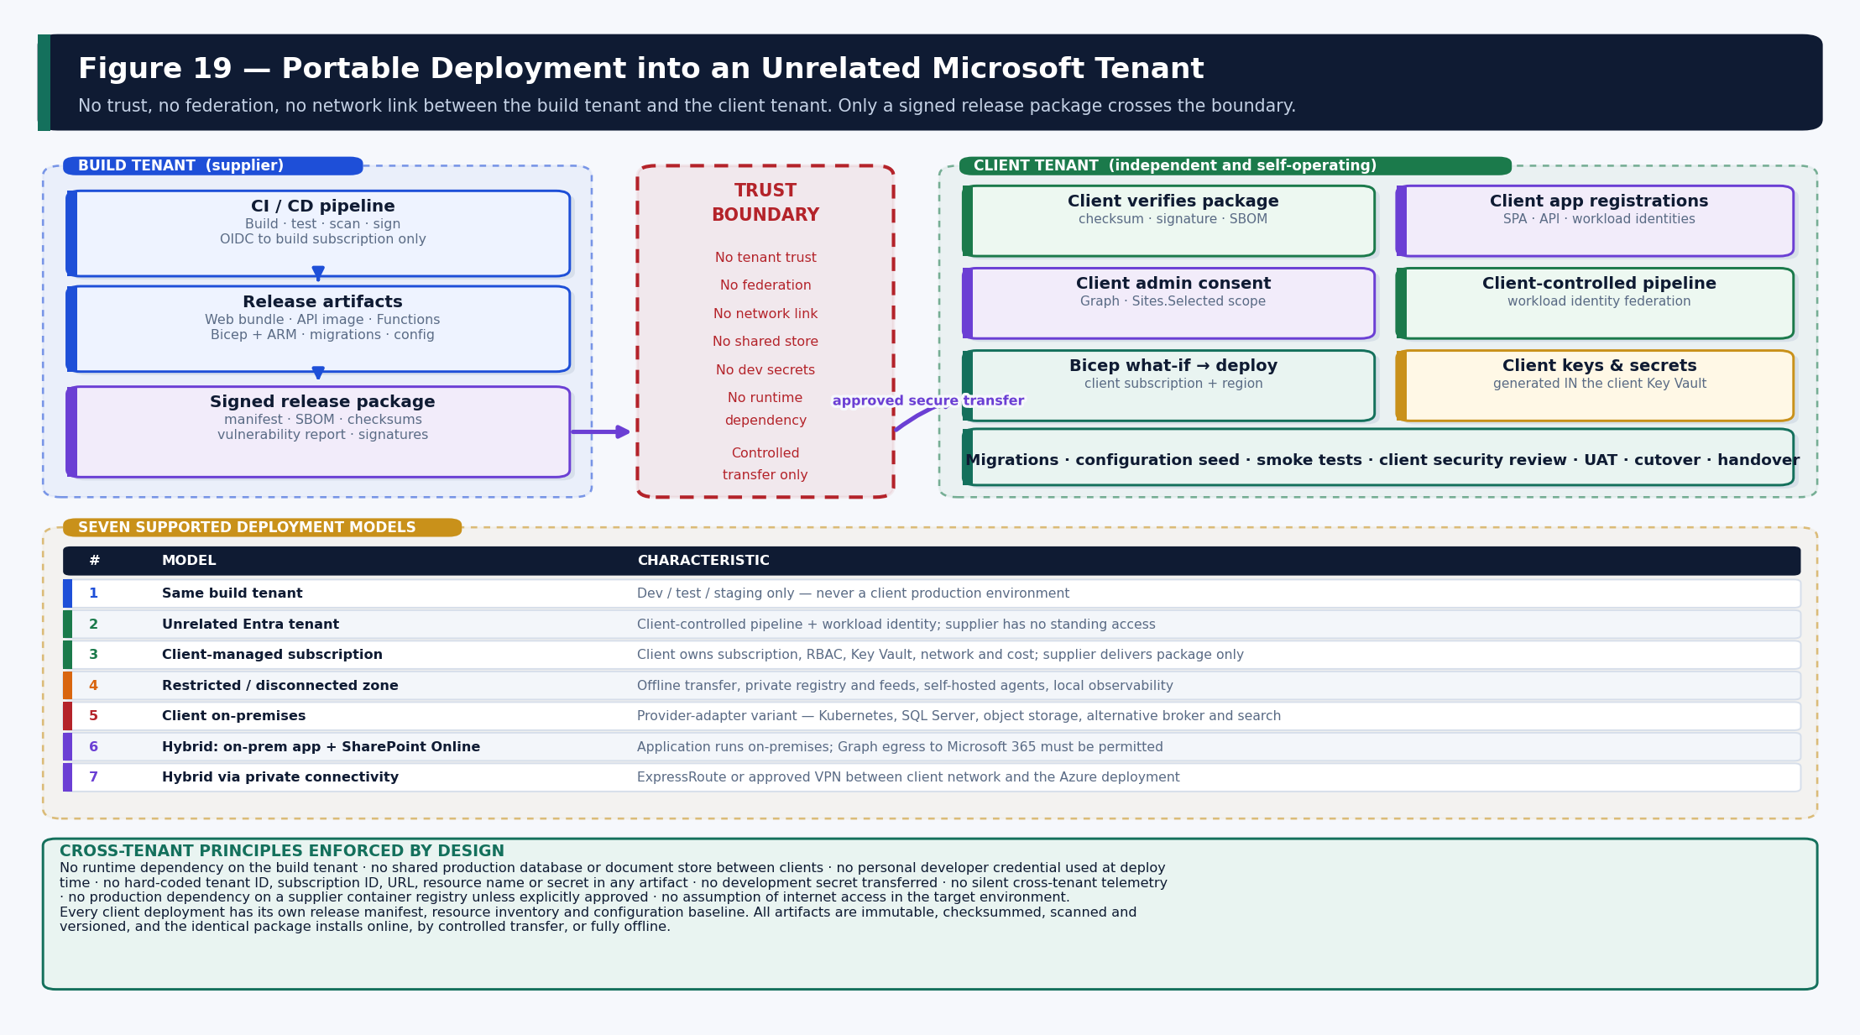
Figure 19 — The trust boundary, what crosses it, and the seven supported deployment models.

20.1 Cross-Tenant Principles
- No runtime dependency on the build tenant — the installed system operates entirely independently.
- No shared production database and no shared document storage between clients.
- No personal developer credential is used at deployment time.
- No hard-coded tenant identifier, subscription identifier, URL, resource name or secret exists in any artifact.
- No development secret is transferred to a client environment under any circumstance.
- No silent cross-tenant telemetry or log export; diagnostics remain in the client environment unless explicitly shared.
- No production dependency on a supplier container registry unless the client explicitly approves it.
- No assumption of internet access in the target environment.
- All client configuration is externalised into parameter files and configuration sets.
- Client-specific application registrations, service identities, certificates and keys are created inside the client environment.
- Every client deployment has its own release manifest, resource inventory and configuration baseline.
- All release artifacts are immutable, checksummed, scanned, signed and versioned.
- The identical approved package installs online, by controlled transfer, or fully offline.

20.2 Release Package Contents
docaya-release-v1.3/
├─ manifest/ release-manifest.json · bill-of-materials.json
│ checksums.sha256 · compatibility-matrix.json
├─ web/ docaya-web-v1.3.zip
├─ api/ container-image-reference.txt · docaya-api-v1.3.tar
├─ functions/ docaya-functions-v1.3.zip
├─ contracts/ openapi.json · events/
├─ infrastructure/ bicep/ · arm-json/ · parameters/
├─ database/ migrations/ · seed/ · rollback/
├─ configuration/ document-types/ · workflows/ · calendars/
│ taxonomies/ · notifications/ · feature-flags/
├─ images/ container-images/ (offline transfer)
├─ scripts/ prereq-check/ · install/ · configure/ · validate/
│ upgrade/ · rollback/ · uninstall/
├─ security/ sbom/ · vulnerability-reports/ · signatures/
│ security-baseline/
├─ tests/ smoke/ · connectivity/ · acceptance/
└─ documentation/ installation · configuration · operations
security · troubleshooting

Concern | How it is handled
Artifact production | Built once by the release pipeline; never produced by hand and never rebuilt at the client site.
Versioning | Semantic version applied uniformly; every artifact carries the same release version and is listed in the manifest.
Container export | docker save produces a .tar for offline transfer; the client imports it into their own registry and deploys by digest.
Checksums and signatures | SHA-256 for every artifact plus a detached signature; both are verified inside the target environment before installation.
SBOM | Generated per package and shipped in security/sbom so the client can assess supply-chain risk independently.
Scan results | Container, dependency and IaC scan reports are included so the client's security review has evidence rather than assertion.
Client parameters | Kept strictly separate from product artifacts in infrastructure/parameters and configuration/.
Sensitive values | Never in the package. Created inside the client environment and stored in the client's own Key Vault.
Transfer | Through the client's approved secure-transfer process; the package is opaque and self-verifying.
Evidence | Installation logs, verification output and the completed manifest are retained by the client as deployment evidence.

20.3 Installation Runbook — unrelated Microsoft tenant
# | Step | Owner | Evidence produced
1 | Complete the client prerequisite questionnaire (tenant, subscription, region, licensing, network, identity). | Client + supplier | Signed prerequisite record
2 | Assess target-tenant readiness: licences, quotas, policy constraints, region availability. | Client IT | Readiness assessment
3 | Select subscription and approved UAE region; create resource groups. | Client IT | Resource group inventory
4 | Register required Azure resource providers. | Client IT | Provider registration output
5 | Create the SPA application registration with redirect URIs. | Client IT | Application (client) ID
6 | Create the API application registration, expose scopes and define app roles. | Client IT | Scope and role definitions
7 | Create workload identities for API, promotion, indexing, workflow, analytics and migration. | Client IT | Identity inventory
8 | Grant Microsoft Graph Sites.Selected to the promotion application. | Client IT | Permission grant record
9 | Provision Docaya SharePoint sites and libraries; grant the application write on each approved site. | Client IT | Site and scope list
10 | Client administrator grants admin consent inside the client tenant. | Client admin | Consent record
11 | Assign Azure RBAC and data-plane roles per identity. | Client IT | Role assignment export
12 | Prepare the Bicep parameter file for the environment. | Client IT + supplier | Parameter file (no secrets)
13 | Run Bicep build and what-if; review and approve the change set. | Client IT | Approved what-if output
14 | Deploy infrastructure in the order defined in Section 18.3. | Client pipeline | Deployment log
15 | Apply database migrations; verify rollback availability. | Client pipeline | Migration log
16 | Seed configuration: document types, routes, stages, calendars, taxonomies, templates. | Client + supplier | Configuration baseline
17 | Deploy web, API and Functions artifacts by immutable version. | Client pipeline | Deployment manifest
18 | Import the API contract and policies into API Management; configure Front Door and WAF. | Client pipeline | Gateway configuration
19 | Configure UAE PASS federation where applicable. | Client IT | Federation test result
20 | Create the search index and configure the embedding deployment. | Client pipeline | Index schema confirmation
21 | Configure Power BI workspace, capacity and row-level security. | Client IT | Report access test
22 | Run end-to-end validation: sign-in, capture, classify, review, return, publish, search, answer, report, audit. | Supplier + client | Smoke test evidence
23 | Client security review and penetration test. | Client security | Findings and closure record
24 | User acceptance testing against the agreed criteria. | Client business | UAT sign-off
25 | Production cutover. | Client | Cutover record
26 | Operational handover: runbooks, dashboards, alerts, support model. | Supplier → client | Handover pack
27 | Remove all temporary deployment access and evidence its removal. | Client IT | Access removal evidence

20.4 Supplier-Assisted Deployment Controls
The preferred model is a client-controlled pipeline using workload identity federation, with the supplier holding no standing access. Where a client requires supplier assistance, the following controls are mandatory.
- Access is time-limited with automatic expiry, granted through Privileged Identity Management and never standing.
- A dedicated deployment account is used; personal developer credentials are never used against a client environment.
- Separation of duties: the person requesting elevation is not the person approving it.
- The session is recorded or, at minimum, all activity is logged to the client's own Log Analytics workspace.
- An approval workflow with a recorded business justification precedes elevation.
- Access is removed immediately after deployment and the removal is evidenced in the handover pack.

21. Offline and Restricted-Zone Deployment
This section covers installation where the production environment cannot reach the build tenant, GitHub, public container registries, npm or NuGet, Microsoft-hosted build agents, or public telemetry endpoints.

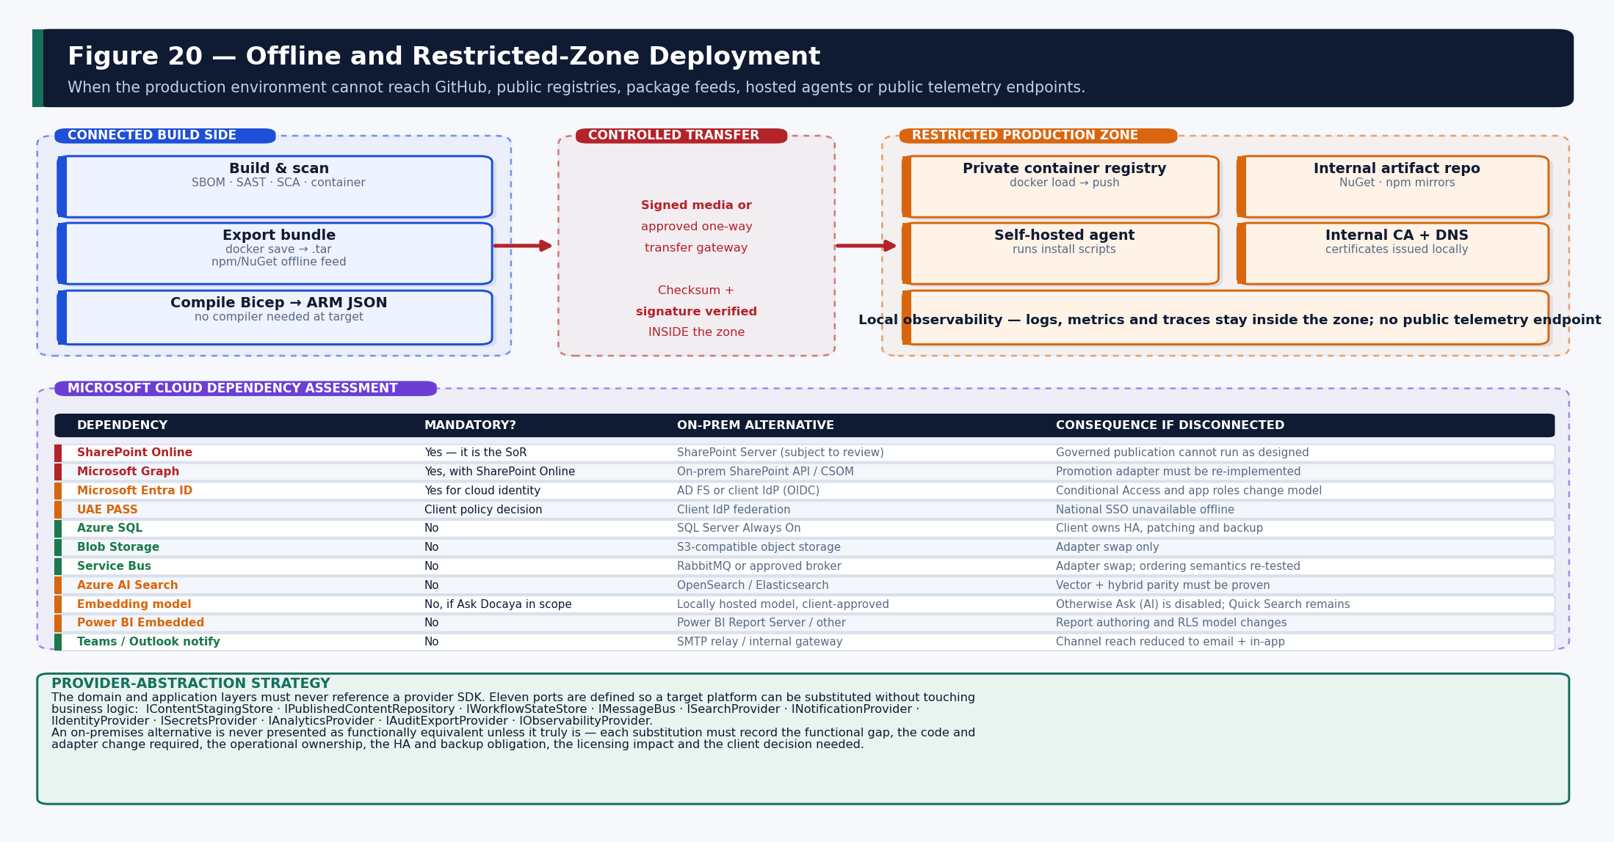
Figure 20 — Offline transfer, restricted-zone components and the Microsoft cloud dependency assessment.

21.1 Offline Installation Mechanics
Concern | Mechanism
Container images | Exported with docker save to a .tar in the release package; imported with docker load and pushed to the client's private registry; deployed by digest.
Package feeds | Offline NuGet and npm feeds are produced at build time; the target uses an internal artifact repository rather than a public registry.
Template compilation | Bicep is compiled to ARM JSON before transfer so no Bicep CLI or compiler is required inside the zone.
Pipeline execution | Self-hosted or local agents run the signed installation scripts; no Microsoft-hosted agent is required.
Script integrity | All deployment scripts are signed; signatures are verified inside the zone before execution.
Scanning | Vulnerability and malware scanning is performed against the package inside the zone using the client's own tooling before installation.
Certificates and keys | Generated inside the secure zone by the client's certificate authority; private keys never leave it.
DNS and certificates | Internal DNS resolution and an internal CA-issued certificate chain are prerequisites recorded in the questionnaire.
Observability | Logs, metrics and traces are collected to a locally hosted stack; no public telemetry endpoint is contacted.
Patching and upgrade | Each patch is a new signed package transferred by the same controlled route; the upgrade script is idempotent.
Rollback | Rollback re-points to the previously imported image digest and bundle already present in the zone; no external connectivity is required.
Support diagnostics | A diagnostic bundle is generated that contains telemetry and configuration but no document content or personal data, and is released only under client approval.

21.2 Microsoft Cloud Dependency Assessment
Some capability cannot operate in a fully disconnected environment. Each dependency is assessed honestly rather than assumed to be replaceable.
Dependency | Mandatory? | On-premises alternative | Functional limitation if disconnected | Decision required
SharePoint Online | Yes — it is the published system of record | SharePoint Server, subject to technical review | Governed publication cannot run as designed; the promotion adapter must be re-implemented and re-certified | Client architecture decision
Microsoft Graph | Yes, where SharePoint Online is used | On-premises SharePoint API / CSOM | Promotion, versioning and column write-back all change shape | Client architecture decision
Microsoft Entra ID | Yes for the cloud identity model | AD FS or a client OIDC provider | Conditional Access, app roles and step-up must be re-expressed in the client IdP | Client security decision
UAE PASS | Client policy decision | Client identity provider federation | National single sign-on is unavailable in a disconnected zone | Client business decision
Azure SQL | No | SQL Server Always On availability group | Client assumes HA, patching, backup and DR ownership | Operational decision
Blob Storage | No | S3-compatible object storage | Adapter substitution only; lifecycle rules must be re-implemented | Low impact
Service Bus | No | RabbitMQ or a client-approved broker | Ordering, dead-letter and retry semantics must be re-tested | Medium impact
Azure AI Search | No | OpenSearch or Elasticsearch | Hybrid and vector parity, Arabic analysis and cross-language retrieval must be proven before Ask Docaya is in scope | Client + architecture
Embedding / answering model | Only if Ask (AI) is in scope | Locally hosted, client-approved model | Otherwise Ask (AI) is disabled and Quick Search and Browse remain fully functional | Client decision (A8)
Power BI Embedded | No | Power BI Report Server or another approved platform | Row-level security must be reproduced exactly or reporting is limited to the in-application standard report library | Client decision (A6)
Teams / Outlook notification | No | SMTP relay or internal notification gateway | Channel reach reduces to in-app and email | Low impact
Defender / Purview | No | Client endpoint protection and DLP tooling | Malware and DLP gates must be re-implemented against client tooling with equivalent assurance | Security decision

22. On-Premises Deployment Architecture
The on-premises variant is a distinct architecture, not a configuration switch. It is made possible by the provider-abstraction strategy: the Domain and Application layers reference no provider SDK, so a target platform is substituted by replacing the Infrastructure adapter behind a port.

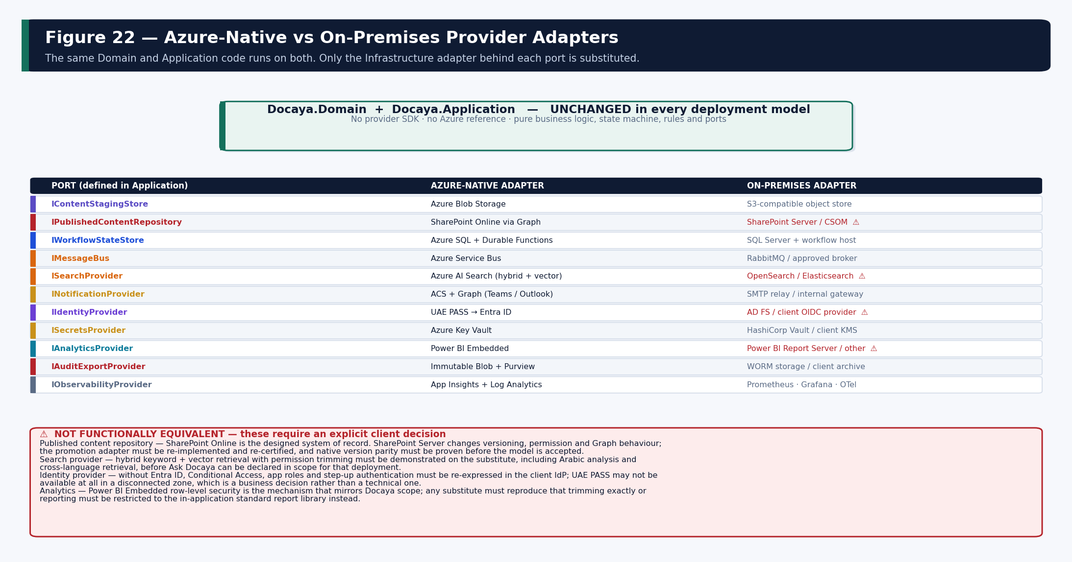
Figure 22 — Ports, Azure-native adapters and on-premises adapters, with the four substitutions that are not equivalent.

22.1 Provider-Abstraction Ports
Port | Responsibility | Azure-native | On-premises
IContentStagingStore | Hold the unchanged original until approval | Azure Blob Storage | S3-compatible object storage
IPublishedContentRepository | Publish and version the approved file | SharePoint Online via Graph | SharePoint Server / CSOM (not equivalent)
IWorkflowStateStore | Persist orchestration and stage state | Azure SQL + Durable Functions | SQL Server + workflow host
IMessageBus | Domain event transport | Azure Service Bus | RabbitMQ or client-approved broker
ISearchProvider | Index and retrieve approved content | Azure AI Search | OpenSearch / Elasticsearch (not equivalent)
INotificationProvider | Multi-channel delivery | ACS + Graph (Teams, Outlook) | SMTP relay / internal gateway
IIdentityProvider | Authenticate and issue claims | UAE PASS → Entra ID | AD FS / client OIDC (not equivalent)
ISecretsProvider | Store and retrieve secrets | Azure Key Vault | HashiCorp Vault / client KMS
IAnalyticsProvider | Permission-trimmed reporting | Power BI Embedded | Report Server / other (not equivalent)
IAuditExportProvider | Immutable evidence export | Immutable Blob + Purview | WORM storage / client archive
IObservabilityProvider | Telemetry collection | App Insights + Log Analytics | Prometheus, Grafana, OpenTelemetry Collector

22.2 What Changes and Who Owns It
Dimension | Azure-native | On-premises
Code change | None beyond configuration. | New adapter implementations for the substituted ports; Domain and Application unchanged.
Deployment | Bicep to Azure; managed PaaS. | Kubernetes or OpenShift manifests or Helm charts; container hosts sized and patched by the client.
High availability | Zone redundancy provided by the platform. | Client designs and operates HA: SQL Always On, broker clustering, storage replication, ingress redundancy.
Patching | Microsoft patches the platform. | Client patches operating systems, runtimes, databases, brokers, search nodes and the container platform.
Backup and recovery | Point-in-time restore and geo-redundancy configured in template. | Client owns backup tooling, schedules, offsite copies and restore rehearsal.
Identity | Entra ID with Conditional Access and app roles. | Client IdP; Conditional Access equivalents must be re-expressed and re-tested.
Search and AI | Azure AI Search plus an in-region model endpoint. | Substitute search platform; a locally hosted model is required if Ask (AI) is in scope.
Observability | App Insights and Log Analytics. | Client-hosted Prometheus, Grafana and an OpenTelemetry collector.
Licensing | Consumption-based Azure charges. | Client licences for database, container platform, search, reporting and any commercial broker.
Operational ownership | Shared — Microsoft operates the platform. | Almost entirely client-owned; the supplier delivers software, not a service.

Honest limitation statement Four substitutions are not functionally equivalent and must be treated as explicit client decisions rather than implementation detail: the published content repository, the search provider, the identity provider and the analytics provider. Each requires its functional gap, code and adapter change, operational ownership, HA and backup obligation, licensing impact and re-certification effort to be recorded and approved before the model is accepted.

23. Installation Modes and Compatibility Matrix
Legend: ● Fully supported ◐ Supported with configuration ◑ Supported with an adapter ○ Partially supported ✕ Not supported ? Requires client decision
Capability | Azure native | Other M365 tenant | Client Azure sub. | Hybrid Azure + on-prem | On-prem Kubernetes | Restricted zone | Fully disconnected
UAE PASS single sign-on | ● | ● | ● | ◐ | ? | ? | ✕
Entra ID SSO and app roles | ● | ● | ● | ● | ◑ | ◐ | ✕
SharePoint Online as SoR | ● | ● | ● | ● | ✕ | ◐ | ✕
SharePoint Server as SoR | ✕ | ✕ | ✕ | ◑ | ◑ | ◑ | ◑
Governed publication pipeline | ● | ● | ● | ● | ◑ | ● | ◑
Blob staging | ● | ● | ● | ● | ◑ | ● | ◑
Object-storage staging | ◑ | ◑ | ◑ | ● | ● | ● | ●
Azure SQL registry | ● | ● | ● | ● | ✕ | ● | ✕
SQL Server registry | ◑ | ◑ | ◑ | ● | ● | ● | ●
Service Bus messaging | ● | ● | ● | ● | ✕ | ● | ✕
Alternative message broker | ◑ | ◑ | ◑ | ● | ● | ● | ●
Azure AI Search (hybrid + vector) | ● | ● | ● | ● | ✕ | ● | ✕
Alternative search provider | ◑ | ◑ | ◑ | ◑ | ◑ | ◑ | ◑
Ask Docaya — Quick Search & Browse | ● | ● | ● | ● | ◑ | ● | ◑
Ask Docaya — AI answering | ● | ● | ● | ● | ? | ◐ | ?
Power BI Embedded analytics | ● | ● | ● | ● | ✕ | ◐ | ✕
On-premises reporting | ◑ | ◑ | ◑ | ◑ | ● | ● | ●
Teams / Outlook notification | ● | ● | ● | ● | ✕ | ◐ | ✕
Email notification | ● | ● | ● | ● | ● | ● | ●
Real-time in-app notification | ● | ● | ● | ● | ◑ | ● | ◑
Microsoft Purview labelling | ● | ● | ● | ◐ | ✕ | ◐ | ✕
Malware and DLP gate | ● | ● | ● | ◐ | ◑ | ◑ | ◑
Centralised monitoring | ● | ● | ● | ◐ | ◑ | ◑ | ◑
Disaster recovery | ● | ● | ● | ◐ | ◑ | ◑ | ◑
Hash-chained audit | ● | ● | ● | ● | ● | ● | ●
Retention and legal hold | ● | ● | ● | ● | ◑ | ● | ◑

24. API and Event Architecture

24.1 API Standards
Standard | Rule
Style | Contract-first REST over HTTPS, described in OpenAPI 3.1 and published from src/contracts before implementation.
Versioning | URI major version under /api/v1. Additive change only within a version; a breaking change requires a new major version and an overlap period.
Authentication | OAuth 2.0 bearer token issued by Entra; validated at API Management and again at the API.
Authorization | Policy applied before any store is touched; deny by default; the decision is logged with the policy version.
Idempotency | Every write accepts or derives an idempotency key; a duplicate request returns the original result rather than repeating the effect.
Correlation | W3C trace context; the correlation ID flows from the browser through the API, the queue, the worker and into the audit record.
Pagination | Cursor-based with deterministic ordering; total counts are not returned where they would leak corpus size.
Errors | A single problem-detail envelope with a machine-readable code, message, field-level validation detail and the correlation ID. No internal detail is exposed.
Rate limiting | Per product, per key and per user at API Management, with separate limits for upload and for Ask Docaya.

24.2 Representative Endpoints
Method | Path | Purpose | Authorization
POST | /api/v1/documents | Create the registry row and open an upload session. | Editor role + department scope
POST | /api/v1/documents/{id}/chunks | Upload a chunk of the single file (max 100 MB total). | Owner of the draft
PATCH | /api/v1/documents/{id}/registration | Set user-entered registration fields. | Owner of the draft
PUT | /api/v1/documents/{id}/classification | Set class, sensitivity, department, Standard, tags, scope and route. | Owner of the draft
POST | /api/v1/documents/{id}/submit | Validate, resolve the route and start the SLA. | Owner of the draft
POST | /api/v1/reviews/{stageId}/decision | Approve or return with a mandatory comment and correction point. | Assigned principal of the ACTIVE stage only
POST | /api/v1/requests/{id}/extension | Record an authorised target extension with reason. | Assurance or Authoriser
POST | /api/v1/documents/{id}/revisions | Submit a New Revision against the approved version. | Editor + read on the approved version
GET | /api/v1/documents/{id}/timeline | Unified decision, comment, SLA and version history. | Read on the document
GET | /api/v1/documents/{id}/versions/{v}/thumbnail | Permission-checked thumbnail for a specific version. | Read on that version
POST | /api/v1/search | Permission-trimmed Quick Search and Browse. | Authenticated + trimmed
POST | /api/v1/ask | Ask Docaya cited answer over approved content only. | Authenticated + trimmed
GET | /api/v1/analytics/embed | Power BI embed configuration with effective identity. | Report consumer role
GET | /api/v1/admin/routes | Read the configured review chains. | Administrator

24.3 Domain Event Catalogue
Event | Raised when | Consumers | Delivery
DocumentRegistered | Tracking number issued and registry row created. | Audit, notification | At-least-once, idempotent
DocumentSubmitted | Editor submits; route and SLA resolved. | Workflow, SLA, notification | At-least-once
ReviewDecisionRecorded | Any stage approves or returns. | Workflow, audit, analytics | At-least-once
SlaRiskChanged | At-risk or overdue state changes. | Notification, analytics | At-least-once
SlaExtensionGranted | An authorised extension is recorded. | Notification, analytics, audit | At-least-once
FinalApprovalGranted | The configured final stage approves. | Promotion worker (single consumer) | Exactly-once effect via ledger
DocumentPublished | Native file promoted and write-back complete. | Cleanup, indexing, notification, analytics | At-least-once
DocumentIndexed | Document Index Record built for a version. | Ask Docaya readiness, audit, analytics | At-least-once
RevisionApproved | A new revision passes final approval. | Promotion, thumbnail, index refresh, notification | At-least-once
AccessPolicyChanged | Policy version published or attributes changed. | Index (aclKeys refresh), cache invalidation | At-least-once
RetentionActionDue | Disposition becomes due and no hold applies. | Records, notification | At-least-once

24.4 Messaging Reliability
- Transactional outbox. State change and event commit in one SQL transaction; dispatch happens afterwards, so an event can never describe a state that did not persist.
- At-least-once with idempotent consumers. Every consumer is safe to re-run; effects are keyed so redelivery produces one result.
- Ordering. Where order matters — stage transitions for one document — messages are session-enabled on the document identifier.
- Retry. Exponential backoff with jitter and a bounded attempt count, then dead-letter.
- Dead-letter. Monitored with an alert on queue age and depth; replay is an audited operator action, never automatic and silent.
- Replay. Events can be replayed to rebuild derived state — the index and reporting model are designed to tolerate this.

25. Notification, Analytics and Audit
These three modules share one characteristic: they all read from the same Azure SQL registry the application writes. There is no separate analytics pipeline, no duplicated notification store and no parallel audit database to keep in step.

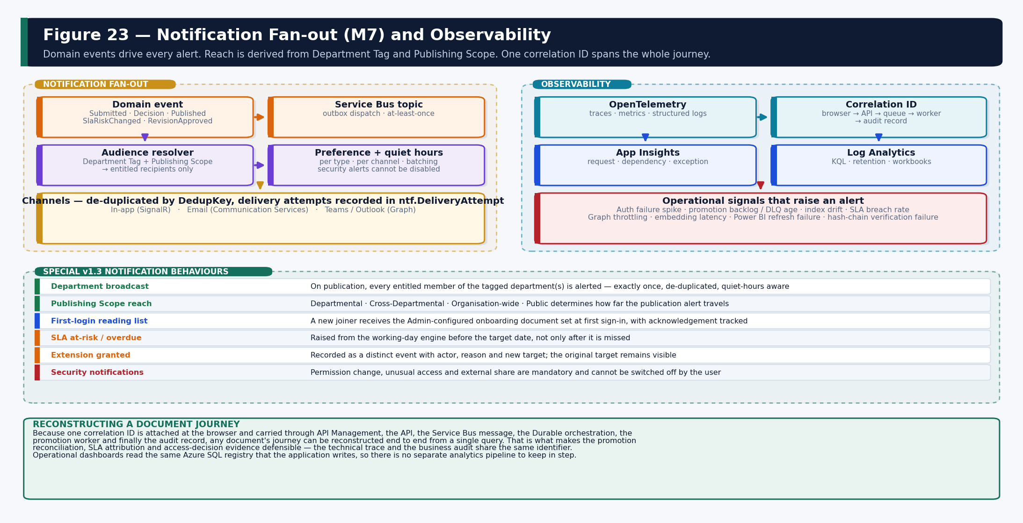
Figure 23 — Notification fan-out, observability and the v1.3 notification behaviours.

25.1 Notification Architecture (M7)
Category | Examples | Default channels | Disable?
Workflow | Approval requested, approved, returned, escalation. | In-app, email, Teams | Yes
Registration | Document registered, submitted, returned for changes. | In-app, email | Yes
Publication | Promoted to SharePoint; new version available. | In-app, email | Yes
Department broadcast | A departmental document has been published. | In-app, email, Teams | Yes
Onboarding | First-login reading list with acknowledgement tracking. | In-app, email | No
Change request / SLA | At-risk warning, overdue flag, extension granted. | In-app, email, Teams | Yes
Expiry / lifecycle | T-30, T-7 and T-1 reminders; retention due. | In-app, email | Yes
Security | Permission change, unusual access, external share. | In-app, email, push | No — mandatory
System | Storage, maintenance, upload-processing status. | In-app, email | Yes

25.1.1 v1.3-specific behaviours
- Department broadcast reach. On publication, the audience resolver derives recipients from the Department Tag and the Document Publishing Scope. Departmental, Cross-Departmental, Organisation-wide and Public each produce a different reach, and every entitled recipient receives exactly one alert.
- De-duplication. A dedup key prevents a user who is entitled through two tags from receiving two notifications for the same event.
- Quiet hours and batching. Per-user quiet hours and smart batching prevent alert fatigue; security notifications ignore both.
- First-login reading list. A new joiner receives the Admin-configured onboarding document set at first sign-in; acknowledgement is tracked and reportable.
- Evidence. The resolved audience and delivery attempts are retained so it can be shown who was notified, when and through which channel.

25.2 Analytics Architecture (M15)
Aspect | Design
Delivery | Power BI Embedded rendered inside Docaya, so end users need no separate Power BI licence or sign-in.
Model | A semantic model over rpt.* views on the same Azure SQL registry the application writes — no separate analytics pipeline and no data duplication.
Security | Row-level security mirrors the Docaya RBAC and ABAC scope, so a dashboard shows exactly what the viewer could see in the application.
Refresh | Operational dashboards use near-real-time querying; trend and historical dashboards refresh on a schedule.
Report set | Volume and classification, sensitivity distribution, most-accessed, stale content, ownership, pending approvals, cycle time, SLA compliance, change-request performance, stage bottleneck, document control, retention and disposition, legal hold, access anomalies and audit export.
Export | PDF, XLSX and CSV with permission-aware scheduled subscriptions; exports are audited.
Bypass prevention | End users are not granted direct dataset access; the embed token carries the effective identity and RLS is applied server-side.

25.3 Audit and Compliance (M16)
- Coverage. Register, classify, submit, decide, return, extend, promote, publish, view, download, search, ask, permission change, configuration change and disposition.
- Attribution. Actor (the real user), executor (the system identity), action, object, tracking number, timestamp, correlation ID, source and outcome.
- Tamper evidence. Hash chain with periodic checkpoints; verification is a scheduled job and can be run on demand; alteration breaks the chain visibly.
- Document timeline. The audit surfaces as a single chronological record per document combining decisions, comments, amendments, extensions and the resulting SharePoint versions.
- Export. Per document, per user or per date range for regulator or internal audit, with the policy version in force at each decision included.
- Standards alignment. Designed for UAE Information Assurance standards, the Federal Data Protection Law, ISO 27001 controls and records-management practice.

26. Implementation Plan
Implementation is divided into eight proof-of-concept workstreams that gate the riskiest modules, followed by seventeen build phases running from repository creation to operational handover. A phase does not start until its prerequisites and, where applicable, its POC decision are recorded.

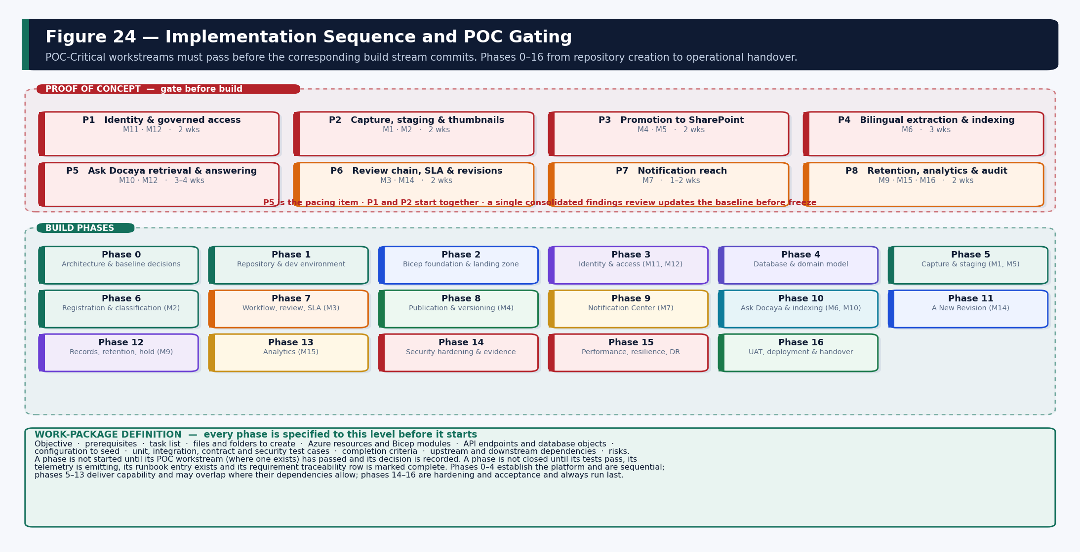
Figure 24 — POC gating and the seventeen build phases from repository creation to operational handover.

26.1 Work-Package Definition
No phase begins until it is specified to the level below, and no phase closes until every element is evidenced.
Element | Requirement
Objective | A single sentence stating the capability the phase delivers and the requirement it satisfies.
Prerequisites | Upstream phases complete and, where applicable, the POC workstream passed with its decision recorded.
Tasks | An ordered task list at a granularity a developer can pick up without further decomposition.
Files and folders | The exact projects, folders and files to be created or changed, consistent with Section 17.
Azure resources | The Bicep modules involved and any new resource, role assignment or policy.
APIs and database objects | Endpoints, events, schemas, tables, indexes and migrations introduced.
Configuration | Reference data, routes, calendars, taxonomies or templates that must be seeded.
Test cases | Unit, integration, contract, security and — where relevant — accessibility and performance cases, including negative paths.
Completion criteria | Tests green, telemetry emitting, runbook entry written, traceability row marked complete.
Dependencies and risks | Upstream and downstream dependencies plus the specific risks this phase carries.

26.2 Proof of Concept — gate before build
Ref | Workstream | Modules | Question it answers | Duration
P1 | Identity and governed access | M11, M12 | Can UAE PASS federate with MFA and Conditional Access, and can one governed service identity hold least-privilege write across the estate? | 2 weeks
P2 | Capture, staging and thumbnails | M1, M2 | Does resumable chunked upload of a single 100 MB file work reliably, and can a usable thumbnail be produced for every supported format? | 2 weeks
P3 | Promotion to SharePoint | M4, M5 | Can the approved file move from staging into the correct library, unchanged, exactly once, with reliable write-back? | 2 weeks
P4 | Bilingual extraction and indexing | M6 | Is extracted Arabic and English text good enough to answer from, and how fresh is the index after publication? | 3 weeks
P5 | Ask Docaya retrieval and answering | M10, M12 | Does hybrid retrieval find the right document, and does the answer stay grounded, cited and trimmed? | 3–4 weeks
P6 | Review chain, SLA and revisions | M3, M14 | Does the working-day engine compute correctly against the UAE calendar, and does a revision behave safely? | 2 weeks
P7 | Notification reach | M7 | Can a department broadcast and a first-login reading list be delivered without alert fatigue? | 1–2 weeks
P8 | Retention, analytics and audit | M9, M15, M16 | Can retention, hold and residency be enforced, and does reporting honour the same scope? | 2 weeks

POC gate Build of a POC-Critical module does not start until its workstream has passed and its decision is recorded. P1 and P2 start together; P5 is the pacing item. A single consolidated findings review updates this baseline before it is frozen. Where a threshold is not met, the recorded fallback is adopted and the design is amended before build rather than during it.

26.3 Build Phases
Phase | Scope | Key outputs | Depends on
0 | Architecture and baseline decisions | This document endorsed; open decisions A1–A10 owned and scheduled. | —
1 | Repository and development environment | Mono-repo, five packages, workspace, PR pipeline, Copilot instructions. | 0
2 | Bicep foundation and landing zone | Network, identity, Key Vault, observability, policy; what-if reviewed. | 1
3 | Identity and access (M11, M12) | App registrations, token validation, RBAC and ABAC engine, decision log. | 2, P1
4 | Database and domain model | All schemas migrated; domain entities and state machine; audit chain. | 2
5 | Capture and staging (M1, M5) | Upload session, chunking, hash, scan gate, tracking number, thumbnail. | 4, P2
6 | Registration and classification (M2) | Schema-validated metadata, Department Tag, Publishing Scope, Standard. | 5
7 | Workflow, review and SLA (M3) | Route definitions, stage execution, thread, working-day engine, extensions. | 4, P6
8 | Publication and versioning (M4) | Graph adapter, promotion ledger, hash verification, write-back, replay. | 7, P3
9 | Notification Center (M7) | Audience resolver, preferences, channels, broadcast, reading list. | 8, P7
10 | Ask Docaya and indexing (M6, M10) | Extraction, index build, embeddings, hybrid retrieval, cited answering. | 8, P4, P5
11 | A New Revision (M14) | Revision workflow, comparison, next version, fresh thumbnail, index refresh. | 8, 10
12 | Records, retention and legal hold (M9) | Schedules, disposition, hold override, defensible deletion. | 8, P8
13 | Analytics (M15) | Reporting views, semantic model, RLS, embedded dashboards, exports. | 12
14 | Security hardening and compliance evidence | Penetration test, threat-model closure, evidence pack, policy assignment. | 10–13
15 | Performance, resilience and disaster recovery | Load and soak tests, failure injection, restore and index-rebuild rehearsal. | 14
16 | UAT, deployment and operational handover | UAT sign-off, release package, client installation, runbooks, handover. | 15

27. Testing Architecture
Layer | Required coverage | Gate
Unit | Domain state machine and illegal transitions; working-day SLA arithmetic across weekends and holidays; routing resolution; idempotency; hash-chain construction; RBAC and ABAC truth tables including deny-overrides. | PR — blocking
Integration | SQL repositories and transaction boundaries; Blob chunked upload and resume; Graph upload session and write-back; index publication and reconcile; Service Bus send, receive and dead-letter; Power BI embed token.
Contract | OpenAPI backward compatibility; event schema compatibility; generated-client regeneration produces no diff. | PR — blocking
End-to-end | Capture → register → classify → submit → review → return → resubmit → approve → publish → index → search → ask. Submit a New Revision through to the next version with a fresh thumbnail and refreshed index. | Release — blocking
Retrieval quality | Bilingual extraction accuracy against a manually verified sample; top-1 and top-5 accuracy against a labelled question set of at least one hundred real business questions; citation correctness; refusal behaviour; cross-language pairs. | Release — blocking
Security | SSO and step-up; the full role and attribute matrix per persona; service-identity scope; negative retrieval and preview tests against restricted content; malware and DLP gate; injection; penetration test. | Release — blocking
Performance | 100 MB upload under contention; search and answer latency at target corpus size; reviewer queue depth; concurrent users; analytics refresh. | Release
Accessibility | WCAG 2.2 AA automated and manual; keyboard-only journeys; Arabic and RTL rendering of every screen. | Release — blocking
Recovery | Promotion replay after injected failure; dead-letter replay; SQL point-in-time restore; full index rebuild; regional recovery exercise. | Release
Deployment | Bicep what-if correctness; post-deploy private-endpoint and DNS assertion; rollback rehearsal; offline package installation dry run. | Release — blocking

27.1 UAT Exit Criteria
- Every Must requirement passes with recorded evidence traceable to Section 4.
- No open Severity-1 or Severity-2 defect; lower-severity defects have an agreed disposition.
- No unapproved document appears in SharePoint, in live search, in an Ask Docaya answer, or as a thumbnail.
- Staged and published hashes match for every document in the acceptance set.
- Role and attribute tests pass for every persona, including trimming applied to answers, result rows and previews.
- SLA dates, stage durations, extensions and analytics reconcile exactly to the test data.
- Every answer in the acceptance question set is grounded and cited to an approved version.
- Arabic and English critical journeys pass, including cross-language retrieval returning the same source document.
- All POC-Critical workstreams have passed and their decisions are recorded in this document.

28. Observability and Operational Support

28.1 Telemetry and Correlation
The platform is instrumented with OpenTelemetry. A single correlation ID is attached at the browser and carried through API Management, the API, the Service Bus message, the Durable orchestration, the promotion worker and into the audit record, so a document's journey can be reconstructed end to end from one identifier.

28.2 Alert Definitions
Signal | Condition | First response
Authentication failures | Sustained 401 or 403 rate above baseline, or issuer mismatch. | Validate federation, token audience and Conditional Access policy.
Authorization denials | Unusual spike in denials for one principal or one document. | Investigate for policy misconfiguration or probing.
Promotion backlog | Queue age or dead-letter depth beyond threshold. | Inspect Graph throttling; replay via idempotent retry.
Hash mismatch | Any published-versus-staged hash mismatch. | Treat as a security incident; the item is quarantined, not published.
Index drift | Reconcile reports records present in one store and not the other. | Repair targeted records; investigate root cause before full rebuild.
Ask Docaya latency | p95 answer time beyond target, or embedding endpoint throttling. | Backoff, inspect quota, degrade to Quick Search if sustained.
SLA breach rate | Overdue proportion above the agreed operational threshold. | Escalate to PMO; the bottleneck report identifies the stage.
Expiry job failure | Missed scheduled run or a delivery spike. | Run the recovery job; confirm owner notification was delivered.
Audit chain | Verification job reports a broken link. | Immediate security incident; preserve state and escalate.
Power BI refresh | Refresh failure or RLS mismatch detected. | Suspend affected report; investigate model and role mapping.

28.3 Runbooks and Support Model
Runbook | Covers
Sign-in and access | Federation failure, token audience mismatch, Conditional Access block, step-up loop, offboarding revocation.
Capture and staging | Stalled upload session, failed scan, orphaned staged file, abandoned draft cleanup.
Review and SLA | Stuck stage, delegation, calendar amendment, extension correction, bottleneck investigation.
Promotion | Failed promotion replay, hash mismatch quarantine, Graph throttling, permission drift reconciliation.
Search and answering | Index drift repair, partial and full rebuild, model upgrade re-embedding, latency degradation.
Notification | Delivery failure, duplicate suppression, broadcast reach verification, reading-list reissue.
Records | Retention execution, legal hold application and release, defensible disposition with approval.
Audit | Chain verification, evidence export, checkpoint creation, tamper investigation.
Release | Deploy, smoke validation, progressive shift, rollback, drift detection.
Recovery | SQL restore, index rebuild, dead-letter replay, regional recovery, decommissioning.

28.4 Non-Functional Targets
Attribute | Target | Verification
Availability | 99.9% baseline, improved by zone redundancy and health-based routing. | Synthetic monitoring; monthly SLO report.
Page load | p95 under 1.5 seconds at agreed load. | Browser telemetry and load tests.
Search latency | p95 under 400 ms at agreed index size and permission-filter complexity. | Permission-trimmed query tests.
Answer latency | p95 under 3 seconds to first answer. | Labelled question-set timing.
Maximum file | 100 MB, one file per registration, resumable and chunked. | Interruption, retry and memory tests.
Recovery | RPO ≤ 5 minutes · RTO ≤ 1 hour for the approved topology. | Restore and regional recovery exercise.
Accessibility | WCAG 2.2 AA; Arabic and English; full RTL and keyboard access. | Automated and manual audits.
SLA engine | 12 working days Urgent, 30 Normal by default; configurable calendar and warning window. | Calendar arithmetic tests across holidays.
Auditability | 100% of lifecycle, access, configuration and security actions attributable. | Audit reconciliation against test data.
Scalability | Stateless horizontal API scale; queue-based worker scale; final sizing confirmed by test. | Load and soak testing.

29. Risks, Architecture Decisions and Open Questions

29.1 Risk Register
Risk | Impact | Likelihood | Mitigation
Bilingual extraction quality is insufficient on scanned Arabic documents. | Ask (AI) accuracy falls below threshold. | Medium | POC P4 measures against a verified sample; documented fallback is to ship Quick Search and Browse in V1 and defer answering.
Microsoft Graph throttling during bulk publication. | Delayed publishing; backlog. | Medium | Batching, exponential backoff with jitter, queue smoothing, and a promotion backlog alert.
Permission-key drift between SQL and the index. | Potential disclosure of an unauthorised result. | Low | Post-retrieval re-check against SQL; near-real-time aclKeys refresh; nightly reconcile; per-persona negative tests as a release gate.
ABAC policy misconfiguration. | Over- or under-granting of access. | Medium | Policy versioning, simulation with diff before publication, rollback, and decision logging for replay.
Staging growth and cost. | Unnecessary storage spend. | Low | Lifecycle rules, abandoned-draft expiry, and purge-or-retain policy after publication.
Client tenant readiness delays consent or Sites.Selected scoping. | Deployment slippage. | Medium | Prerequisite questionnaire and readiness assessment completed before mobilisation; POC P1 proves the pattern early.
On-premises substitution treated as equivalent. | Functional shortfall discovered late. | Medium | Four non-equivalent substitutions are explicitly flagged and require a recorded client decision before acceptance.
Model upgrade invalidates existing vectors. | Retrieval quality regression. | Low | idx.EmbeddingRun records model name and version; upgrade is a controlled re-embedding, never an in-place mix.
Audit chain break through operational error. | Loss of evidential integrity. | Low | No UPDATE or DELETE grant exists; verification job and checkpoints detect immediately; incident procedure defined.
Scope creep into AI at registration. | Breaks a core v1.3 control. | Medium | Explicitly excluded in this document, in the Copilot instructions and in code review criteria.

29.2 Architecture Decision Records
ID | Decision | Status
ADR-01 | SharePoint Online is the published content system of record; Azure SQL is authoritative for all structured data. | Accepted
ADR-02 | All content follows staging → manual classification → configured final approval → native-file promotion. | Accepted
ADR-03 | User access is governed inside Docaya; SharePoint content operations use a governed service identity. On-behalf-of is not used. | Accepted
ADR-04 | Indexing, embedding and answering apply to approved, published content only, and are always permission-trimmed and cited. | Accepted
ADR-05 | No AI classification, metadata or approver suggestion at loading, registration or classification. | Accepted
ADR-06 | Asynchronous orchestration via Durable Functions and Service Bus with a transactional outbox and idempotent consumers. | Accepted
ADR-07 | Zero-trust: private networking, managed identity, deny-by-default authorization, no secret outside Key Vault. | Accepted
ADR-08 | Five deployable packages in one mono-repository; Durable workflow lives inside the Functions package. | Accepted
ADR-09 | One file per registration, maximum 100 MB; bulk upload is not supported. | Accepted
ADR-10 | A document thumbnail is captured per approved version and treated as document content for permission purposes. | Accepted
ADR-11 | Nine bounded database schemas with least-privilege principals per workload and an append-only audit schema. | Accepted
ADR-12 | Azure AI Search write and query rights are held by different identities; API keys are disabled. | Accepted
ADR-13 | The product is portable: no artifact contains a tenant, subscription, endpoint, resource name or secret. | Accepted
ADR-14 | The Domain layer references no provider SDK, enforced by an architecture test, to enable the on-premises variant. | Accepted
ADR-15 | Deployment is by immutable image digest; floating tags are prohibited outside local development. | Accepted
ADR-16 | POC-Critical modules are gated: build does not commit until the workstream passes. | Accepted

29.3 Open Questions Requiring Client Decision
Ref | Question | Needed by | Owner
Q1 | Confirm Azure Blob staging as the production standard, or approve a SharePoint staging area. | Phase 5 | Architecture + Client IT
Q2 | Confirm document classes, handling markings, Standard taxonomy and the departmental library map. | Phase 6 | PMO / Records
Q3 | Confirm stage variants, parallel and quorum rules, and correction-point behaviour per document type. | Phase 7 | PMO
Q4 | Confirm the working-day calendar, public holidays and the at-risk warning window. | Phase 7 | Client HR / PMO
Q5 | Approve the Microsoft Graph application permission scope and the approved site collections. | Phase 8 | Client Security
Q6 | Approve Power BI capacity, licensing and dashboard layouts. | Phase 13 | Client IT / Finance
Q7 | Confirm whether e-signature is required for final authorisation, and the provider. | Phase 8 | Product / Security
Q8 | Confirm whether Ask (AI answering) is in V1 scope or deferred to V2, based on POC P4 and P5. | End of POC | Architecture / PMO
Q9 | Confirm the customer-managed key policy for encryption at rest. | Phase 2 | Client Security
Q10 | Confirm the target container registry and image-signing approach at the client site. | Phase 16 | Platform / Client IT
Q11 | Confirm which deployment model applies (Section 23) and, if on-premises, approve the four non-equivalent substitutions. | Phase 0 | Client architecture board

30. Appendices

A. Azure Resource Inventory (per environment)
Resource | Purpose | Network posture
Azure Front Door + WAF policy | Global ingress, OWASP protection, TLS termination. | Public — the only public surface
API Management (internal) | Token validation, throttling, versioning, policy. | Private — snet-edge
Static Web App | Web bundle hosting. | Public content, authenticated API calls
Container Apps environment + app | API and backend-for-frontend. | Private — snet-app
Functions plan + app | Durable orchestrations, consumers, timers. | Private — snet-func
Azure SQL Database | Registry, workflow, access, audit. | Private endpoint
Storage account (staging + preview) | Original file, chunks, extraction, thumbnails. | Private endpoint
Service Bus namespace | Topics, queues, subscriptions, dead-letter. | Private endpoint
Azure AI Search | Hybrid index and vector store. | Private endpoint, RBAC only
Embedding / answering deployment | Post-approval embeddings and answer composition. | Private endpoint, in-region
SignalR Service | Real-time notification push. | Private endpoint
Communication Services | Email delivery. | Microsoft backbone
Key Vault | Secrets, certificates and keys. | Private endpoint, RBAC data plane
Log Analytics + Application Insights | Telemetry, alerting, workbooks. | Microsoft backbone
Managed identities (6) | API, capture, promotion, indexing, workflow, analytics. | n/a
Virtual network + 5 subnets + NSGs | Segmentation and default-deny east-west. | n/a
Private DNS zones | Private name resolution for every data service. | n/a

B. Glossary
Term | Meaning
ABAC | Attribute-Based Access Control — access decided from attributes such as department, sensitivity and clearance.
aclKeys | The permission-trimming field on an index record; a query returns a passage only if its keys intersect the caller's.
Ask Docaya | Module M10 — the single search and answering entry point covering Quick Search, Ask (AI Search) and Browse.
Correction point | The stage at which a returned item re-enters the review chain, chosen by the returning reviewer.
Department Tag | The owning department plus any related departments; drives navigation, filtering and broadcast reach.
Document Index Record | One indexed entry per approved version holding metadata, passages, vectors, thumbnail reference and ACL keys.
Document Thumbnail | The automatically generated preview image captured at registration and at each approved revision.
Governed service identity | The least-privilege workload identity that performs content operations after Docaya has authorised the user action.
Idempotency key | A value that makes a repeated write produce one effect; the mechanism behind exactly-once promotion.
Promotion | Publication of the approved, unchanged native file into the resolved SharePoint library.
Publishing Scope | Departmental, Cross-Departmental, Organisation-wide or Public — how widely an approved document is published.
RBAC | Role-Based Access Control — baseline capability granted by application role.
A New Revision | Module M14; the on-screen action “Submit a New Revision” that produces the next approved version.
Staging Zone | The controlled transient store holding the original file, extraction output and thumbnail until final approval.
Working-day SLA | Target measured in working days, excluding weekends and configured public holidays.

C. Definition of Ready and Definition of Done
Definition of Ready (phase may start) | Definition of Done (phase may close)
Requirement traced in Section 4 · POC workstream passed where applicable · open decisions resolved or explicitly deferred with an owner · Bicep modules identified · database objects specified · test cases drafted · dependencies confirmed available. | Code merged with a green pipeline · unit, integration, contract and security tests passing including negative paths · accessibility and RTL verified · telemetry emitting with correlation · runbook entry written · documentation updated · traceability row marked complete · demonstrated to the product owner.

Approval to build Endorsement of this Technical Architecture Document authorises detailed design and build against the solution, application, data, search, identity, security, network, infrastructure, development, deployment and operations architectures defined herein — subject to the POC-Critical workstreams in Section 26.2 passing before their corresponding build streams commit.

— End of Document —

